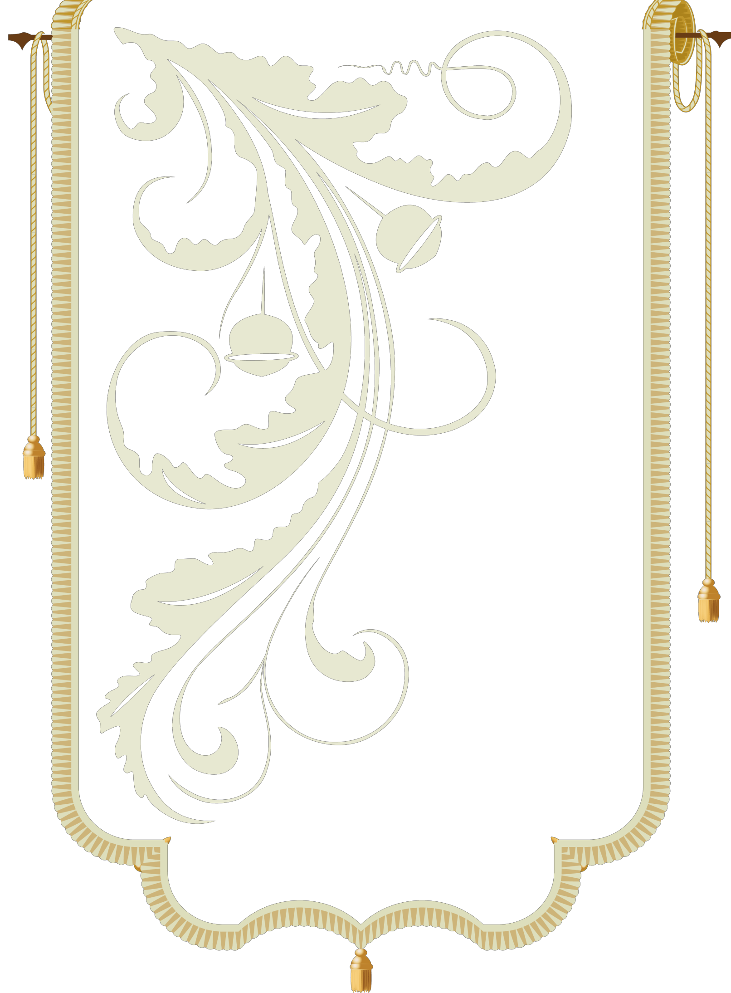
IN THE NAME OF ALLAH MOST GRACIOUS MOST MERCIFUL




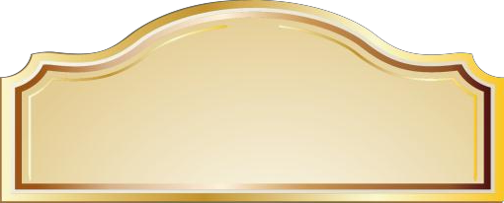
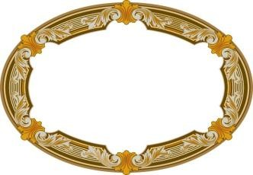
Third
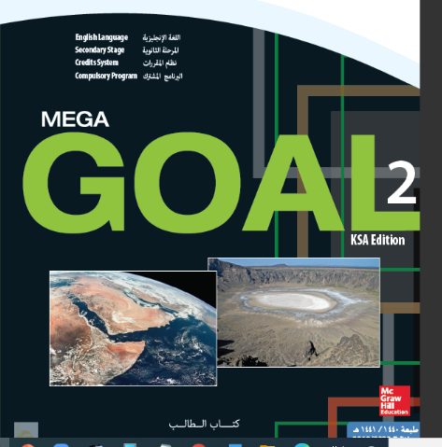
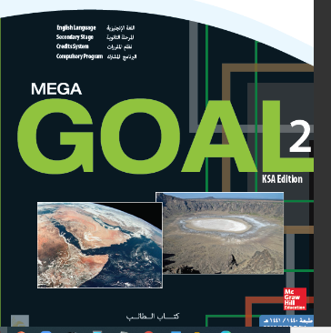

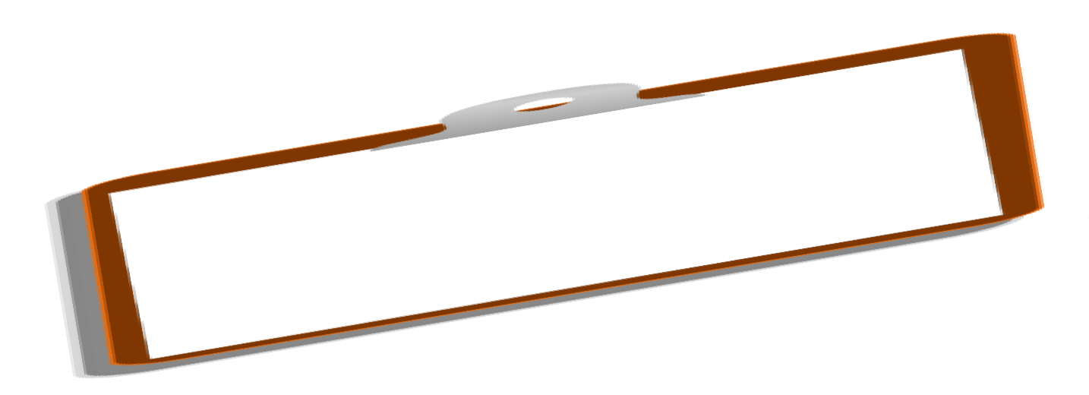

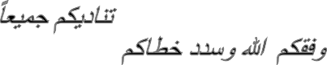









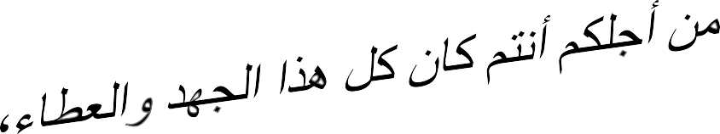

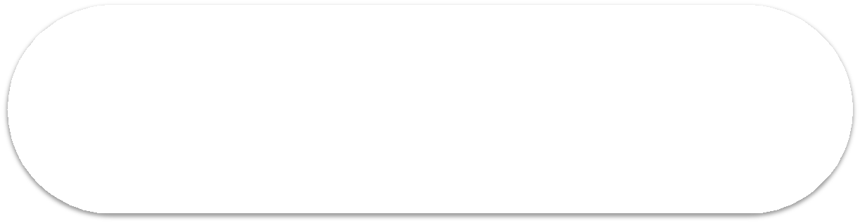

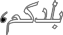
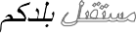
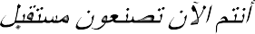
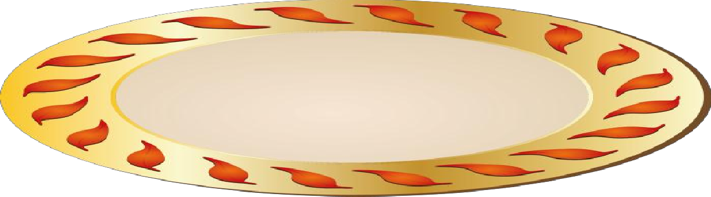



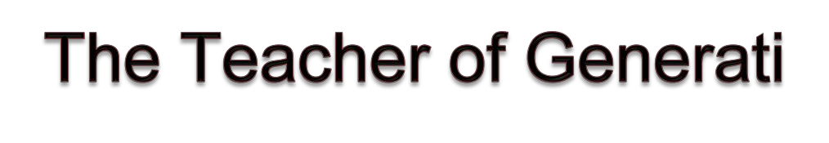

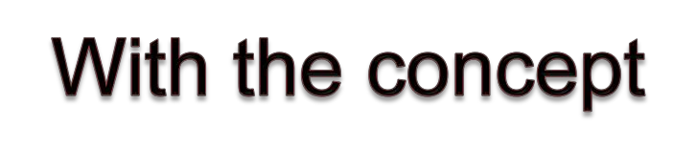



MegaGOAL 2
الصف الأول الثانوي/ الفصل الثالث
Best of Luck
for You All
ABOKHALEDAMER
High School
1st

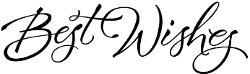
repairيصلح
replaceيستبدل
sharpenيحد / يسن
dry-cleanتنظيف جاف
rechargeيعيد شحن
hair dryerمجفف شعر
ironكواية ملابس
baby strollerعربة الطفل
meat grinderفرامة لحم
frozen dinnerعشاء مجمد
dessertحلا / تحلية
bottle of milkزجاجة حليب
shower capغطاء شعر الدش
salespersonبائع
customerزبون / عميل
Can I help you?ممكن أساعدك
Yes, please.نعم من فضلك
It sounds like.يبدو
returnيرجع / يعود
a pair of jeansجينز
faded colorsألوان باهته
creationsابداعات
designيصمم / تصميم
loose-fittingملابس واسعة
seasonموسم / فصل
fabricقماش
flimsyضعيف
latest trendأحدث موضة
latest styleأحدث موضة
lightweightخفيف الوزن
understandيفهم
kneeركبة
severalعديد / عدة
materialمادة / خامة
fall apartيتمزق
noticeيلاحظ
washerغسالة
apartmentشقة
Murphy's Lawقانون ميرفي
invite يدعو / يعزم
plenty of كثير من
refrigerator ثلاجة
bowl علبة / وعاء
fuzzyمشوش
wrong خطأ
Complaint شكوى
consumer مستهلك
Housing السكن
Wall جدار / حائط
filthy قذر / متسخ
need to be يحتاج أن
repaintيعيد طلاء
Don't worry لا تقلق
Car Repairs اصلاح السيارات
engineمحرك / موتور / ماكينة
strange غريب
noise ضوضاء / صجة
check يفحص
Clothing الملابس
sleeve كم
torn ممزق
sew يخيط
refundيستعيد القيمة
Products المنتجات
crash يتدمر/ يخرب
warranty ضمان
technician فني
awareness وعي
leaky pipeماسورة تسرب
dripping faucetحنفية تنقط
broken doorknobمقبض مكسور
broken windowpaneشباك مكسور
loose floorboardsأرضية مفكوكة
cracked windshieldزجاج مشروخ
flat tireكفر مهوي
worn tireكفر خربان
dead batteryبطارية فارغة
dent in the bodyصدمة بدي
scratched DVDمخدوش
no signalلا توجد إشارة
lines on screenخطوط على الشاشة
air conditioner مكيف
stainبقعة
holeثقب / خرم
missing buttonزر مفقود
brokenمكسور
crackedمشروخ
damagedمحطم / مدمر
tornممزق
sewnمخيط
Unit 1
Unit 1
Unit 1
Complaints

Unit 1
similar مشابه
situation موقف
remaining متبقي
coincidence مصادفة
physicist عالم فيزيائي
explain يشرح
memory ذكريات / ذكرى
rememberيتذكر
episodes حلقات
probabilityاحتمالية
againstضد
cashierمحاسب
80 percent = %80
slower laneحارة بطيئة
popularمحبوب
scientistعالم
proveيثبت
toastخبز
butterزبدة
halfنصف
becauseلأن
early enoughمبكر كفاية
be honestكن صادق
faultخطأ
backupتخزين
filesملفات
engineerمهندس
Air Force Baseقاعدة طيران
machineآلة
measureيقيس
heartbeatدقات القلب
breathingتنفس
pilotطيار
Malfunctionعطل / خلل
Equipment آلة / جهاز
human errorخطأ بشري
crash downيتحطم
failureفشل
negative سلبي
areaمنطقة

Real Talk It sounds like = It seems to be
Yes, please, if you could. = polite way to respond to an offer
Consumer Awareness : توعية المستهلكين
What to be aware of : مالذي يجب عليك ادراكه
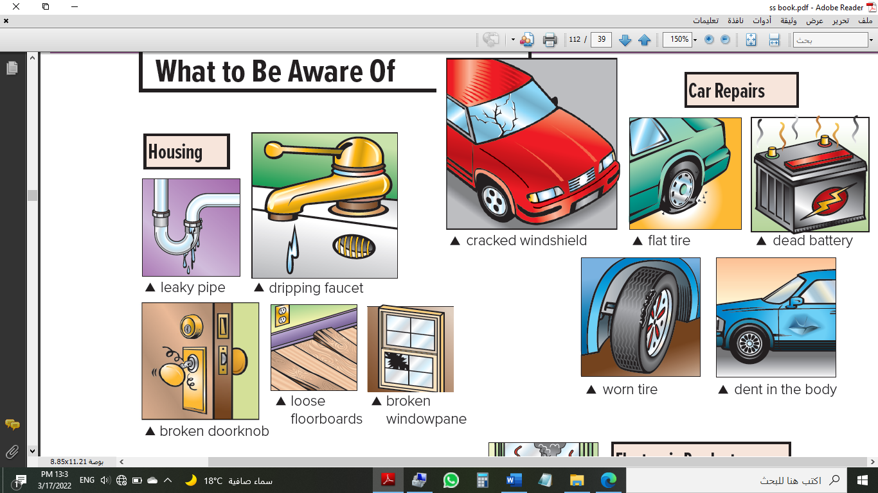  Housing: السكن  leaky pipe:  تسريب في الأنابيب  dripping faucet:  صنبور يقطر  broken doorknob:  مقبض الباب مكسور  broken windowpane:  زجاج النافذة مكسور  loose floorboards:  ألواح الأرضية محلولة | Car Repairs: صيانة السيارة  cracked windshield:  زجاج مشروخ  flat tire:  كفر مبنشر  dead battery:  بطارية منتهية  worn tire:  كفر متآكل  dents in the body:  خدوش في هيكل السيارة
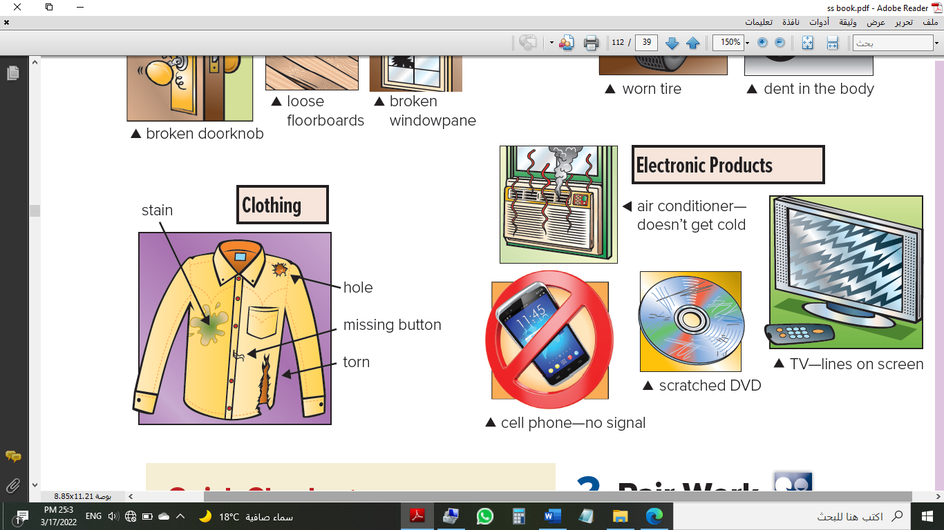  Clothing: الملابس  stain:  بقعة  hole:  القميص مخروم  missing button:  أزرار مفقود  torn:  ممزق | Electronic Products: الكترونيات  air conditioner—:  المكيف ما يبرد  doesn’t get cold  cell phone-no signal:  لا يوجد إشارة  scratched DVD:  اسطوانة مخدوشة  TV-lines on screen  تشويش في التلفزيون
Comprehension: قطعة فهم
1. The walls are dirty and need to be repainted.
2. He says he’ll have the engine checked.
3. The sleeve of the jacket is torn.
4. The computer crashed.
Consumer Complaints: شكاوي المستهلكين
الجدران متسخة (قذرة). تحتاج الي دهان مرة آخري
السكن
لا تقلق. سوف ندهنها

المحرك يصدر صوت غريب. لقد أدخلتها للصيانة منذ أسبوع.
صيانة السيارة
سوف نقوم بصيانتها

هذه الأكمام مقطوعة ... أطالب بجاكت جديد او القيمة النقدية
الملابس
سأقوم بخياطته

هذا الكمبيوتر خربان ... نعم، معي ضمان لثلاث سنوات
منتجات
هل لديك ضمان؟ سأجعل الفني يرى ما الأمر

Consumer complaints problems Resolving problems Repairs Consumer protection Customer service Products Clothing
Housing Car Repairs Electronic Products
1- leaky pipe 2- broken doorknob 3- broken Windowpane
4- cracked windshield 5- dead battery 6- cell phone-no signal 7- flat tire
1- What’s wrong with the apartment? - ما هو الخطأ في الشقة؟
2- What does the mechanic say he’s going to do? ماذا يقول الميكانيكي انه ذاهب الى القيام به؟
3- What’s wrong with the jacket?
4- What’s wrong with the computer?
How you’re going to solve these problems.
Problem | Solution
The air conditioner isn’t working. | ------------------------------------------------
The pants are torn. | ------------------------------------------------
The car has a dent. | ------------------------------------------------
The tire on the car is worn. | ------------------------------------------------
Complete:
Answer | Complaints.
............................................. | Computer crashed.
............................................. | Pen not writing.
............................................. | The car has a flat tire.
Match each word in Column 1 with a word in Column 2.
Make a list of problems of each category:
No | The category | Its problems
1
2
3
4

Column 1 | Column 2
1. leaky ___ | A. jeans
2. dead ___ | B. pipes
3. flat ___ | C. window
4. dripping ___ | D. faucet
5. scratched ___ | E. tire
6. broken ___ | F. battery
7. cracked ___ | G. windshield
8. torn ___ | H. DVD
Fill in the blank with the correct word: leaky – no signal – stain
1) There is a big ________ on my thobe. I should clean it.
2) I can bot receive your call. I think my cell phone has _________________.
3) There are drops on the floor. I think the problem is a _________________.
Match the correct word from A with the correct word from B:
1- Flat tire ___ polite answer
2- It sounds like ___ it seems like
3- Yes, please ___ about cars

What is the problem?
 | 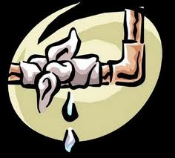 | 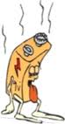
----------------------- --------------------- ------------------ ---------------------- ---------------- ------------------

Say how the things should be fixed. Use the words: repair – replace – sew
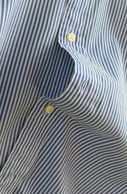

----------------------------------------------- ------------------------------------
Name the pictures:
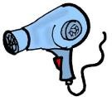
--------------------- | ------------ | ------------ | -----------------

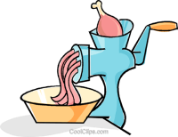
On hair dryer (don't use in water) >> Your advice: -----------------------------------------------
On meat grinder (don't use for other purposes) >> Your advice: -------------------------------
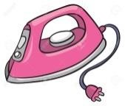
On iron (don't iron clothes on body) >> Your advice: ---------------------------------------------
Match:
a- this guy [ ] have a good time
b- to me [ ] echo question, to confirm what was said
c- You wouldn’t know…? [ ] in my opinion
d- have a ball [ ] informal way to say “this person".
The word | Its meanings
Yes, please, if you could. | --------------------------------------
It sounds like | ---------------------------------------
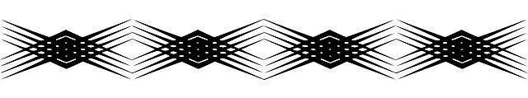
Answer the questions.
The questions | The answers
1. Was the salesperson helpful?
1. What's Milo's latest styles?
2. What was the problem with the jeans according to the mother?

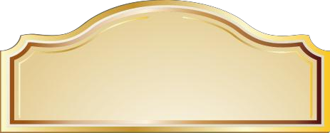
Third Term

MEGAGOAL 2

Grammar
need to be + P.P يحتاج إلى القيام به
The windows need to be cleaned. النافذة بحاجة إلى التنظيف (= Someone needs to clean the windows.)
The car seats need to be fixed. مقاعد السيارة بحاجة إلى الإصلاح (= Someone needs to fix the car seats.)

Choose the best answer:
1. Henry: Was your house damaged in the storm? Kevin: Yes, the roof _____.
A. need fix B. needs be fixed C. needs to be fixed D. needs to be fix
2. Zoe: Can I help with dinner? Hilary: Yes, the salad _____.
A. needs to be made B. needs make C. needs to make D. need make
3. The button on that shirt needs to be _____.
A. sew B. sewed C. sewd D. sewn

have / get شيء + P.P أتم شيء ما أو حصل على شيء ما
تستخدم have أو get مع التصريف الثالث للفعل عندما يقوم شخص آخر بفعل خدمة لك
The rooms need to be decorated. We are having / getting the rooms decorated.
The roof needs to be repaired. We are going to have / get the roof repaired.
The house needed to be painted. We had / got the house painted.

Choose the best answer:
1. Jessica: Your house looks great! I love the color. Mona: Yes, we ____ last month.
A. have it painted B. had it painted C. it had painted D. have painted it
2. Hussain: Oh no! Your jacket _____. John: I’ll return it to the store.
A. tear B. teared C. is tore D. is torn
3. Ed: Your windshield is cracked. Frank: Yes, I’m going to _____ this afternoon.
A. have it repaired B. have repaired it C. repaired it D. have to repaired it
Past Participles as Adjectives استخدام التصريف الثالث كصفة
break–broken: The windows were broken. I fixed the broken windows.
لقد كُسرت النافذة. أنا أصلحت النافذة المكسورة.
crack–cracked: The vase was cracked. I threw away the cracked vase.
لقد شرخت الزهرية. رميت بعيدا الزهرية المشروخة.
damage–damaged: The car was damaged. The mechanic fixed the damaged car.
لقد تلفت السيارة. أصلح الميكانيكي السيارة التالفة.
tear–torn: The shirt was torn. The tailor sewed the torn sleeve.
لقد مُزق القميص. خاط الخياط الكم الممزق.
Choose the best answer:
1. The plumber fixed the (breaked – broked – broke – broken) pipe.
2. The tailor sewed the (tear – tore – torn – tearing) shirt.
Give the past Give the past participle:
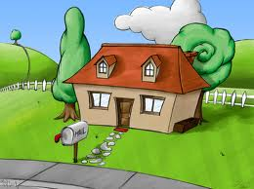
clean ………… damage …………. fix …………. paint ……….…. break …………. tear ……………… sew ………… stain ………….
Write the past participle of the verb in parentheses.
1. The button on that shirt needs to be _______________. (sew)
2. The car was _______________ in the accident. (damage)
3. Don’t drink out of that _______________ glass. (crack)
Choose the correct answer:
1- The windows need to be (cleaned – clean – cleans).
2- We're having the rooms (decorate – decorated – decorates).
3- The vase was cracked. I threw the (crack – cracking – cracked) vase.
Choose the best answer:
1. Henry: Was your house damaged in the storm? Kevin: Yes, the roof ___.
A. need fix B. needs be fixed C. needs to be fixed D. needs to be fix
2. Zoe: Can I help with dinner? Hilary: Yes, the salad _____.
A. needs to be made B. needs make C. needs to make D. need make
3. The button on that shirt needs to be _____.
A. sew B. sewed C. sew D. sewn
4. Jessica: Your house looks great! I love the color. Mona: Yes, we _____ last month.
A. have it painted B. had it painted C. it had painted D. have painted it
5. Hussain: Oh no! Your jacket _____. John: I’ll return it to the store.
A. tear B. teared C. is tore D. is torn
6. Ed: Your windshield is cracked. Frank: Yes, I’m going to ___ this afternoon.
A. have it repaired B. have repaired it C. repaired it D. have to repaired it
7. The plumber fixed the _____ pipe.
A. breaked B. broked C. broken D. broke
Complete with: need+ to be+ past participle. Choose a verb from the box.
repaint sew wash sharpen cut dry repair dry-clean

The tie………. | The pencils……… | The boy ͑s hair…… | The grass ……...

Salim bought a new house. What needs to be done before he can move in?
1- clean / kitchen …………………………………………………………………………………………………….
2- living room / decorate ………………………………………………………………………………………….
For Smart للأذكياء فقط
Choose the best answer to each question.
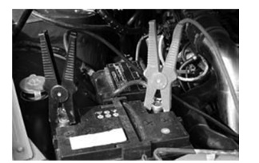
1. What problem does the picture show?
A. a dripping computer B. a flat computer
C. a broken computer D. a torn computer
2. What problem does the picture show?
A. a dead battery B. a missing battery
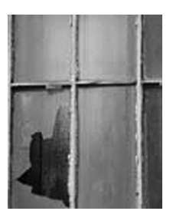
C. a flat battery D. a leaky battery
3. What problem does the picture show?
A. a loose windowpane B. a worn windowpane
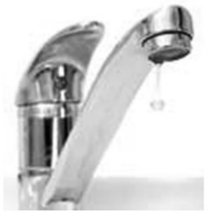
C. a dripping windowpane D. a broken windowpane
4. What problem does the picture show?
A. a cracked faucet B. a loose faucet
C. a dripping faucet D. a scratched faucet
Write the past participle of the verb in parentheses.
5. The button on that shirt needs to be ______________. (sew)
6. The car was ________________ in the accident. (damage)
7. Don’t drink out of that _________________ glass. (crack)
Choose the best answer to fill in each blank.
8. Our refrigerator isn’t working properly. It _______________.
A. need to be fixed B. needs to be fixed C. needs be fixed D. needs fixed.
9. Our house looks much better since we _______________.
A. got repainted B. get repainted C. had it repainted D. had repainted it
Complete the conversation. Use the correct form of the verbs in parentheses.
Khaled: I__________ (have) this car for six months, and it gives me all kinds of problems.
Joe: What is it this time?
Khaled: It ________ (not start) in the mornings.
Joe: Maybe it’s because of the cold, or the battery ________ (might/be) low.
It probably needs ________ (recharge).
Khaled: It isn’t that. I just ________ (have/put in) a new battery___________, and it still won’t start. I think the starter needs _________________ (repair).
Joe: Is there anything else wrong with the car?
Khaled: Yes, the exhaust pipe ________ (fall) of, and the radiator is leaking.
They both need _______________ (fix).
Joe: Is your car under warranty?
Khaled: Yes, it is.
Joe: Then you shouldn’t worry. We’ll _______ (have/fix) everything __________ for you.
Khaled: That’s what you ___________ (say) the last time.
Sub-Grammar

Present Perfect with already yet just
يستخدم المضارع التام للتعبير عن حدث حصل في الماضي وانتهى قبل لحظات أو انتهى في الماضي ولازالت آثاره موجودة حتى الآن
يتكون زمن المضارع التام من [HAS / HAVE] + [past participle]
I have seen that movie many times.
- just للتعبير عن أن شيئاً ما اكتمل حديثا
I've just finished reading this book. لقد انتهيت للتو من قراء هذا الكتاب
- already للتعبير عن أن شيء ما سيكتمل في الحاضر أو اكتمل في الماضي
I've already read this book. لقد قرأت الكتاب مسبقاً
- yet للتعبير عن أن شيئا ما لم يكتمل في وقت الكلام
I haven't read it yet. لم أقرأ هذا الكتاب بعد (لكني سأقرأه قريباً)
Questions الأسئلة | Affirmativeالإثبات | Negativeالنفي
Have you done the dishes yet? | Yes, I've already done them. | No, I haven't done them yet.
Have you already finished reading of this book? | Yes, I've just finished reading this book. | No, I haven't finished reading this book yet.
Verb + Gerund
- Use the gerund form (which ends in –ing) after the following words:
استخدم صيغة الفعل المضاف اليه –ing بعد الكلمات التالية
[avoid- enjoy- give up- imagine- mind- stop- can't stand- finish- hate- keep- miss- suggest]
- He can't stand waiting in the line. - I don't enjoy sitting in the sun.
Subject and Object Pronounsضمائر الفاعل وضمائر المفعول
Subject Pronouns  ضمائر الفاعل | Object Pronouns  ضمائر المفعول به
I | me
You | you
He | him
She | her
It | it
We | us
You | you
They | them
Need/Want/Like + [to + Infinitive] استخدام need / want:/ like + to الفعل في المصدر
She needs to buy some snacks. He doesn't want to do dishes. I like to help my mother.
Imperatives and Two-Word Verbs الأوامر باستخدام أفعال من مقطعين (فعل + حرف جر)
Clean up the mess. Clean the mess up. Clean it up.
-I really need to lose weight but I ________ eating candy!
A: can’t stop B: can stop C: can’t stand D: can stand

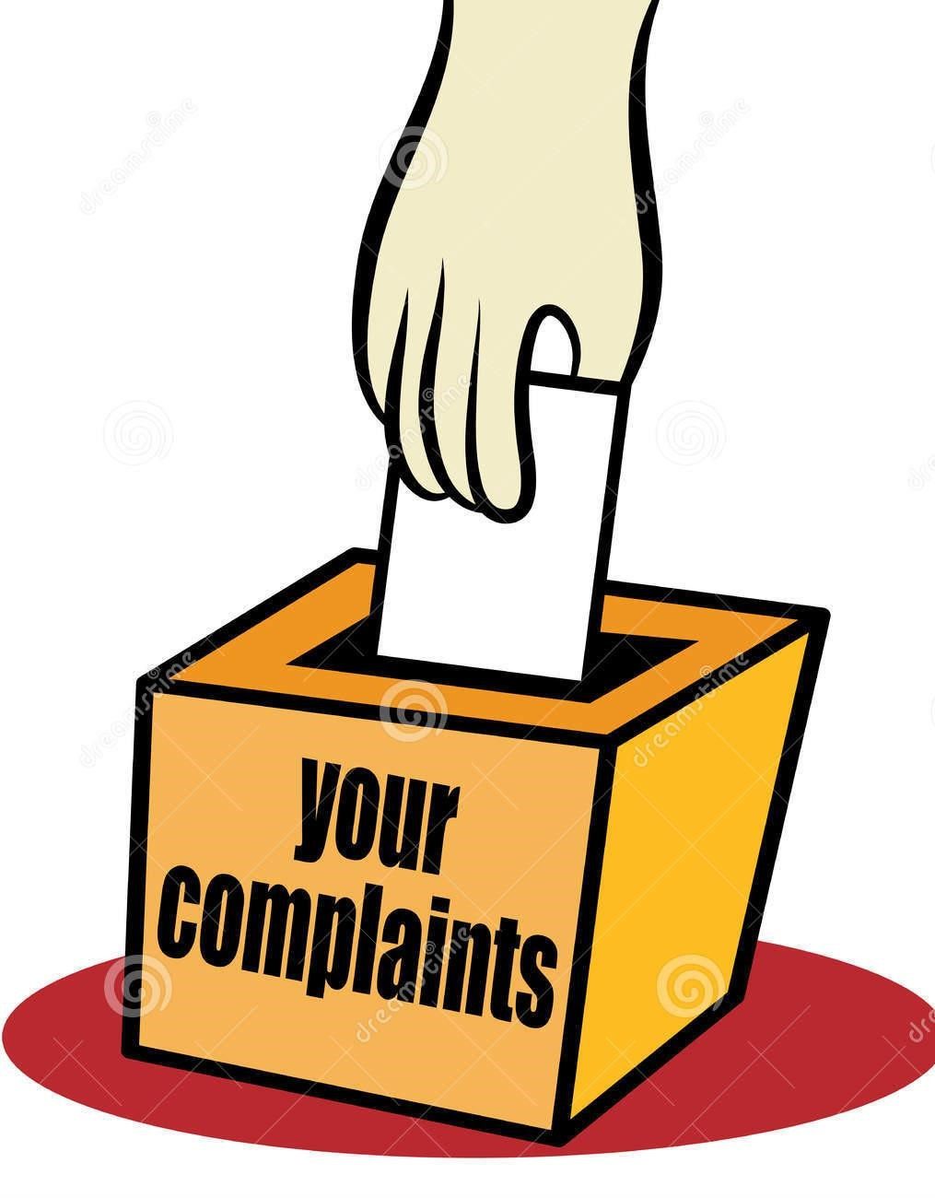
Choose the correct verb:
can't stand – avoided – keep on

- What a pity you failed the test. You must ………….….. trying.
- Can you ask me your question now? I …………..….. waiting.
- Ask your brother what happened. He didn't answer me. Actually, He ……….. talking to me.
Rewrite the sentences adding: (Already / Just / Yet).
1. I have eaten sushi before. (already)
2. She hasn’t visited Germany. (yet)
3. They have seen this movie. (already)
4. We have met your teacher. (just)
5. My brother hasn’t started school. (yet)
6. Daniel hasn’t fixed the broken pipe. (yet)
8. My daughter has lost her purse. (just)
9. He has finished his assignment. (already)
10. Dad, do you want me to take out the garbage or __________ done it?
A: did you already B: you have already C: have you already D. already you have
Use the correct object pronoun: me, you, him, her, it, us, or them
- Noha is her best friend. She's going to visit_________________.
- I'm going to be at home tonight. Please call_________________.
- I want to meet my neighbors. I don't know_________________.
- Please listen. I'm talking to_________________.
- He wants to invite Ali. He's going to call _________________.
- We want to come to your graduation. Don't forget_______________.
Rewrite each sentence with a two-word verb:
- Turn up the news. ____________________________________.
- Please turn off the light. _______________________________.
- Put away those toys. __________________________________.
- Please pick up your jacket. _____________________________.
- Please turn the TV on. _________________________________.
- Clean up this mess. ____________________________________.
- Turn down the radio. __________________________________.
The various ways to give advice:
should / shouldn’t ought to must / must not had better / had better not.
What does a defective product mean? It means that the product
1. --------------------------------------------
2. ---------------------------------------------
Write a letter of complaint to the store where you bought a faulty product.
Third Term

MEGAGOAL 2

Concentrateركز
* Choose:
1. The windows need to be ( clean – cleaning – cleaned ) .
2. The correct form of past participle for "break" (breaking – broken – breaks)
3. I'm going to be at home tonight. Please call ( him – me - her ) .
#Rearrange the sentences:
1- my / to call / need / I / friends
2- snacks / to buy / you / Do / need ?
3- don't / an invitation / need / we / to send
Match :
 | A |  | B
1 | Yes, please, if you could |  | Lamp
2 | It sounds like |  | Polite way
3 | Electronic products |  | It seems to be
4. | Of Course. |  | Used to say yes
Choose the correct answer:
1- The dress is torn. It (needs- need – needed) to be ( sew – sewn – sewed).
2- When the ambulance arrived, the injured man had ( died - die – dead ).
3- You (mustn´t - couldn´t - mightn´t) smoke here.
4- I (has - have - had) finished my homework before my mom returned .
Do as shown between brackets:
1.The walls are filthy. They need to be repaint (Correct the verb ).
2. The vase was cracked. (Use the past participle verb as adjective).
Choose the correct answer:
1.The disk is ( broken – break – broke). It (need – needs – needing) to be fixed.
2.My shirt is ( stain – stained – stains). It (need – needs – needing) to be cleaned.
Write the sentence differently "Don’t Change the meaning:
1.The room is decorated.
2.The picture is colored.
Choose the correct letter:
1. st__in ( a / o / b ) 2. lea__y ( t / k / o) 3. t__rn ( a / o / b ) 4. c__acked (t /o / r)
Fill in the missing letters :
1. ho__e 2. Scratc__ed 3. fau__et 4. scra__ched
Put the word in the correct place:
1. I will go to the bank to …….. money back ( technician / continually/ refund)
2. The kitchen is very ……….. I will clean it. (filthy / continually/ refund)
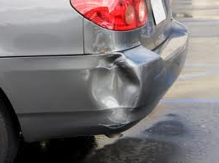
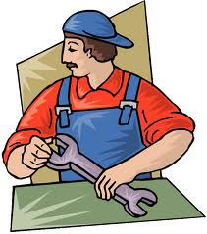
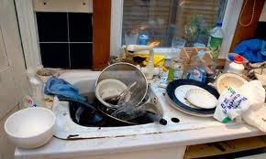
Put the word under the picture: (filthy / dent / flat tire / technician )
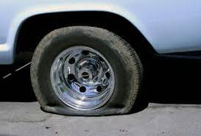

------------------------ ----------------- ---------------------- ----------------------------
Match the word with its meaning:
No. | The Word |  | The Meaning
1 | flat tire |  | someone who makes repairs.
2 | dead battery |  | a tire that has no air in it .
3 | technician | -

No. | The Word |  | The Meaning
1 | dent |  | no power in the battery.
2 | dead battery |  | dirty
3 | filthy | -
Read the passage and then answer the questions:
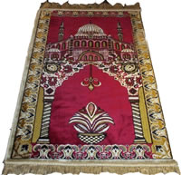
The Muslim world is famous for its rugs. Our rugs are made of wool or silk. They contain many colors, but the most common color is red. The most famous rugs come from Iran. Some have flowers on them and some have geometrical shapes. Many of them have a shape of a Mihrab in the center. This is because the first Muslim rugs were only used for praying. All the rugs are made by hand. It sometimes takes a man a year to make one rug.
A. Answer the following questions:
1. Where do the most famous rugs come from?
2. Are the rugs made by hands?
B. Choose:
1. Some rugs have { flowers – doors - writing}.
2. The common color of rugs is: { green – yellow – red}.
C. Put ( ) or ( ):
1. The first rugs were only used for decorating rooms. ( )
2. One rug takes about one year to finish. ( )
#Answer the following questions
1.What could have caused the extinction of dinosaurs?
2.What does Murphy's Law state ?

Third Term

MEGAGOAL 2

Test on Unit 1 اختبار على الوحدة الأولى
Write the correct number under the correct picture:
1.microwave 2.hairdyer 3.car dent 4.lines on screen 5.headphones 6.hole 7.airplane

( ) ( ) ( ) ( ) ( ) ( ) ( )
Write the correct number under the correct picture:
1. The air conditioner needs to be repaired. 2. The pants need to be sewn.
3. The knife needs to be sharpened. 4. The car dent needs to be repaired.
5. The shirt button needs to be sewn. 6. The shoe heel needs to be replaced.
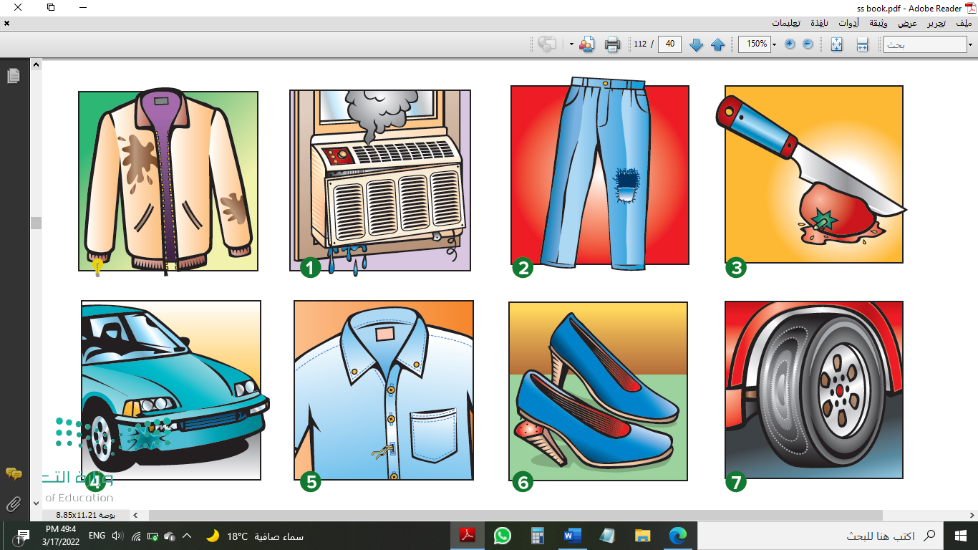
7. The jacket stain needs to be dry-cleaned. 8. The worn tire needs to be replaced.
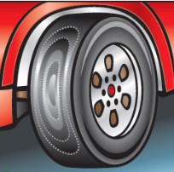

( ) ( ) ( ) ( ) ( ) ( ) ( ) ( )
Write the correct number under the correct picture:
1. I’m going to have the windowpane fixed. 2. I’m going to have the faucet fixed.
2. I’m going to have the window cleaned. 4. I’m going to have the wall painted.
5. I’m going to have the hole repaired. 6. I’m going to have the TV repaired.

( ) ( ) ( ) ( ) ( ) ( )
Choose the correct answer:
1. The windows need to be (cleaned – cleaning – cleans).
2. The car seats need (to – toe – to) be fixed.
3. The house needed to (bees – be – been) painted.
4. We're having the rooms (decorated – decorates – decorating).
5. We're going to have the roof (repairing – repairs – repaired).
6. The mechanic fixed the (damages – damaged – damaging) car.
7. I fixed the (breaks – breaking – broken) windows.
Match the Following:
1. Yes, please, if you could. a. It seems to be.
2. It sounds like b. polite way to respond to an offer.
3. meat grinder c. used for ironing clothes.
4. iron d. used for grinding meat.
5. Murphy's Law e. If anything can go wrong, it might go wrong!
Supply the missing letters:
compla__nt cons__mer d__nt engi__e fab__ic fau__et hol__
p__pe refu__d rep__ir scr__en sta__n warra__ty brok__n dam__ged
اختبار الوحدة الأولى Unit 1 Test
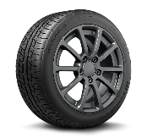
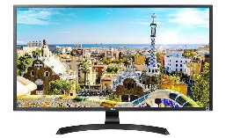
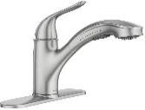
Match : Car Engine – Faucet – Tire – Screen
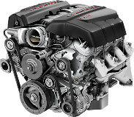

Fill in the missing letters: P__pe Bat__ery __utton Sho__s
A | B
1- a hair | ( ) stroller
2- a bottle of | ( ) dryer
3- a meat | ( ) milk
4- a baby | ( ) grinder
Match:

Fill in: cleaned – sewn – waiting – off
1. Turn the TV ………… 2. The windows need to be ……………….
3. The pants need to be ……………. 4. He can't stand ………………… in line.
Rewrite each sentence using a two-word verb:
- Clean up this mess. - Please pick up your jacket.
Choose the correct answer:
The disk is (broken–break–broke). It (need–needs–needing) to be fixed.
Write the sentence differently "Don’t Change the meaning:
The room is decorated.……………………………………………………………………………………………………………..
Choose the correct letter: 1. st__in ( a / o / b ) 2. lea__y ( t / k / o)
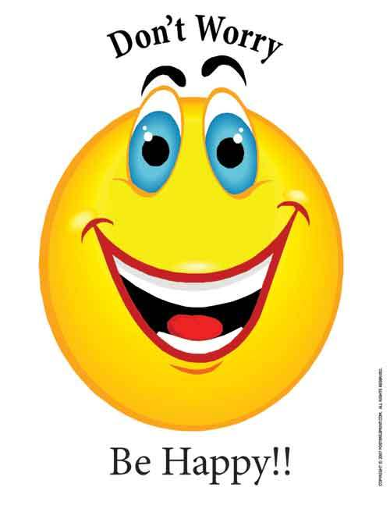
Fill in the missing letters : 1. ho__e 2. Scratc__ed
Match the correct Sentences:
No. | The Word |  | The Meaning
1 | flat tire |  | someone who makes repairs.
2 | dead battery |  | a tire that has no air in it.
3 | Technician | a battery with no power.
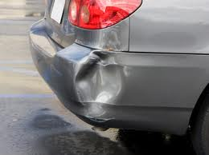
Put the word under the picture: (filthy / dent / signal )

……………………… …………………………….
Put the word in the correct place: (technician / continually/ refund)
I will go to the bank to ……………………………………. money back.
Choose the correct answer:
1. My shirt is (stain–stained–stains). 2. It (need–needs–needing) to be cleaned.
Write the sentence differently "Don’t Change the meaning:
The picture is colored ………………………………………………………..
Choose the correct letter:
t__rn (a / o / b) c__acked (t /o / r) Fau__et
No. | The Word |  | The Meaning
1 | Dent |  | no power in the battery.
2 | dead battery |  | Dirty
3 | Filthy | Damage in the body.
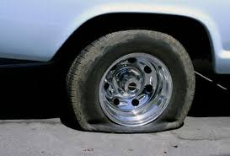
Put the word under the picture: (flat tire / technician / signal)

……………………… ……………………….
Put the word in the correct place: (filthy / continually/ refund)
The kitchen is very ……………………………………. I will clean it.
Choose the best answer to fill in each blank.
1. Our refrigerator isn’t working properly. It (need to be fixed – needs to be fixed – needs be fixed – needs fixed).
2. Our house looks much better since we (got repainted – get repainted – had it repainted – had repainted it).

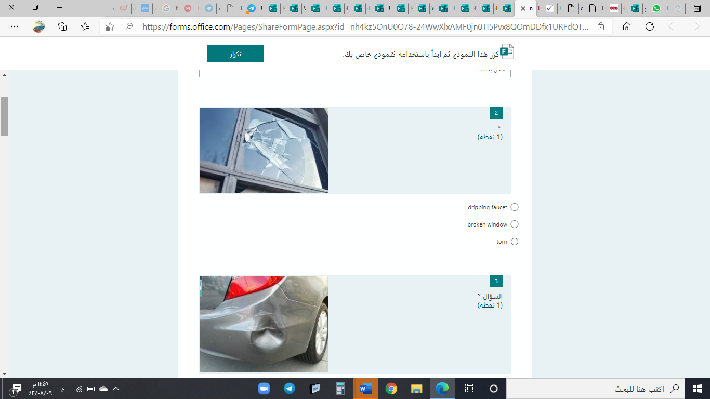
اختبار المنصة
1. (dripping faucet – broken window – torn shirt).
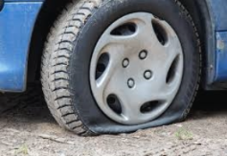
2. (dent in the body – worn tire – flat tire)
3. (dead battery – loose floorboards – flat tire)
4. I fixed the (broken – break – breaking) windows.
5. The past participle of the verb "fix" is: (fixing – fixen – fixed).
6. The windows need to be (clean – cleaned – cleaning).
7. "It sounds like" means: (It seems to be – It runs fast – It is a cat).
8. The car windscreen is cracked. please can you fix (them – him – it)
9. Which sentence is true? (the light turn off – off the light turn – turn off the light).
10. I need to (call – called – calling) my friends.
11. I don't want to ask my neighbors. I don't know (her – them – it).
12. I enjoy (watch – watching – watches) TV.
13. Which sentence is true? (I have already done my homework – I already have done my homework – I have done my home work already)
14. He (have – has – are) taken the garbage.
15. We are (have – having – has) the room decorated.
Choose the correct answers:
1- The windows need to be ( clean – cleans – cleaned).
2- We're going to ( has – have – had) the roof repaired.
3- The vase was cracked. I threw away the ( cracks – cracked – crack) vase.
4-The past participle of the verb "tear" is ( torn – tears – tearing).
5- I ( has – have – had) the jacket dry-cleaned yesterday.
6- The car seats ( need to be – need to – need) fixed.
7- We are (getting – gets – need ) the car seats fixed.
8- Have they ( takes – took – taken) the car to the garage?
9- He has ( gone – been – is) to Jeddah but he turned back.
10- I haven't done my homework ( just – already – yet).
11- They have made a big house ( yet – already – just).
12-Prophet Muhammad peace be upon him ( has – have – is) built Quba'a Mosque.
13- Children stop ( play – playing – plays) tennis.
14- Mothers ( like to – enjoy – want to ) helping their kids.
15- Nora ( needs – needs to be – needs to ) buy some snacks.
16- We need to invite our friends. I can ask ( us – them – it).
17-The teacher can help ( me – it – her) because I don't know the answer.
18-( Turns – Turning – Turn) off your cell phone.
19- "Clean up the miss" or ( "Clean it up" - "Clean up" - Clean" )
20- Put away your clothes or ( Put away – Put your clothes away – Put).
Fill in the blanks with correct words: ( sounds like – if you could- flimsy)
A: Can I help you , ma'am ?
B: Yes, please. ……………………… I'd like to return this ………………….jeans.
A: It ………………………… as if you don't like it. It's OK.
B: Thanks
Ma tch the words with Meaning or pictures or completion part:
1. filthy | - turn back the money
2. refund | - dirty
3. fuzzy | - event
4. episode | - not clear
5. backup | - not working correctly
6. malfunctioning | - copy
7. leaky pipe | 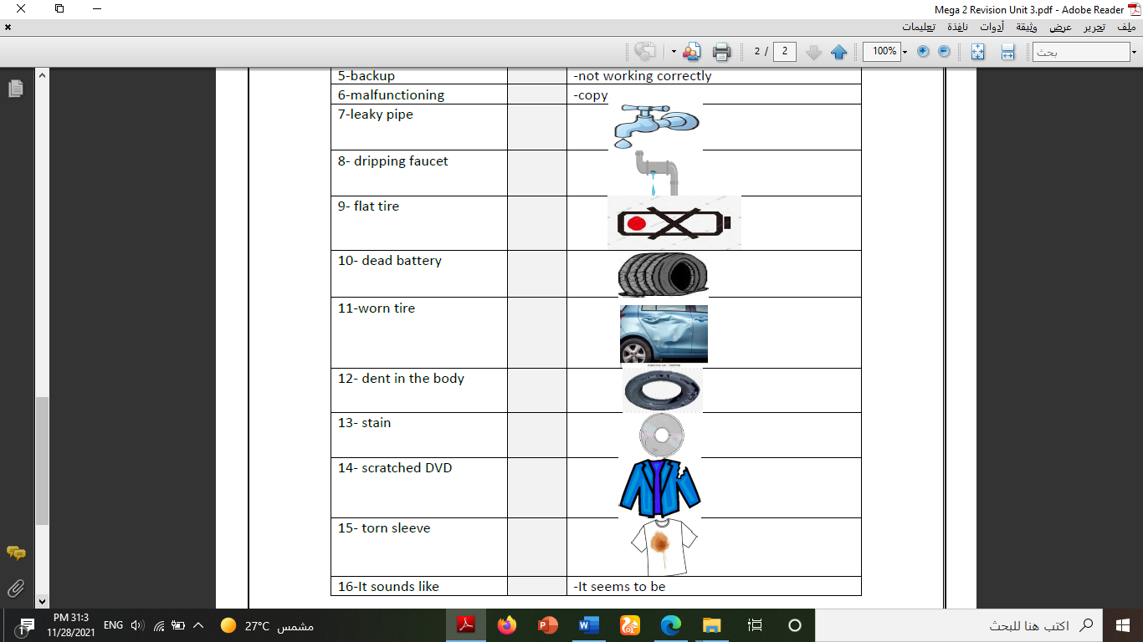
8. dripping faucet
9. flat tire
10. worn tire
10. dead battery
12. dent in the body
13. stain
14. scratched DVD
15. torn sleeve
16. It sounds like | - It seems to be
Read the text and answer the questions:
The Blue Whale is the largest animal in the world. It grows up to thirty- three meters in length and may weigh as much as 130,000kilograms. It is even bigger than the huge animals that lived on earth long ago. Some people think that the Blue Whale is a fish because it lives in the sea and has a tail like the tail of a fish. However, it is not a fish. Fish breathe water but Blue Whales breathe air. They can stay under water for about an hour but then they have to come to the surface to breathe. The Blue Whale has a thick coat of fat under its skin. This acts as a blanket to keep it warm. The number of Whales in the sea is becoming less every year. This is because men hunt them and kill them, for almost every part of a Whale's body can be used to make something useful.


1. Why do some people think that a Whale is a fish?
2. Is the whale the largest animal in the world?
3. Choose the correct answer:
1. Whale may grow to be ----------- long.
a. 33metres b. 30 feet c. 7 or 8 meters d. 100 meters
2. The layer of fat under the whale's skin ----------------
a. helps it to float. b. keeps its blood warm. c. helps it to breathe. d. keeps its blood cool.

Read the text and answer the questions. Write T or F at the end:
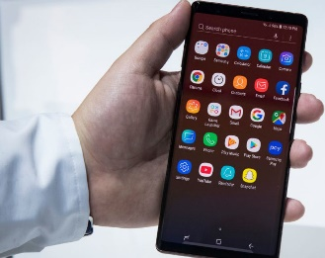
To: Talk and Text Cell Phone Company@email.com
From: Michael Reed@email.com
Subject: Complaint
Dear Talk and Text Representative,
I am writing to you to complain about my new cell phone and service plan. I bought a new cell phone from Talk and Text last month, but the phone is already broken. The instructions say that I can take pictures with it and store them on my phone, but when I take a picture, it is erased after a few minutes. I would like to return this phone and get a new one without a charge. Also, my text messaging plan needs to be changed. I thought my plan was for unlimited texting, but I just received a bill for all of the texts I sent last month. I do not think that I should have to pay this bill because my service contract with Talk and Text says that I have unlimited texting. Please respond to this email, or call me at 326-555-8125.
Sincerely,
Michael Reed
1. Michael is unhappy with his new cell phone. ____
2. Michael cannot take pictures with his phone. ____
3. Michael’s phone doesn’t store pictures. ____
4. Michael probably texts a lot. ____
5. Michael will probably pay his texting charges. ____

Read the text. Write T or F at the end of each question:
Curling
Curling was made an official sport in the Winter Olympics in 1988. When spectators watched the first curling match in the Olympics, many people in the audience did not know anything about the game. They thought that it was a new sport. However, in spite of the fact that curling is little-known, it has been around for hundreds of years.
In the sport of curling, a team of players slide stones across the ice to reach a target spot. The stones are made of granite, a naturally-occurring hard rock. Each team throws eight stones. The stones that are closest to the target spot gain points for their team.
The name curling comes from the movement of the stones on the ice. When a stone was thrown, it would often curve, or curl, as it slid across the ice. This game involves more skill and strategy than it first appears. In fact, good players spend so much time thinking about where to throw their stone that curling has been referred to as “chess on ice.” The stones need to be thrown skillfully to land in the target spot.
In the 1500s, curling was a recreational sport in Scotland. Friends and family gathered on frozen lakes, or lochs to play. They used ordinary flat stones that they gathered from the ground. The first curling club was established in Scotland in 1668. The first curling club in the United States was founded in 1830. Today, curling is played in many countries around the world, including Canada, the U.K., the U.S., Norway, Sweden and Japan. Even though curling is an Olympic sport, it can be played by almost anyone.
1. Curling is an Olympic sport. ____
2. Curling is a new sport. ____
3. The first curling club was established in the United States. ____
4. Curling is often played in countries that have cold weather. ____
5. The name curling comes from the movement of the player’s body. ____
button
complaint
consumer
dent
doorknob
engine
fabric
faucet
hole
housing
packaging
pipe
refund
repair
retail outlet
screen
signal
sleeve
stain
technician

warranty
windowpane
check
crash
dry-clean
purchase
refrain
repaint
repair
sew
sharpen
broken
cracked
damaged
dead
dripping
faded
filthy
flat
intact

leaky
loose
loose-fitting
missing
scratched
sewn
stained
torn
Don’t worry.
leaky
loose
loose-fitting
missing
scratched
sewn
stained
torn
Don’t worry.

For smart test unit 1 اختبار الأذكياء الوحدة
Grammar: Choose the correct form in brackets
1- The rooms need to be (clean – cleans – cleaned – cleaning).
2- I (has – have – having – had) my hair cut yesterday.
3- He fixed the (crash – crashed – crashes – crashing) computer.
4- Has he (driven – drove – drive – driving) the car.
5- I haven't eaten at that restaurant (already – just – as soon as – yet).
6- I don't enjoy (siting - sit - sat – sits) in the sun.
7- I'm going to be at home today. Please call (him – them – us – me).
Correct the errors in the following sentences
1- I had my house (paint) ................................
2- The mechanic fixed the (damage) ................................ car.
3- She (need) ................................ to take more exercises.
4- Put your clothes (up) ................................
5- I have done my homework (just) ................................
6- We want to come to your graduation. Don't forget (him) .................................
Do as shown between brackets
1- She have sent the email. (Complete using: already or yet)
2- Please listen to me when I'm talking to ............... (Complete)
3- "Clean up this mess" (Rewrite the sentence differently)
Vocabulary: Circle the odd words
1. cracked – broken – damaged – fixed 2. stain – hole – no signal – torn
Fill in the spaces with suitable word: (sharpened – torn – stained – crashed)
1- The knife doesn't cut. It needs to be ...............................
2- The sleeve of the jacket is ............................... I will have it sewn.
3- This computer ............................... I'll have a technician look at it
Classify the items: stain – dripping faucet – leaky pipe – missing button
Clothing | Housing
Match the words with their meanings: Match the words with their opposites:

1 | faded | Clean - spotless
2 | stained | unsewn
3 | Loose-fitting | tight-fitting
4 | sewn | dark & brightened

1 | crashed | shredded
2 | filthy | event
3 | episode | broken
4 | torn | dirty
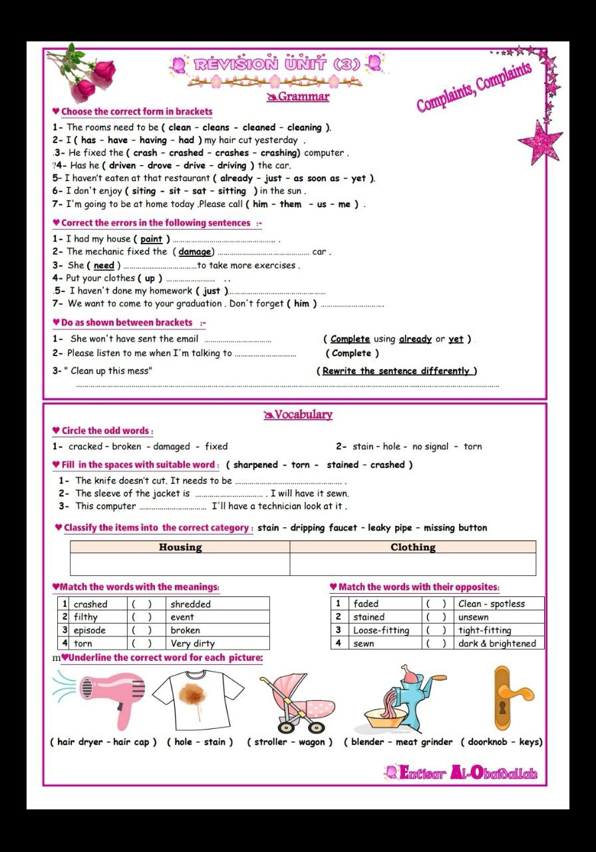
Underline the correct word:

(hair cap – hair dryer) (stain – hole) (stroller – wagon) (blender – meat grinder) (door knob – key)

