NAMES : …………………………………………………………………………………………………………………………….
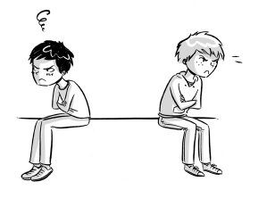
1-What did the writer lend his friend ? ……………………………………………………………………………………………………
2- What did the writer's friend want to buy ? ……………………………………………………………………………………………
3-what did the writer need to buy ? ……………………………………………………………………………………………………….
4- The writer lent his friend 20 $ ( ) ( T OR F ) ?
5- What happened when the writer asked his friend some of the money ?
……………………………………………………………………………………………………………………………………………………..
6- The writer is really sad because he lost his best friend ( ) ( T OR F ) ?
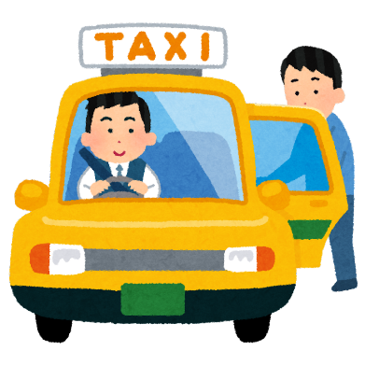
1-The writers job is taxi driver ( ) ( T OR F ) ?
2- What did people leave in the driver's car ? …………………………………………………………………………………………..
3- Last Saturday night he picked up a rich man at his hotel ( ) ( T OR F ) ?
4- What did the driver find in his car ? ………………………………………………………………………………
5- The driver called the hotel where the man was staying ( ) ( T OR F ) ?
6- How much money did the taxi driver get ? …………………………………………………….
7- Did the driver taxi regret getting the watch back to the man ?
………………………………………………………………………………………………………………….

