Choose the correct answer :
1-The rooms need to be ( clean – cleans - cleaned – cleaning ).
2I ( has – have – having – had ) my hair cut yesterday-.
3-Has he ( driven – drove – drive – driving ) the car
4-I'm going to be at home today .Please call ( him – them – us – me ).
Correct the mistake:
. The mechanic fixed the ( damage) ……………………………………… car .
I haven't done my homework ( just )…………………………………………
Rewrite the sentence differently :
" Clean up this mess"
………………………………………………………………………………
Fill in the blanks with suitable words : ( torn - stained – crashed)
1- The sleeve of the jacket is …………………………… . I will have it sewn.
2- This computer …………………………… I'll have a technician look at it .
Match the words with their meanings :
1-it sounds like …… a)Event
2-episode …… b)it seems to be
3-filthy …… c)Causing great fear
d)very dirty
Write the words under the right pictures:
( hair dryer – coins – doorknob )
Bonus Q
+1
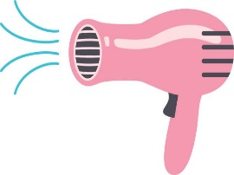
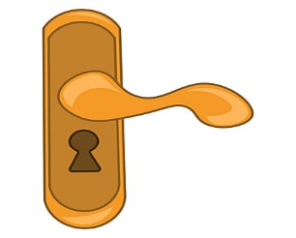
Correct the mistake:
I stop (play) tennis.
……………………………………………………..

