 |  | اختبار الفصل الدراسي الثاني ( ف 2)  عام 1443-1444  اللغة الإنجليزية  للصف الثالث متوسط  الزمن: 45 دقيقه
  المملكة العربية السعودية
  وزارة التعليم
  تبوك
  المتوسطة الحادية والعشرون

اسم الطالبة: الفصل:

1-Composition, write a paragraph about Tabuk. Use the key words below:
[-city- big – Saudi Arabia-flowers- famous- parks- malls-restaurants]

……………………………………………………………………………………………………………………………………………..
……………………………………………………………………………………………………………………………………………….
………………………………………………………………………………………………………………………………………………
………………………………………………………………………………………………………………………………………………
……………………………………………………………………………………………………………………………………………..
………………………………………………………………………………………………………………………………………….
……………………………………………………………………………………………………………………………………..
…………………………………………………………………………………………………………………………………………
………………………………………………………………………………………………………………………………………..

4

 |  | اختبار الفصل الدراسي الثاني ( ف 2)  عام 1443-1444  اللغة الإنجليزية  للصف الثالث متوسط  الزمن: 45 دقيقه
  المملكة العربية السعودية
  وزارة التعليم
  تبوك
  المتوسطة الحادية والعشرون

اسم الطالبة: الفصل:
Q2-Reading: Read the passage and choose the correct answer:
My Father
I love my father. He is very kind. He is called Robert. He is 45 years old. He is an active person. He gets up Early to get ready for his work. He is an architect. He always designs high skyscrapers.
false | true | 1-His father's name is Robert.
false | true | 2-His father age is 55 years old
false | true | 3- He is an architect
false | true | 4-His father is very sad.
Q3-Grammar: Choose the correct answer:
C-Who | B-What | A- How long | 5-………have you played football?
C- inventing | B- invented | A- invent | 6-The telephone was…….by Graham Bell.
C- since | B- for | A-some | 7-Hameed has had the same T.V…….15 years.
C- When | B- How | A-Where | 8-…….many people live there?
C- the most expensive | B-more expensive | A-expensive | 9-trains are as…….as planes.
C-The | B-on | A- in | 10- ……moon is big.
Q4-Vocabulary:
A-Write the correct word for each picture:
A-camera – B-television – C-ladder – D-spoon – E- lap top –
 | 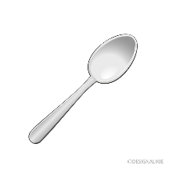 |  | 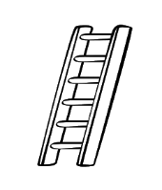
11-………. 12-……………. 13-………… 14-…...
B-Match sentences in column A with column B correctly
15- | A way of doing things. |  | A orphan
16- | The bride of the Red Sea |  | B- technique
17- | A child who has lost his parents. |  | C -get married
18- | Settle down. |  | D – Jeddah  E-aspects

Q5-Orthography (Spelling):
-Choose the missing letters:
19-This is a new pri…er | a-( ut ) | b-( nt ) | c-( tm )
20-I bought a t..ap..t | a-( e - o) | b-( t-t ) | c-( u)
21-Use a gar…ge can, please | a-( eb ) | b-( ba) | c-( si )
22-I like this te….y bear. | a-( dd ) | b-( da ) | c-( k )

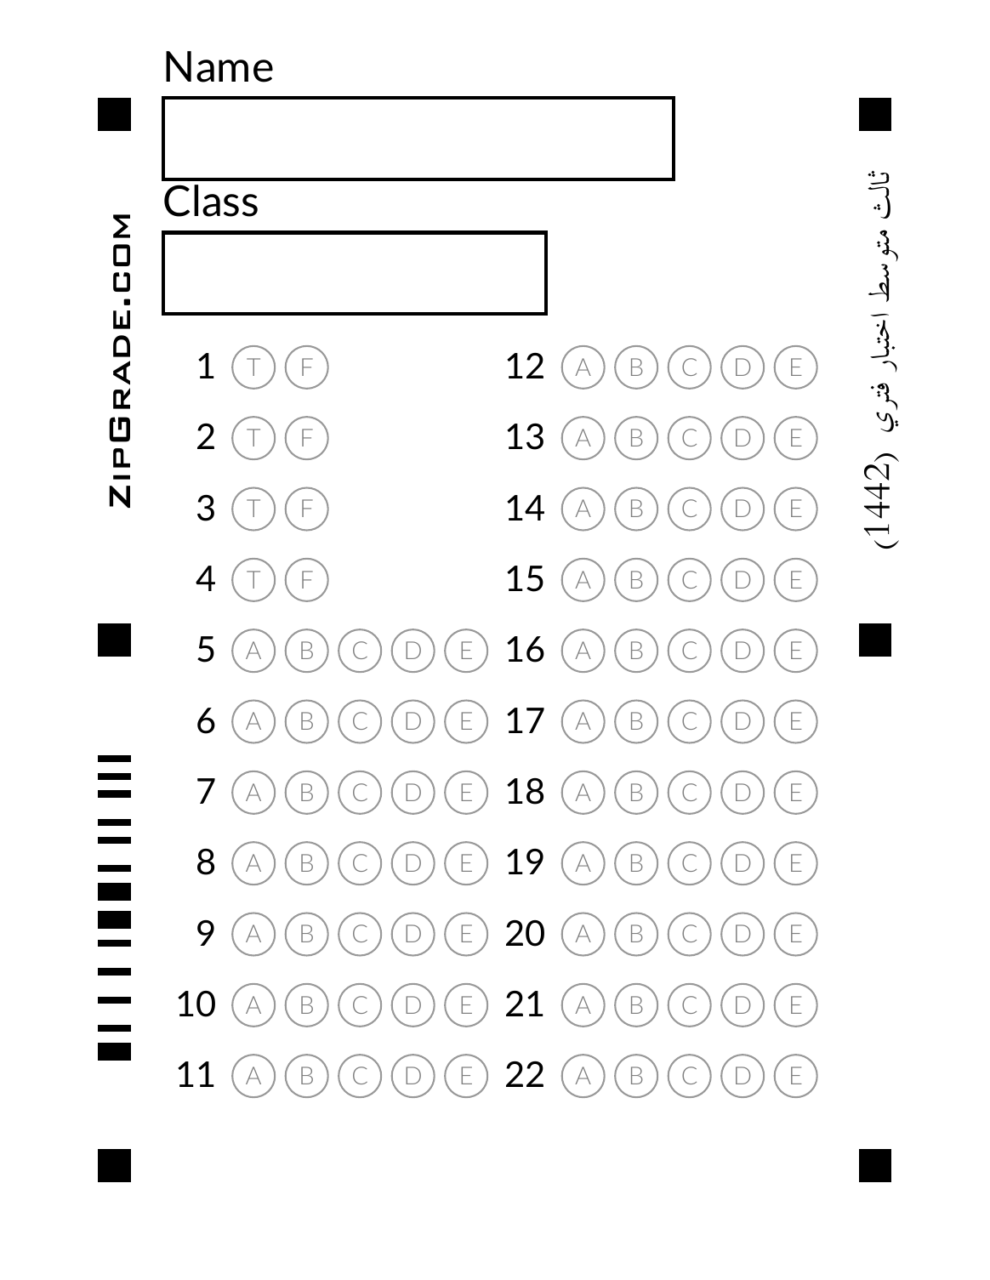
  Kingdom of Saudi Arabia    Ministry of Education  …………… Intermediate  School in ……………….. | English Language  3rd Intermediate Grade  2nd Term Exam 1443 -2022  Time: 2 hours  The first session
Name/ …………………………………………………………… | Seat No./ ………………………

( اللهم لا سهل إلا ماجعلته سهلا وأنت تجعل الحزن إذا شئت سهلا )

Student’s Mark Written | Student’s Mark Number | Question |  | Number
Student’s Mark Written | Student’s Mark Number | Mark | Question | Number
 |  | 6 | Writing | Q1
 |  | 6 | Reading Comprehension | Q2
 |  | 7 | Grammar | Q3
 |  | 7 | Vocabulary | Q4
 |  | 4 | Orthography | Q5
 |  | 30 | Total Written Tasks

عدد الصفحات : 4 صفحات

اسم المصحح وتوقيعه :
اسم المراجع وتوقيعه :
اسم المدقق وتوقيعه :

1

Q : 1 ( Writing )

6
Write a paragraph about ( your best friend ) not less than 3 lines using the following words .
( name – age – favorite subject – colour – character )
…………………………………………………………………………………………………………………………………………………………………………………………………………………………………………………………………………………………………………………………………………………………………………………………………………………………………………………………………………………………………………………………………………………………………………………………………………………...

6
Q : 2 ( Reading )
Read the following passage then answer the questions :
Prophet Mohammad (PBUH ) was born in Makkah in 571AD. He was an orphan. His father , Abdullah, died before he was born. His mother ,Amena, died when he was achild of six . He lived with his grandfather, Abdulmuttaleb. Prophet Mohammad died in Al-Madina in 11 Hijra( 633AD).
A – Where was prophet Mohammad born ?
………………………………………………………………………………………………………………………….
B – Choose the correct answer :
1 – Prophet Mohammad was born in ( 571AD – 434AD – 999AD )
2 – His father`s name is ( Khaled – Ahmad – Abdullah )
3 – His mother died when he was (a child – a young – an adult ) of six.
4 – He lived with his ( aunt – uncle – grandfather )
C – Put ( T ) or ( F ):
1 – His mother is Amena . ( )
2 – Prophet Mohammad died in Tabouk . ( )
Q : 3 ( Grammar )

7
A – Choose the correct answers for the following questions:
1 – How long have you played football ?
a- I have played football for 3 years.
b- I played football 3 years ago.
2
c- I`m playing football now
2 – How does he drive ?
a – He is driving slowly. b - He drives slowly. c - He is drive slowly.
B – Complete :
1 – Your name is Khaled, ( is it – isn`t it ).
2 – You ( must – should ) stop at the traffic lights when it`s red.
3 – She ( must – should ) have a rest.
4 – Ahmad works ( good – well ) .
5 – I drive ( careful – carefully ) .
6 – They should ( drink – drinking ) warm liquid .
7 – Khalifa tower is the ( tall – tallest ) tower in the world .
8 – Cheetahs are ( fast – faster ) than rabbits .
C – Write the correct answer :
( for – since )
1 – Hameed has had the same TV ……………… 15 years.
2 – I`ve had my laptop ………….. last June.
Q : 4 ( Vocabulary )

7
A – Match :
a – a bit ( ) 1 – Three children born at the same time.
b – triplets ( ) 2 – a little .
c – Orphan ( ) 3 – I am driving 60 .
d – I am doing 60 ( ) 4 – a child who has lost his parents.
B – Choose :
1 – inventions are like ( computers – gold – gas ) .
2 – The complexed word of steering ( mirror – wheel – board )
3 – Technique means ( a way of doing things – actions and events )
4 – Miniature means ( stop in the middle – a small model )
3

C – Put the correct word under its picture :
( cups – spoons – rearview mirror – hose )
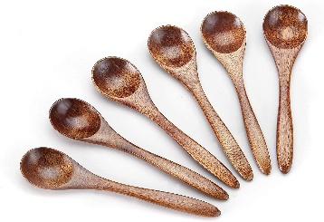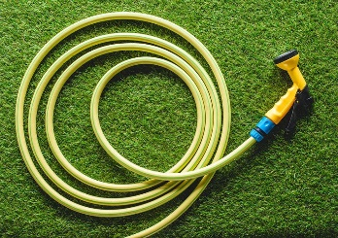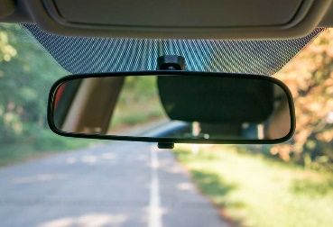
…………………………… ………………………………. ………………………… ……………………….
------------------------------------------------------------------------------------------------------------------------------
D – Write the command under its sign :
( Speed limit – No parking – Stop )
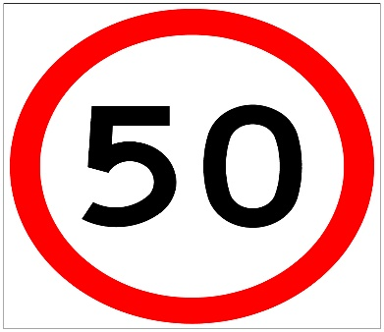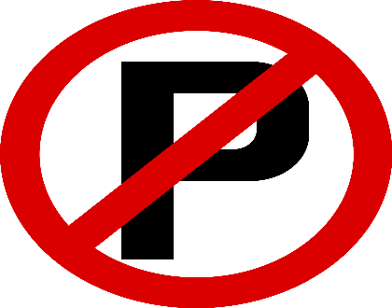
…………………………………….. ……………………………………
--------------------------------------------------------------------------------------------------------------------------------

4

Q : 5 ( Orthography )
A – Write the missing letter :
1 - …….top.( r – d – s ) 2 – Fa…… ( e – n – i )
3 – Tou…… ( ch – th – ph ) 4 – Kni……e ( f – r – d )
B – copy :
1 – Ali knows what career he will follow.
……………………………………………………………………………………………………..
2 – The man is leaving the store .
………………………………………………………………………………………………………
Good luck….
T.
(إجعل دقائق الإنتظار مليئة بالإستغفار )
4

