المملكة العربية السعودية  وزارة التعليم  الإدارة العامة للتعليم بـن  مدرسة م ن الابتدائية |   بسم الله الرحمن الرحيم  اختبار الفصل الدراسي الثاني  للعام الدراسي 1444 هـ | المادة | لغة انجليزية
 |  | الصف
 |  | الزمن | ساعة ونصف
 |  | الفصل | -----
اسم الطالب رباعيا: ............................................................................................................رقم الجلوس:....................
السؤال | 1 | 2 | 3 | 4 | 5 | 6 | المجموع
الدرجة
الدرجة | 6 | 5 | 4 | 5 | 6 | 4 | 30
المصحح


I- General Questions:

6
Q1: A- Choose the correct answer:
1. Look. It’s a flower.
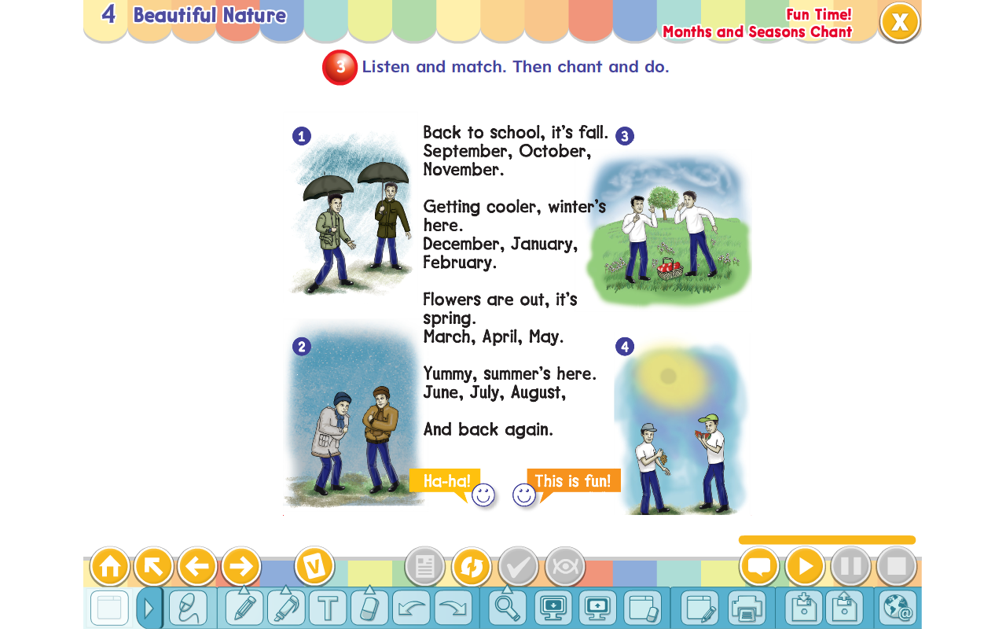
( It’s ugly. – It’s beautiful. – It’s bad. )

2. What’s the weather like in winter?
( It’s cold. – It’s sunny. – It’s hot. )
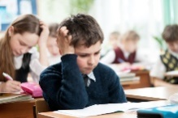
3. Where is Ali?
( He’s at school. - He’s tall. – He’s eating. )
B- Match the questions in column (A) with the correct answers in column (B):
B | A
( ) by the tail.  ( ) Walk straight then turn left.  ( ) It’s over there. | 1. Where’s the lion? 2. I will catch a tiger 3. Where is the train station?

5
II- Controlled Writing:
Q2: Do as shown between brackets:
1. go – How – you – to – do – school? (Rearrange)> ________________.
2. have – Elephants – trunks – big (Rearrange)> _______________.
3. Is he playing football? (Answer)> _______________________.
4.January, _____________, March. (Complete)>
5. When you see red light, _____________. (Complete)

III- Reading Short Sentence:

4
Q3: Match the sentence with the pictures:
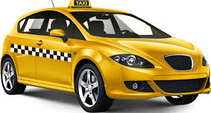
1. I love the mountains.


2. Let’s go to bed.

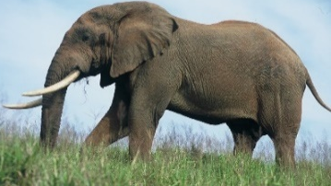
3. Look. It’s an elephant.

4. I go to the airport by taxi.
IV- Grammar:

5
Q4: Choose the correct answer:
1- Excuse me. (Why – When – Where) is the hospital?
2- Chimpanzees (am – is – are) smart.
3- That is (a – an – at) octopus.
4- I have breakfast (in – on – at) the morning.
5- The word “cats” is pronounced as ( Z – S – IZ )

6
V- Vocabulary:
Q5: Write the number under picture:
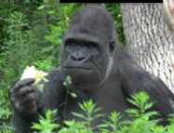
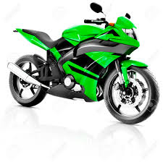
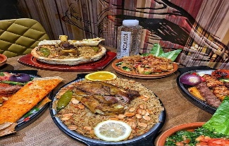
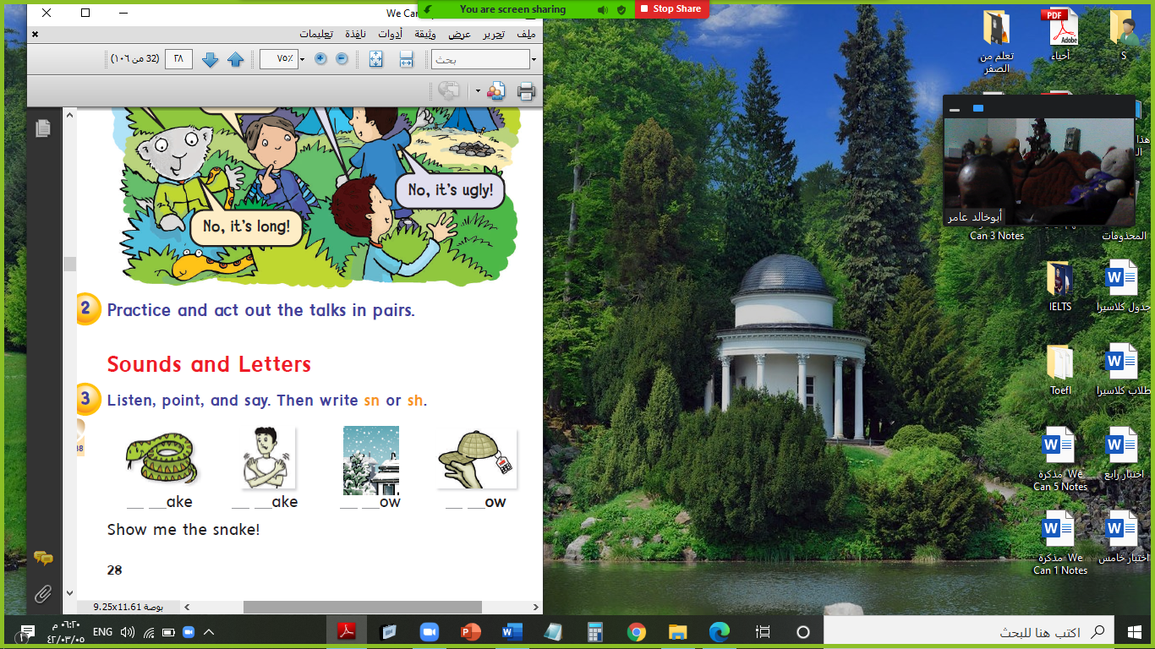

1.motorbike 2.lunch 3.snake 4.gorilla 5.night 6.class

( ) ( ) ( ) ( ) ( ) ( )
VI- Orthography:

4
Q6: Fill in the missing letters:

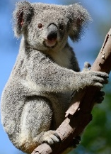

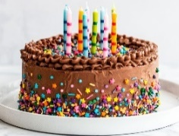
c / e / o / u / r / t / u / a
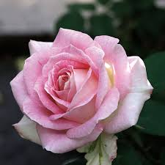
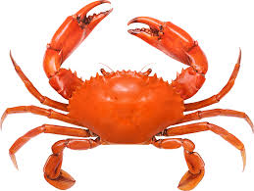

r__se b__s s__mmer ko__la s__rong m__at c__ab __ake

