I – Listening :
A- Choose:
1- The robbery happened about ……………………………………
a- half past three b- three o'clock c- five thirty d- one o'clock

2- The man with dark hair was about ………………….years old.
a- Twenty b- Twenty eight c-thirty d- ten

3- …………………….went into the kitchen.
a- the short man b-both men c-the tall d-none

4- she lost …………………………dollars.
a-50 b-150 c- 5 d-15

B- True √ or False ×:
1-They said 'they from water company. ( )
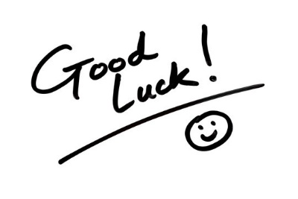
2- The blond man about fourteen . ( )
3-They took the woman's wallet . ( )
4-She didn’t ask them about their identification. ( )
End

