المملكة العربية السعودية |  | اسم الطالب/ه .........................
وزارة التعليم |  | رقم الجلوس : .........................
إدارة تعليم منطقة ..................... |  | المادة : انجليزي
مكتب التعليم ب........................ |  | الزمن : ساعة ونصف
مدرسة : .............................. |  | الصف : فصل ( )
اسم المصحح / ه: | التوقيع : | الدرجة رقما :
اسم المراجع / ه : | التوقيع : | الدرجة كتابة :
نموذج إجابة - اختبار نهاية الفصل الدراسي الأول للعام الدراسي 1444 – لغة انجليزية –– للصف الخامس ابتدائي

_ 1 mark each درجة لكل فقرة

Q1 : Choose the right answer:

A . I am 11 years old . I am fine, thank you | 1 – How are you?
A . I am 13 . Hi | 2 – Hello!
It's mine .Thank you B . I am fine, thank you. | 3- Whose hat is this?
A. It's nice to meet you, too. Thank you. | 4 –Wow! I like your thobe.
I am doing my homework. B. He is watching TV. | 5- What are you doing?
I am wearing blue . B . I am 13 . | 6- Who is wearing blue ?
Q2:Do as shown between brackets:
_ 1 mark each درجة لكل فقرة

I am wearing a blouse. |  |  | 1 – a – I – blouse - am - wearing . (Rearrange)
I am a cold . |  |  | 2 – cold – I – am . (Rearrange)
whose | who | what | 3- ______ book is this? It’s not mine. (choose)
playing | watching | doing | (choose) 4- I am ______ TV .
Fifth | Second | Fourth | (choose) 5-First, ______ , Third

_ 1 mark each درجة لكل فقرة

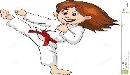
1. She is doing Karate .

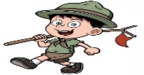
2. I am wearing sunglasses.

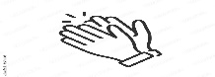
3. Clap your hands.

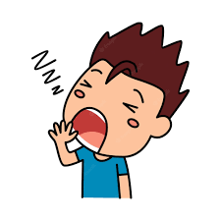
He is sleepy..4
Q3:Choose ( ) or ( × ) :

_ 1 mark each درجة لكل فقرة

Q4:Choose :

are | am | is | 1 – I ___ hungry .
is | are | am | 2- What __ the matter?
my | am | mine | 3 – It's ___ pen .
wears | wearing | wear | 4- Who is _____ green ?
do | doing | playing | 5- I am _____ football.
Q5: Write the right word under its picture :
_ 1 mark each درجة لكل فقرة

clock -lock - Jacket -sunglasses – elephant - ring

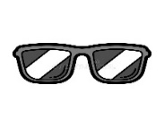 | 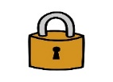 | 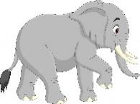 | 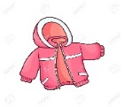 | 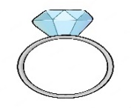 | 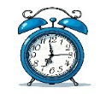
sunglasses | lock | elephant | jacket | ring | clock

Q6:Fill in the missing letters :
_ 1/2 mark each نصف درجة لكل فقرة

Choose the correct letter: ( tr, a , i , i_e , a_e , b , t , bl )

 | 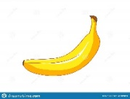 | 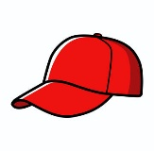 | 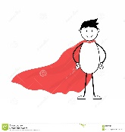 |  | 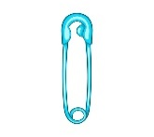 | 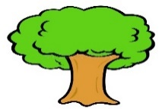 | 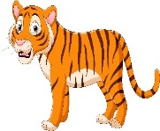
black | banana | cap | Cape | time | Pin | tree | tiger

GOOG LUCK

