المملكة العربية السعودية |  | اسم الطالب/ه .........................
وزارة التعليم |  | رقم الجلوس : .........................
إدارة تعليم منطقة ..................... |  | المادة : انجليزي
مكتب التعليم ب........................ |  | الزمن : ساعة ونصف
مدرسة : .............................. |  | الصف : فصل ( )
اسم المصحح / ه: | التوقيع : | الدرجة رقما :
اسم المراجع / ه : | التوقيع : | الدرجة كتابة :
اختبار نهاية الفصل الدراسي الأول للعام الدراسي 1444 – لغة انجليزية –– للصف الرابع ابتدائي

_ 1 mark each درجة لكل فقرة

Q1 : Choose the right answer:

It's nice to meet you, too. B. I live in Riyadh. | 1 – It's nice to meet you .
A . I am 13 . Hi | 2 – Hello!
My name is Nora. B . I am fine, thank you. | 3-What is your name?
A. It's nice to meet you, too. Thank you. | 4 –Wow! I like your thobe.
I am doing my homework. B. He is watching TV. | 5- What are you doing?
I am wearing green . B. I am 13 . | 6- Who is wearing green ?
_ 1 mark each درجة لكل فقرة

Q2:Do as shown between brackets:

I am wearing a cap. |  |  | 1 – a – I – cap - am - wearing . (Rearrange)
I am hungry . |  |  | 2 – hungry – I – am . (Rearrange)
whose | who | what | 3- ______ book is this? It’s not mine. (choose)
playing | watching | doing | (choose) 4- I am ______ karate .
Fifth | Second | Fourth | (choose) 5-Third, ______ , Fifth

Q3:Choose ( ) or ( × ) :
_ 1 mark each درجة لكل فقرة

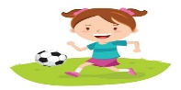
1. She is watching TV.

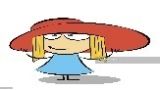
2. I am wearing a hat.

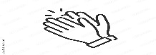
3. Clap your hands.

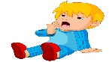
He is sleepy ..4

_ 1 mark each درجة لكل فقرة

Q4:Choose :

are | am | is | 1 – she ___ cold .
is | are | am | 2- What __ the matter?
my | am | mine | 3 – It's ___ pen .
wears | wearing | wear | 4- Who is _____ green ?
play | plays | playing | 5- I am _____ football.
Q5: Write the right word under its picture :
_ 1 mark each درجة لكل فقرة

face -happy - hat - shoes – phone - ring

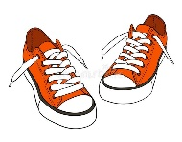 | 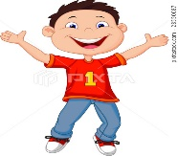 |  |  | 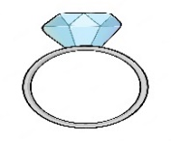 | 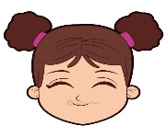
shoes | happy | phone | hat | ring | face

_ 1/2 mark each نصف درجة لكل فقرة

Q6:Fill in the missing letters :

Choose the correct letter: ( dr, a , i , i_e , ph , p , d , pl )

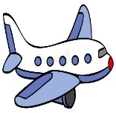 | 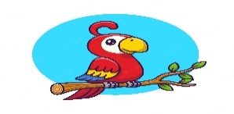 | 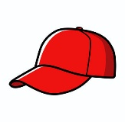 | 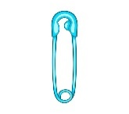 |  | 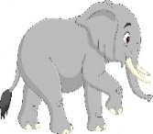 | 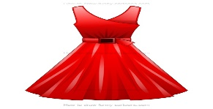 | 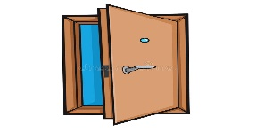
plane | parrot | cap | Pin | time | elephant | dress | door

GOOG LUCK

