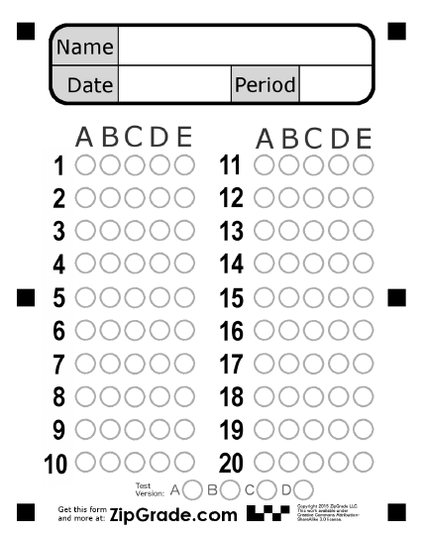
Unit 4 Quiz

Class
Grammar

Choose the correct answer:
1- Look, it …… a plastic bag.
(C) are | (B) am | (A) is

2- I love ……… daffodils.
(C) one | (B) the | (A) a

Vocabulary
3- December is in ………………..
(C) winter | (B) summer | (A) fall

4- The opposite of …………….. # short.
(C) quiet | (B) small | (A) long



(D) | (C) | (B) | (A)



5- I love stars…

(D) | (C) | (B) | (A)

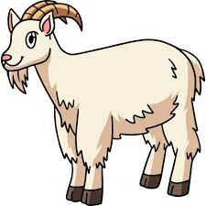
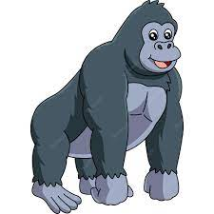

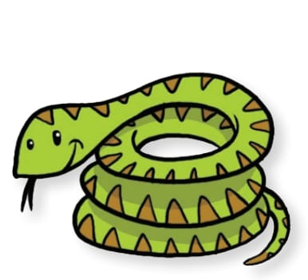
6- This is a snake ..

(D) | (C) | (B) | (A)

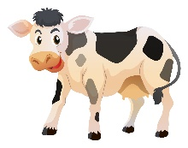


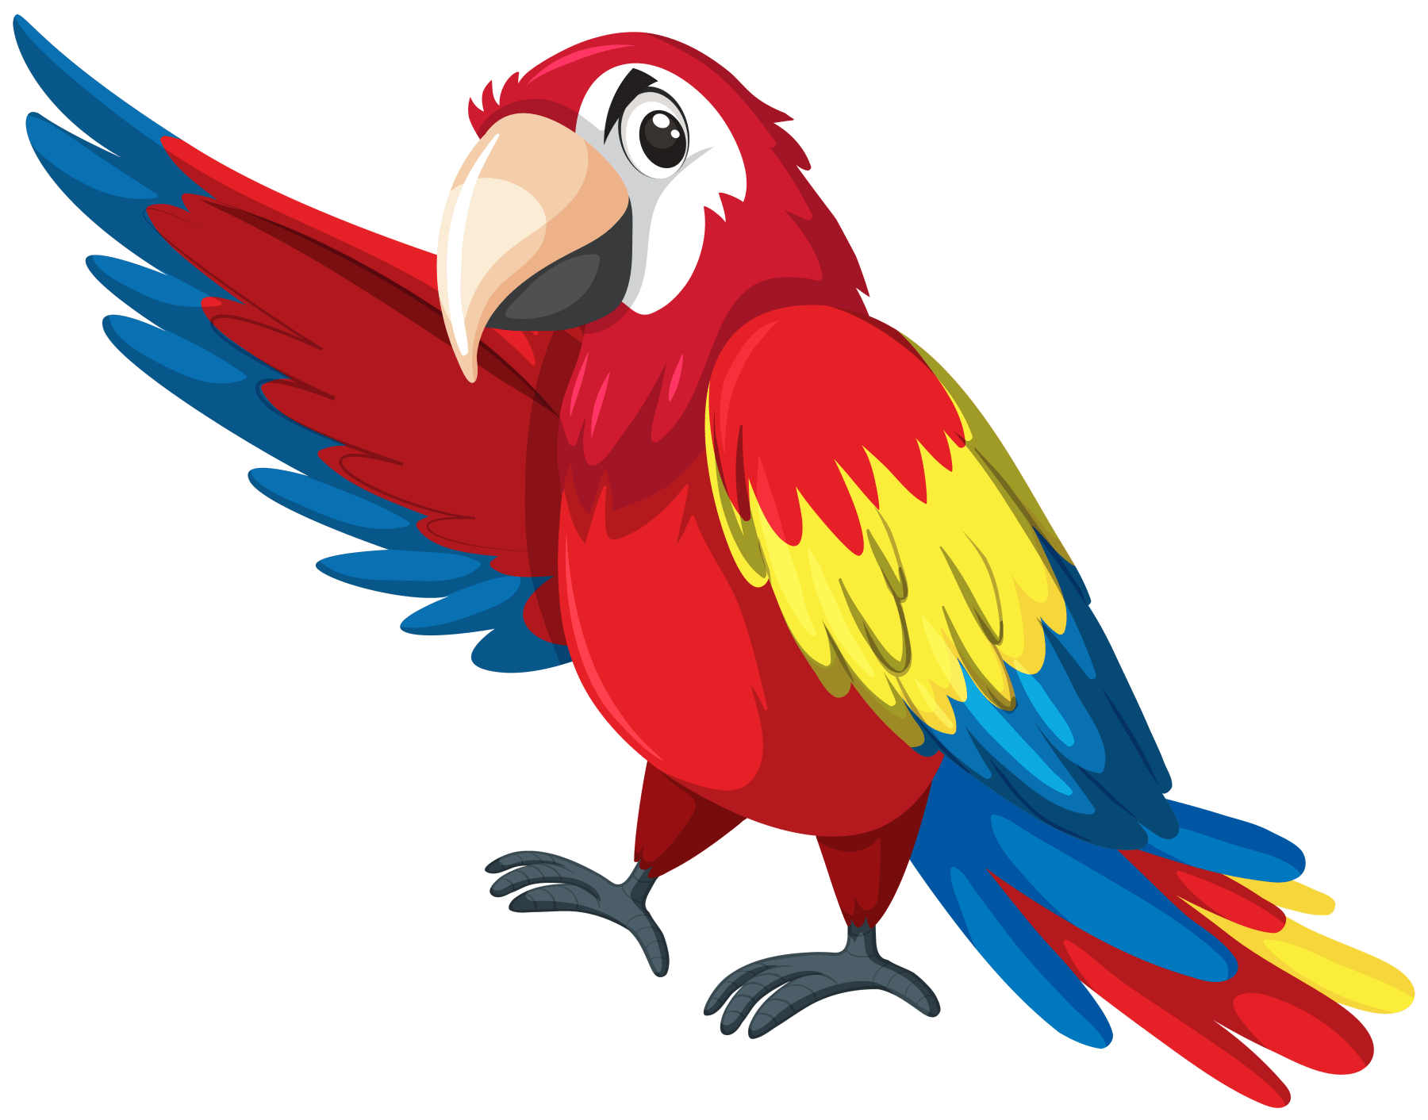
7- It's small & noisy

Dictation
(D) F | (C) L | (B) S | (A) R

8- weak # st….ong .
(D) N | (C) G | (B) F | (A) T

9- They are beauti…ul.
(D) D | (C) M | (B) R | (A) K

10- I love ca….pfire.

