Mega Goal Book 1.2
Unit 2: Take My Advice

Vocabulary

Choose the correct word:-
1. I am always glad to see Hameed. We .............. each other so well.

a-turn down | b-get along with | c-give up | d-put off

2. Our teacher does not ..................talking during class.
a-put up with | b-take up | c-throw away | d-turn down

3. After the interview Alex decided to ............ the job offer. He didn’t like the idea of working long hours and being on the road seven days a week.
a-turn down | b-get along with | c-give up | d-put off

4. If you really want to get in shape, you should ................ tennis.
a-put up with | b- take up | c-throw away | d- turn down

5. I hate to ................ art class, but I just don’t have time to go anymore.

a-turn down | b-get along with | c-give up | d-put off

6. Don’t .......................... cleaning your car. It will just get messier!
a-turn down | b-get along with | c-give up | d-put off

7. Some people never ................ anything. They keep things they don’t use anymore.

a- put up with | b- take up | c-throw away | d- turn down

Grammar

Choose the best answer to fill in the blank in each question.

8. It is freezing outside! You ................ wear a warmer coat.
A. had better
B. better had
C. might
D. could

9. Sara is waiting for you. You .................... go meet her.
A. might
B. should
C. could
D. may

10. It doesn’t matter which car you buy. You _______________ buy the blue one or the red one.
A. had better
B. ought to
C. could
D. should

11. If that company offers me a job, I had better not _______________.
A. turn down
B. them turn down
C. turn down them
D. turn them down

12. He feels much more relaxed since he _______________ yoga.
A. took up it
B. took it up
C. took up
D. take up

13. If you can’t _______________ each other, you shouldn’t work together.
A. get along with
B. get them along with
C. get along
D. get along to

14. I didn’t wear those shoes anymore so I _______________.
A. threw away it
B. threw it away
C. threw away them
D. threw them away

15. _________sugar do you eat?
A. How many
B. How
C. Much
D. How much

16. ______________ when you have a toothache?
A. What do you do
B. How do you do
C. What do you feel
D. How do you

Reading
Read the text and answer the questions. Write T or F at the end of each question/ statement. 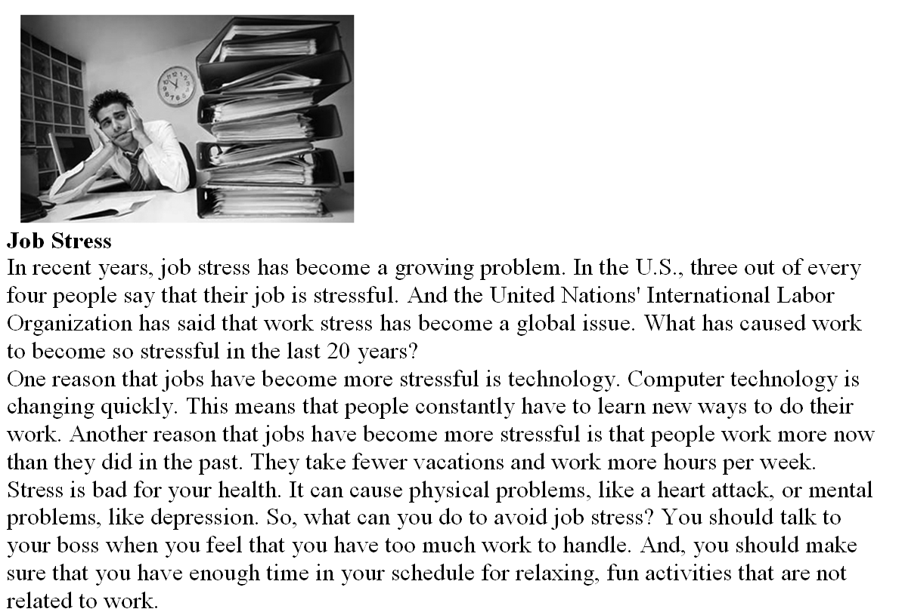

1. Job stress is only a problem in the United States
2. Changing technology is a cause of job stress.
3. Depression is a cause of job stress
4. Jobs are more stressful now than they were in the past.
5. The writer thinks that you should quit your job if you feel stressed.

