المملكة العربية السعودية |  |  |  |  |  | المادة: |  | اللغة الانجليزية (شفوي)
وزارة التعليم |  |  |  |  |  | الصف |  | 4+5+6 الابتدائي
الادارة العامة للتعليم ب______ |  |  |  |  |  | التاريخ: |  | / /1445 هـــ
مدرسة________الابتدائية |  |  |  |  |  | الزمن: |  | نصـف ساعة
اختبار نهاية الفصل الدراسي الثاني – الدور الأول للعام الدراسي 1445 هـ
الاستماع 5 |  | التحدث 5 |  | المجموع 10
الاسم ثلاثي |  |  |  | الفصل | / |  | رقم الكشف

Listen and circle the right answer:

- What time is it?
It’s ten - eleven – twelve o’clock.

- Noura stayed home.
That’s okay - boring – great .

- What bad things happened to you last year?
We lost a tennis – basketball – football game by 8 to zero.

- An architect designs buildings.
He works in an office – company – laboratory .

- When I grow up,
I want to be a cook - policeman – businessman .

- At half past twelve,
I eat my lunch - snack – sandwich .

- Nd says
hand - sand – around .


Write or :

- Her dad and mom are lawyers. ( )
- The girls are making salad. ( )
- The boy ate an ice cream. ( )

Audio :https://youtube.com/watch?v=mTRg5c3Li5U&si=EnSIkaIECMiOmarE

Audio Script:
We Can 3 Listening | Resources
- Teacher: What time is it?  Boys: It’s twelve o’clock. | Unit 5 - Page 43  Finding Out Time  Audio CD2 trick 14
- Girl: Nourah stayed home.  Boy: That’s boring. | Unit 7- Page 50  Finding Out Time  Audio CD3 trick 02
- Teacher: What bad things happened to you last year?  Boy: We lost a football game by 8 to 0. | Unit 8– Page 58  Finding Out Time  Audio CD3 trick 16
- Narrator: An architect designs buildings.  He works in an office. | Unit 6 – Page 182  Grammar in Action  Audio CD7 trick 45
- Boy: When I grow up, I want to be a businessman. | Unit 6 – Page 184  Rhythms and Reading  Audio CD7 trick 47
- Boy: At half past twelve , I eat my lunch. | Unit 5 – Page 39  Challenge time  Audio CD2 trick 21
- Teacher: ND Sand, sand , sand  Girls: sand, sand | Unit 7 – Page 56  Phonics  Audio CD3 trick 12
- Girl 1: What does your dad do?  Girl 2: He’s a businessman.  Girl 1: What does your mom do?  Girl 2: She’s a teacher. | Unit 6– Page 42  Finding Out Time  Audio CD2 trick 26
- Girl 1: Are you hungry?  Girl 2: Yes, I am. Is there anything to eat?  Girl 1: Why don’t we make a pizza?  Girl 2: That’s great idea. What do we need? | Unit 7– Page 54  Reading and Writing  Audio CD3 trick 9
- Boy: Yesterday, we went to an adventure park.  Our father drove us there. It was great fun.  After the rides, dad got me a burger.  My sister didn’t want one, so he got her an ice cream.  We were really good so Dad promised to take us again  next week. I can’t wait. | Unit 8 – Page 65  Challenge Time  Audio CD3 trick29

Audio :https://youtube.com/watch?v=mTRg5c3Li5U&si=EnSIkaIECMiOmarE
Forms: https://forms.office.com/Pages/ShareFormPage.aspx?id=b4OQU5QpqkK9sELnf3f9C84PUFGeBGBFuY4-jPdGsvZUMk1RRzdIOVVLS1ZaV0FPQzRKRUJKQUlJQyQlQCNjPTEu&sharetoken=iw9rji6FjVMFxtxViibq

المملكة العربية السعودية |  |  |  |  |  | المادة: |  | اللغة الانجليزية (شفوي)
وزارة التعليم |  |  |  |  |  | الصف |  | السادس الابتدائي
الادارة العامة للتعليم بالإحساء |  |  |  |  |  | التاريخ: |  | /١٤٤٥هـــ
مدرسة________الابتدائية |  |  |  |  |  | الزمن: |  | نصـف ساعة
اختبار نهاية الفصل الدراسي الثاني – الدور الأول للعام الدراسي ١٤٤٥هـ
الاستماع 5 |  | التحدث 5 |  | المجموع 10
أسم الطالب |  |  |  | الفصل | سادس / |  | رقم الكشف
Listen and choose
- What time is it? |  | 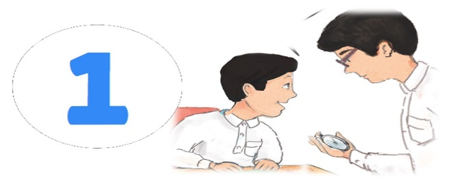
 | It’s ten o’clock.
 | It’s eleven o’clock.
 | It’s twelve o’clock.

- Noura stayed home.
That’s okay.
That’s boring.
That’s great.

- What bad things happened to you last year?  We lost a______ game by 8 to 0. |  | 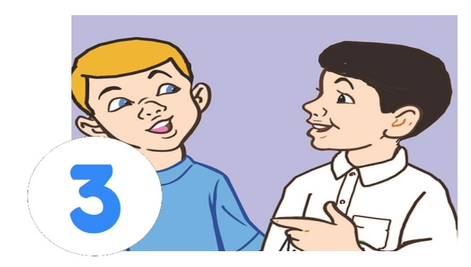
 | tennis.
 | football.
 | basketball.

- An architect designs buildings  He works in a _________ |  | 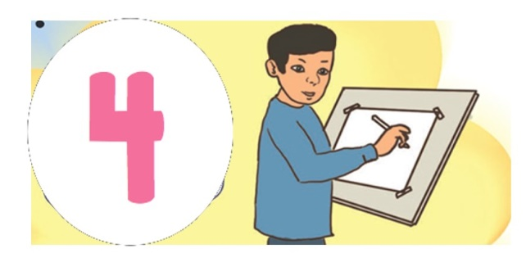
 | office.
 | company.
 | factory.

- When I grow up, I want to be_____ |  | 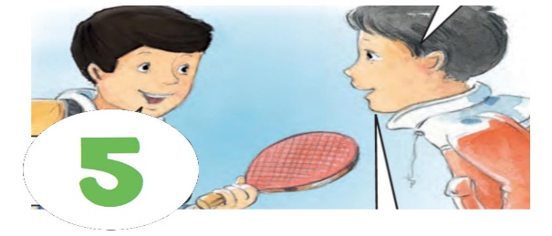
 | cook.
 | policeman.
 | businessman.

Audio :https://youtube.com/watch?v=mTRg5c3Li5U&si=EnSIkaIECMiOmarE

المملكة العربية السعودية |  |  |  |  |  | المادة: |  | اللغة الانجليزية (شفوي)
وزارة التعليم |  |  |  |  |  | الصف |  | 4 و5و6 ابتدائي
الادارة العامة للتعليم ب______ |  |  |  |  |  | التاريخ: |  | / /1445 هـــ
مدرسة________الابتدائية |  |  |  |  |  | الزمن: |  | نصـف ساعة
اختبار نهاية الفصل الدراسي الثاني– الدور الأول للعام الدراسي 1445 هــــــ We Can3
الاستماع 5 |  | التحدث 5 |  | المجموع 10
الاسم ثلاثي |  |  |  | الفصل | / |  | رقم الكشف

Listen and circle the right answer:

- What time is it?
It’s one - two - three o’clock.

- Listen and circle the number
150 – 250 – 315 .

- There is some orange juice
in the bottle - fridge - kitchen .

- When I grow up,
I want to be a baker – a writer – an engineer .

- Did you say
i-n-k – r-i-n-g – p-i-c-k .

- What bad things happened to you last year?
I broke my leg - arm – finger .

- Ali cooked breakfast
That’s okay - great – fantastic .

- A cook cooks food
He works in a cafe – cafeteria – restaurant .

Write or :

- The boy orders pizza. ( )
- Fatimah is a doctor. ( )

Audio: https://youtu.be/9R8e_tSk_s8?si=HU2Sqk6a4pmXJhNR
Forms: https://forms.office.com/Pages/ShareFormPage.aspx?id=b4OQU5QpqkK9sELnf3f9C84PUFGeBGBFuY4-jPdGsvZUMlpJOUNCTkYyN1AyREM0M1owRTlZSzkzVSQlQCNjPTEu&sharetoken=iw9rji6FjVMFxtxViibq

Audio Script:
We Can 3 Listening | Resources
- Teacher: What time is it?  Boy: It’s three o’clock. | Unit 5 - Page 43  Finding Out Time  Audio CD2 trick 14
- Narrator: Listen and circle the numbers.  Girl: 250 , 250 . | Unit 6 - Page 186  Phonics  Audio CD7 trick 49
- Girl: There is some orange juice in the kitchen. | Unit 7– Page 191  Reading and Writing  Audio CD8 trick 06
- Boy: When I grow up, I want to be an engineer. | Unit 6 – Page 184  Rhythms and Reading  Audio CD7 trick 47
- Girl : ink , ink .  Did you say I – N - K | Unit 5 – Page 177  Phonics  Audio CD7 trick 40
- Teacher: What bad things happened to you last year?  Boy: I broke my finger. | Unit 8 – Page 58  Finding Out Time  Audio CD3 trick 16
- Boy 1: Ali cooked breakfast  Boy 2: That’s great. | Unit 7 – Page 50  Finding Out Time  Audio CD3 trick 02
- Narrator: A cook cooks’ food.  He works in a restaurant. | Unit 6– Page 182  Grammar in Action  Audio CD7 trick 45
- Boy 1: What would you like?  Boy 2: I’d like a burger and fries please.  Boy 1: Sure. Just a moment. | Unit 7– Page 192  Reading and Writing  Audio CD8 trick 07
- Girl 1: What’s your mom’s name?  Girl 2: My mom’s name’s Fatima.  Girl 1: What does she do?  Girl 2: She’s a teacher. | Unit 6 – Page 179  Finding Out Time  Audio CD7 trick 42

Audio: https://youtu.be/9R8e_tSk_s8?si=HU2Sqk6a4pmXJhNR
Forms: https://forms.office.com/Pages/ShareFormPage.aspx?id=b4OQU5QpqkK9sELnf3f9C84PUFGeBGBFuY4-jPdGsvZUMlpJOUNCTkYyN1AyREM0M1owRTlZSzkzVSQlQCNjPTEu&sharetoken=iw9rji6FjVMFxtxViibq

المملكة العربية السعودية |  |  |  |  |  | المادة: |  | اللغة الانجليزية (شفوي)
وزارة التعليم |  |  |  |  |  | الصف |  | السادس الابتدائي
الادارة العامة للتعليم ب |  |  |  |  |  | التاريخ: |  | /07/1444 هـــ
مدرسة________الابتدائية |  |  |  |  |  | الزمن: |  | نصـف ساعة
اختبار نهاية الفصل الدراسي الثاني – الدور الأول للعام الدراسي 1443/1444 هـ
الاستماع 5 |  | التحدث 5 |  | المجموع 10
أسم الطالب/هـ |  |  |  | الفصل | سادس / |  | رقم الكشف
Listen and choose
- What time is it? |  | 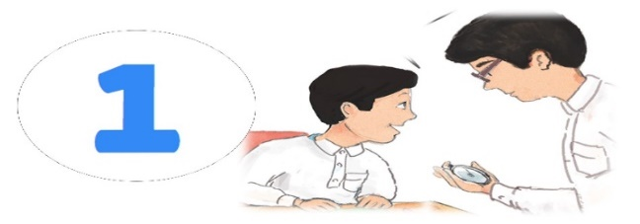
 | It’s ten o’clock.
 | It’s eleven o’clock.
 | It’s twelve o’clock.

- Noura stayed home.
That’s okay.
That’s boring.
That’s great.

- What bad things happened to you last year?  We lost a______ game by 8 to 0. |  | 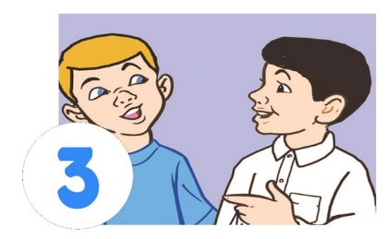
 | tennis.
 | football.
 | basketball.

- An architect designs buildings  He works in a _______ |  | 
 | office.
 | company.
 | factory.

- When I grow up, I want to be_____ |  | 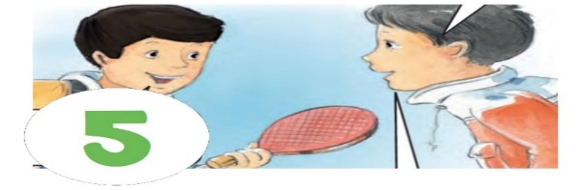
 | cook.
 | policeman.
 | businessman.

Write or :

6.At 3 o'clock I eat my lunch. ( )
7. nd – sand . ( )
- His dad is a doctor . ( )
- She is hungry . ( )
- Yesterday we went to the mall . ( )

Audio :
https://youtube.com/watch?v=mTRg5c3Li5U&si=EnSIkaIECMiOmarE

