اسم الطالب/ة : ................................................ الفصل: .......................
6
I- General Questions:
A- Match the questions in column (A) with the correct answers in column (B):
B | A
( ) He is a doctor.  ( ) I cooked breakfast.  ( ) I made a rocket  ( ) 2 cups of flour  ( )I want to be a teacher  ( ) I usually go to bed at 9:00 | 1- What did you do over the weekend?  2- How much flour do we need ?  3-What good things happened to you last year ?  4- What does your dad do ?  5- What time do you go to bed ?  6- What do you want to be when you grow up ?

II- Controlled Writing:
5
A- Complete the sentences with the correct word:
sick
fires
thirty
1- Firefighter put out ______
2- Ten , twenty , ________ , forty.
3- Doctors help _________ people.

B- Rearrange the words to form a sentence:
1- game / We / a football / won
………………………………………………….
2- scary / How
………………………………………………….
III- Grammar:
5
A) Choose the correct word:
1- I usually ( take – took ) a bath in the morning.
2- Yesterday , I ( play – played ) computer games.
3- We don't have ( some – any ) oil.
B) Fill in the spaces with much or many :
1- How ________ oil do you need ?
2- How ________ apples do you eat ?

IV- Reading Short Sentence:
A- Read the sentences and match them with the correct pictures:
4

1- It's 10:30 2- a half past three 3- He is a baker
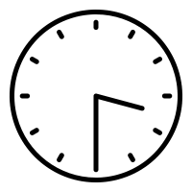
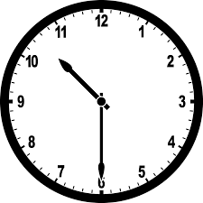


B- Read the question and choose the correct answer:
1- I broke my leg.
a) congratulations b) How nice c) sorry about that

6
V- Vocabulary:
A) Write the correct number under each picture:
1- pizza 2- teacher 3- boot 4- diver 5- bed 6- reporter

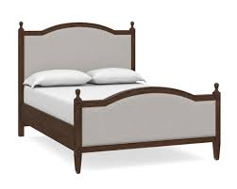
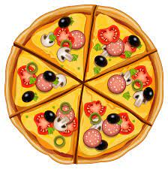

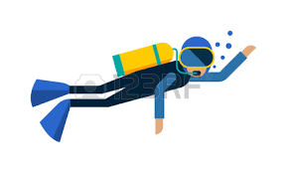
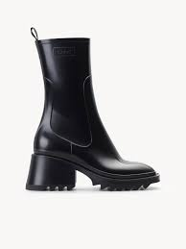


( ) ( ) ( ) ( ) ( ) ( )
VI- Orthography:
4
A) Choose the correct letter:

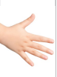
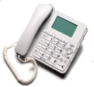
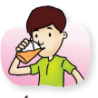

1- dri_ _ 2- _ _one 3- ha_ _ 4- lau_ _
( nk – sh – ch ) ( f – ph – kn ) ( gh – sh – nd ) ( gh – nt – nk )

وزارة التعليم  الإدارة العامة للتعليم بمنطقة مكة المكرمة  مدرسة عبدالرحمن بن عوف الابتدائية |  | رقم السؤال | الدرجة |  | المصحح | المراجع
 |  | رقم السؤال | رقماً | كتابة | المصحح | المراجع
 |  | 1
 |  | 2
  المادة | لغة إنجليزية
  الصف | الرابع الابتدائي
  الزمن | ساعة ونصف
 |  | 3
 |  | المجموع
أسئلة اختبار الفصل الدراسي ( الثاني ) للعام الدراسي 1445هـ

اسم الطالب : |  | رقم الجلوس
Q1. A– Answer the following questions :

10
- Where do you work? I work ………………
B. in time | A. in a school
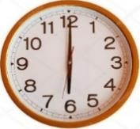
2. What time is it?
B. It's 9 o'clock | A. It's 6 o'clock
3. How much flour do we need?
B. We need 2 cups. | A. It is 10 SAR.
4. I won a table tennis game 21 to 3 .
B. bad | A. good
5 – What would you like ?
B. I would like a burger . | A. No, thanks.
_____________________________________________________________________________________
B- Read and put or :
1. It is seven o'clock | 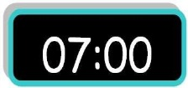
2- That's boring . | 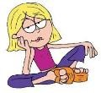
3- He is fire fighte | 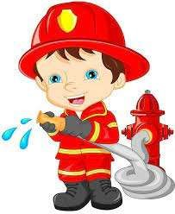
4- He is a pilot. | 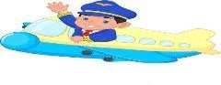
5- She watched TV. | 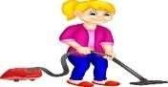
__________________________________________________________

Q2. A- Choose the correct answer:

10
1- I usually ………….to bed at 11 p.m. | goes | go | went
2-Yesterday, I …………. my room. | clean | cleaned | cleans
3-How.……….tomatoes do you need? | is | much | many
4-last year, I …………. my leg. | break | broke | breaks
5-We have.......................apples. | a | some | any
B- Write the word under the correct picture
1-Three hundred 2- doctor 3- trampoline 4 -brush teeth 5- drink
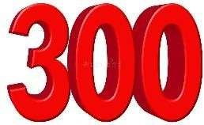 |  | 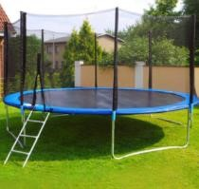 | 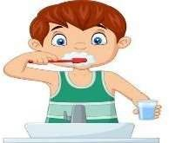 | 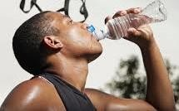
.................... | .................... | .................... | .................... | ....................
______________________________________________________________________
Q3 A- Do as shown between brackets:

10
1- room _ my _ cleaned _ I . | (Rearrange) | …………………….................................
2– pilot – a – is - He | (Rearrange) | …………………….................................
3 – 100______500 | (complete) | 100, 200, …….............,400,500
  4- I'd like ……………. please . | (choose) | cheese | pizza | Ice cream
5- ………… time do you come home? | ( choose ) | Where | What | When
B. Fill in the missing letters with: [ ph – kn – ng – nt – nd ]
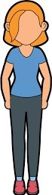 | 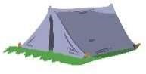 |  | 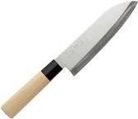 | 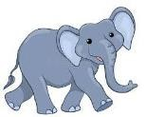
Sta ……… | Te ……… | Ri ………… | ………ife | ele ………ant
______________________________________________________________________
GOOD LUCK

اختبار نهاية الفصل الدراسي الثاني للعام الدراسي 1445 (الدور الأول) – لغة انجليزية –– للصف السادس ابتدائي
Q1 : Choose the right answer:

A. I'm 10 years. B. He is a doctor. | 1 – What does your dad do ?
A. Yes, please. B. No, I'm not. | 2-Can I help you?
A. It's ten o'clock. B. It's ten thirty. | 3- What time is it? 10:30
A. He puts out fire. B .He flies planes. | 4 – What does the firefighter do?
A.I got up at 6:00 B .I usually get up at 6:00 | 5- What time do you get up in the morning?
A. I broke my leg. B. I'm playing tennis. | 6- What happened to you last week?
Q2:Do as shown between brackets:

…...................................................... |  |  | 1 – sick – was – I (Rearrange)
million | thousand | hundred | 2 –One _________ (Complete )
six | four | five | 3-It's ________ o'clock (Complete)
soup | Ice cream | Cheese | (choose) 4-I'd like ______ please.
grocer | park | bank | 5-I went to the _____ to buy some milk.

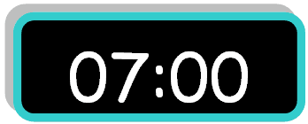
1. It's seven o'clock
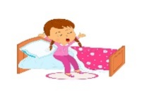
2.I eat my lunch
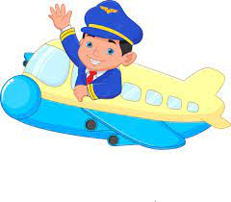
3. He is a pilot.


4. She works in a school.
Q3: Choose ( ) or ( × ) :

1

Q4:Choose :
get | got | go | 1 – I usually ____ up at 5:00 .
go | came | come | 2- yesterday, I ____ home at 1:00 .
what | which | who | 3 – ____ is he ? He is Abdullah.
where | what | who | 4- ____ does she do ? She is a nurse .
much | many | some | 5-How _____ oil do we need?
many | any | some | 6- We don't have ____ flour.

Q5: Choose the right word under the picture :
 |  | 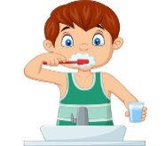 | 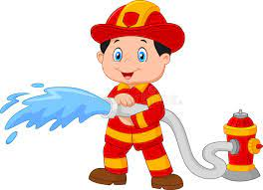 | 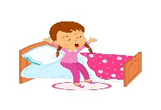
- Baker  - nurse | - police man  - doctor | - brush  - watch TV | - house wife  - firefighter | - get up  - play

Q6:Fill in the missing letters :

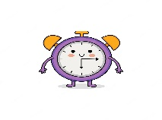 | 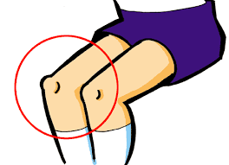 |  | 
_ _ock  - cl  - th | _ _ ee  - rt  - kn | li_ _t  - gh  - sh | ri _ _  - ch  - ng

GOOD LUCK

المملكة العربية السعودية  وزارة التعليم  إدارة تعليم .......................  مكتب تعليم ....................  مدرسة .......................... |  | اختبار مادة اللغة الإنجليزية  الصف السادس الابتدائي  الفصل الدراسي الثاني  التاريخ ........................  الزمن : ساعة ونصف

المعلم/ة | التوقيع | المراجعـ/ة | التوقيع

السؤال الأول | السؤال الثاني | السؤال الثالث | السؤال الرابع | السؤال الخامس | السؤال السادس | المجموع
6 | 5 | 4 | 5 | 6 | 4 | 30

اسم الطالب : |  | الصف : |  | رقم الجلوس :

استعن بالله

1. General Questions
A. Choose

- when I grow up, I want to be ( a doctor – police man )

- I usually get up at ( half past six – 6 o'clock ) . 6:30

- I ( watch – watched ) a scary movie last night .
/ 4
- What did you do over the weekend?

- I ........................... my room. ( cooked – cleaned )

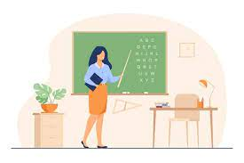
B. Complete

- Who is she ?
- she is a ( teacher – nurse )
/ 2

- Where does she work?
- She works in a ( hospital – school )

2. Controlled Writing

Complete the story: A.

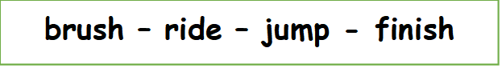
/ 2

At six o'clock, I ………… out of bed and ………………… my teeth. At one o'clock, I ………………… school and ……………… the bus home.
P.T.O

B. Rearrange:
/ 1
firefighter – a – is – He
…………………………………………………………………..

C. Complete:
/ 2

100 - 200 - ………. - 400 - ……… - ………. – 700 – 800 – 900 - ………. .

3. Reading short sentences:

A. Write each word under the suitable picture:
/ 2
Rocket – Operation – Ball – fire fighter

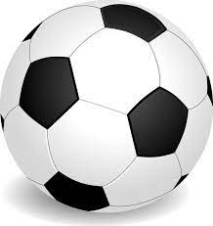 | 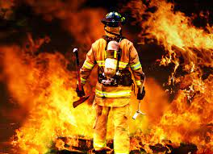 | 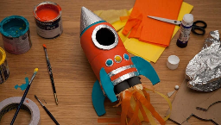 | 
………..……….. | …………..……… | ……………..….. | ……………….…

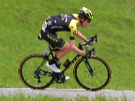
B. Write true or False:


- He kicked a ball ( )
/ 2
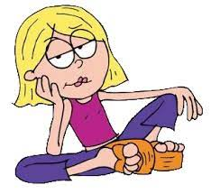
- He is a doctor ( )
- That's great ( )

- That's boring ( )

4. Grammar :

A. Choose the correct answer:

- ( What – Where ) time do you go to bed ?
- yesterday , I ( get up – got up ) at 8 : 00.
- ( How much – How many ) cheese do you have?
/ 3
- What did you do on the weekend ( ! - ? )
- He's ( a – an ) teacher .
- We have ( some – any ) Flour .

P.T.O
B. put in the suitable column :

Milk – Tomatoes – Juice – Potatoes
/ 1

Uncountable | Countable
/ 1
C. Do as shown between brackets :

I see a rainbow ……………………………………….. ( change to past )

5. Vocabulary:

A. Choose the suitable word with suitable pictures?
/ 2
Cook – tent – drink – knife – doctor – pilot

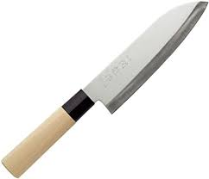 |  |  |  |  | 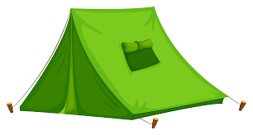

B. Circle the odd word.

- Cheese – chocolate – phone – cake
/ 2
- architect – astronaut – chip – diver.
- great – pizza – funny – happy .
- played – cleaned – got – kicked.

C. Match .
/ 1
9 : 30 | 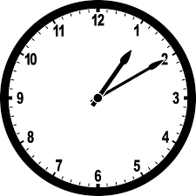
1 : 10 | 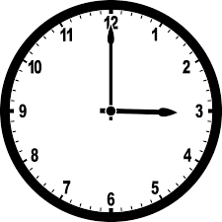
3 : 00 | 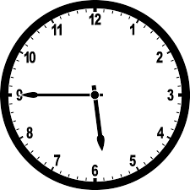
5 : 45 | 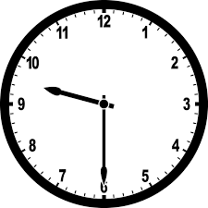

P.T.O

D. Match .
/ 1
plant | 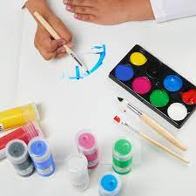
stand | 
paint | 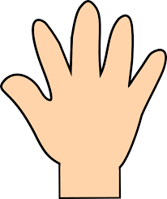
hand | 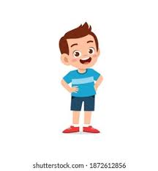

6. Orthography:
/ 1

A. Fill in with ( cl – ph – gh )

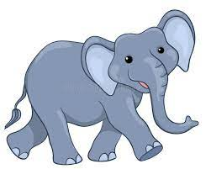
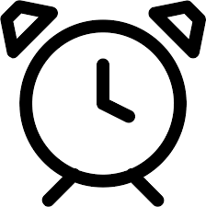


_ _ ock ele _ _ ant _ _ oto Li _ _ t


B. Rearrange the letters :

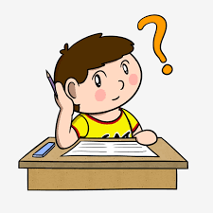
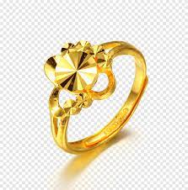
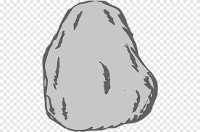
/ 1

Ockr \ ………. ingr \ …….. inkth \ ……… nki \ ………

C. Choose the correct sound : ( \z\ - \s\ - \iz\ )
/ 1

1-Sleeps ______ 2- teaches ______
3-Walks _______ 4- goes _______

D. Fill in the missing letter :
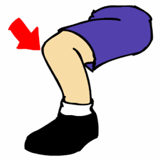


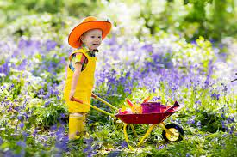

_ rog _ now _ _ ee sprin__
/ 1

Best of wishes
المملكة العربية السعودية  وزارة التعليم  إدارة تعليم .......................  مكتب تعليم ....................  مدرسة .......................... |  | اختبار مادة اللغة الإنجليزية  الصف السادس الابتدائي  الفصل الدراسي الثاني  التاريخ ........................  الزمن : ساعة ونصف

المعلم/ة | التوقيع | المراجعـ/ة | التوقيع

السؤال الأول | السؤال الثاني | السؤال الثالث | السؤال الرابع | السؤال الخامس | السؤال السادس | المجموع
6 | 5 | 4 | 5 | 6 | 4 | 30

اسم الطالب : |  | الصف : |  | رقم الجلوس :

استعن بالله

1. General Questions
A. Choose

- when I grow up, I want to be ( a doctor – police man )

- I usually get up at ( half past six – 6 o'clock ) . 6:30

- I ( watch – watched ) a scary movie last night .
/ 4
- What did you do over the weekend?

- I ........................... my room. ( cooked – cleaned )

B. Complete

- Who is she ?
- she is a ( teacher – nurse )
/ 2

- Where does she work?
- She works in a ( hospital – school )

2. Controlled Writing

Complete the story: A.

/ 2

At six o'clock, I jump out of bed and brush my teeth. At one o'clock, I finish school and ride the bus home.

B. Rearrange:
/ 1
firefighter – a – is – He
He is a firefighter

C. Complete:
/ 2

100 - 200 - 300 - 400 - 500 - 600 – 700 – 800 – 900 - 1000 .

3. Reading short sentences:

A. Write each word under the suitable picture:
/ 2
Rocket – Operation – Ball – fire fighter

Ball | fire fighter | Rocket | Operation

B. Write true or False:

- He kicked a ball ( F )
/ 2
- He is a doctor ( T )
- That's great ( F )
- That's boring ( F )

4. Grammar :

A. Choose the correct answer:

- ( What – Where ) time do you go to bed ?
- yesterday , I ( get up – got up ) at 8 : 00.
- ( How much – How many ) cheese do you have?
/ 3
- What did you do on the weekend ( ! - ? )
- He's ( a – an ) teacher .
- We have ( some – any ) Flour .

B. put in the suitable column :

Milk – Tomatoes – Juice – Potatoes
/ 1

Uncountable | Countable
Milk | Tomatoes
Juice | Potatoes
/ 1
C. Do as shown between brackets :

I see a rainbow I saw a rainbow ( change to past )

5. Vocabulary:

A. Choose the suitable word with suitable pictures?
/ 2
Cook – tent – drink – knife – doctor – pilot

knife | doctor | Cook | pilot | drink | tent

B. Circle the odd word.

- Cheese – chocolate – phone – cake
/ 2
- architect – astronaut – chip – diver.
- great – pizza – funny – happy .
- played – cleaned – got – kicked.

C. Match .
/ 1
9 : 30
1 : 10
3 : 00
5 : 45

D. Match.
/ 1
plant
stand
paint
hand

6. Orthography:
/ 1

A. Fill in with ( cl – ph – gh )

cl ock ele ph ant ph oto Li gh t

B. Rearrange the letters :
/ 1

Ockr \ rock ingr \ ring inkth \ think nki \ ink

C. Choose the correct sound : ( \z\ - \s\ - \iz\ )
/ 1

1- Sleeps s 2- teaches iz
3- Walks s 4- goes z

D. Fill in the missing letter :

f rog s now kn ee spring
/ 1

Best of wishes
المملكة العربية السعودية  وزارة التعليم  إدارة تعليم .......................  مكتب تعليم ....................  مدرسة .......................... |  | اختبار مادة اللغة الإنجليزية  الصف السادس الابتدائي  الفصل الدراسي الثاني  التاريخ ........................  الزمن : ساعة ونصف

المعلم/ة | التوقيع | المراجعـ/ة | التوقيع

السؤال الأول | السؤال الثاني | السؤال الثالث | السؤال الرابع | السؤال الخامس | السؤال السادس | المجموع
6 | 5 | 4 | 5 | 6 | 4 | 30

اسم الطالب : |  | الصف : |  | رقم الجلوس :

استعن بالله

General Questions
A. Write the time under the correct clock ( 2 marks )

7 o'clock – 8:30 – 5:45 – 9:20
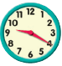
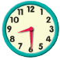
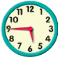
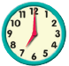

…………… …………… …………… ……………

B. Complete ( 2 marks )

- Who is she ?
- she is a ( teacher – nurse )

- Where does she work?
- She works in a ( hospital – school )

C. Circle good or bad : ( 2 marks )

- I got first place in a race ( good - bad )
- I saw a rainbow ( good - bad )
- I caught a cold ( good - bad )
- I broke my leg ( good - bad )

P.T.O

Controlled Writing

A. Complete the story: ( 2 marks )

At six o'clock, I ………… out of bed and ………………… my teeth. At one o'clock, I ………………… school and ……………… the bus home.

B. Rearrange: ( 1 mark )

firefighter – a – is – He
…………………………………………………………………..

C. Complete: ( 2 marks )

100 - 200 - ………. - 400 - ……… - ………. – 700 – 800 – 900 - ………. .

Reading short sentences:

A. Read and circle the correct answer : ( 2 marks )

- How ( many – much ) flour do we have ?
- We have ( some – any ) flour .
- How ( many – much ) tomatoes do we have ?
- We don't have ( some – any ) tomatoes .

B. Write true or False: ( 2 marks )

- He kicked a ball ( )
- He is a doctor ( )
- That's great ( )
- That's boring ( )

Grammar :
A. Choose the correct answer: ( 3 marks )

- ( What – Where ) time do you go to bed ?
- yesterday , I ( get up – got up ) at 8 : 00.
- ( How much – How many ) cheese do you have?
- What did you do on the weekend ( ! - ? )
- He's ( a – an ) teacher .
P.T.O
- We have ( some – any ) Flour .
B. Do as shown between brackets : ( 2 mark )

I see a rainbow ……………………………………….. ( change to past )
I play football ……………………………………….. ( change to past )

Vocabulary:

A. Choose the suitable word with suitable pictures? ( 3 marks )

Cook – tent – drink – knife – doctor – pilot

B. Circle the odd word. ( 2 marks )

- Cheese – chocolate – phone – cake
- architect – astronaut – chip – diver.
- great – pizza – funny – happy .
- played – cleaned – got – kicked.

D. Match .( 1 mark )
plant
stand
paint
hand

Orthography:

A. Fill in with ( cl – ph – gh ) ( 2 marks )

_ _ ock ele _ _ ant _ _ oto Li _ _ t

B. Rearrange the letters : ( 2 marks )

Ockr \ ………. ingr \ …….. inkth \ ……… nki \ ………
المملكة العربية السعودية  وزارة التعليم  إدارة تعليم .......................  مكتب تعليم ....................  مدرسة .......................... |  | اختبار مادة اللغة الإنجليزية  الصف السادس الابتدائي  الفصل الدراسي الثاني  التاريخ ........................  الزمن : ساعة ونصف

المعلم/ة | التوقيع | المراجعـ/ة | التوقيع

السؤال الأول | السؤال الثاني | السؤال الثالث | السؤال الرابع | السؤال الخامس | السؤال السادس | المجموع
6 | 5 | 4 | 5 | 6 | 4 | 30

اسم الطالب : |  | الصف : |  | رقم الجلوس :

استعن بالله

General Questions
A. Write the time under the correct clock ( 2 marks )

7 o'clock – 8:30 – 5:45 – 9:20

9:20 7 o'clock 8:30 5:45

B. Complete ( 2 marks )

- Who is she ?
- she is a ( teacher – nurse )

- Where does she work?
- She works in a ( hospital – school )

C. Circle good or bad : ( 2 marks )

- I got first place in a race ( good - bad )
- I saw a rainbow ( good - bad )
- I caught a cold ( good - bad )
- I broke my leg ( good - bad )

P.T.O

Controlled Writing

A. Complete the story: ( 2 marks )

At six o'clock, I jump out of bed and brush my teeth. At one o'clock, I finish school and ride the bus home.

B. Rearrange: ( 1 mark )

firefighter – a – is – He
He is a firefighter

C. Complete: ( 2 marks )

100 - 200 - 300 - 400 - 500 - 600 – 700 – 800 – 900 - 1000 .

Reading short sentences:

A. Read and circle the correct answer : ( 2 marks )

- How ( many – much ) flour do we have ?
- We have ( some – any ) flour .
- How ( many – much ) tomatoes do we have ?
- We don't have ( some – any ) tomatoes .

B. Write true or False: ( 2 marks )

- He kicked a ball ( F )
- He is a doctor ( T )
- That's great ( F )
- That's boring ( F )

Grammar :
A. Choose the correct answer: ( 3 marks )

- ( What – Where ) time do you go to bed ?
- yesterday , I ( get up – got up ) at 8 : 00.
- ( How much – How many ) cheese do you have?
- What did you do on the weekend ( ! - ? )
- He's ( a – an ) teacher .
P.T.O
- We have ( some – any ) Flour .
B. Do as shown between brackets : ( 1 mark )

I see a rainbow I saw a rainbow ( change to past )
I play football I played football ( change to past )

Vocabulary:

A. Choose the suitable word with suitable pictures? ( 3 marks )

Cook – tent – drink – knife – doctor – pilot
Knife | doctor | Cook | pilot | drink | Tent

B. Circle the odd word. ( 2 marks )

- Cheese – chocolate – phone – cake
- architect – astronaut – chip – diver.
- great – pizza – funny – happy .
- played – cleaned – got – kicked.

D. Match .( 1 mark )
plant
stand
paint
hand

Orthography:

A. Fill in with ( cl – ph – gh ) ( 2 marks )

cl ock ele ph ant ph oto Li gh t

B. Rearrange the letters : ( 2 marks )

Ockr \ rock ingr \ ring inkth \ think nki \ ink

