Mega Goal 2.2 – Units 5-6 Quiz – Group A
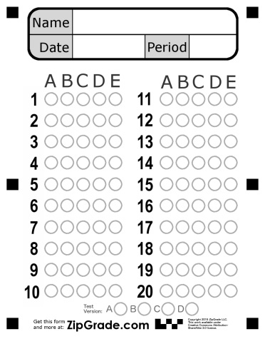
Name: ……………………………………………………………………………….. Class: ……………………………..
1 | The……………………… performed surgery to fix the patient's broken leg.
- engineer |  | - habitat | - sewing | - surgeon
2 | Don’t tell that guy what I said . ……………………
- in a bind |  | - keep it to yourself | - take off | - cover
3 | ………………….. = exactly the same
- identical |  | - flair | - captive | - analyze
4 | ……………… fruits and vegetables are grown without the use of harmful chemicals.
- recycling |  | - canvas | - organic | - energy
5 | How do you do that ? “ It’s …………………………………… ! watch.
- chucked |  | - a piece of cake | - no-brainer | - lame
6 | …………….. = depending on
- bold |  | - I guess | - perspective | - relying
7 | ……………….. = extremely large .
- perspective |  | - harsh | - enormous | - bold
8 | It is important that she ………………………………… late.
- not be |  | - be not | - not being | - being not
9 | I want you to …………………………… the dish
- are cleaned |  | - cleaned | - cleaning | - clean
10 | You ……………………………… smoke here . It’s not allowed
- must |  | - mustn’t | - not must | - have to
11 | He was watching TV, ……………………………………………. ?
- Wasn't he |  | - Was he | - He wasn't | - Doesn't He
12 | I prefer …………………………… organic food
- eats |  | - to eats | - eating | - eat
13 | I want to …………………………… TV
- watches |  | - watching | - watched | - watch
14 | He …………………………… basketball every Sunday .
- plays |  | - is playing | - play | - are playing
15 | If you freeze water , it …………………………… a solid .
- became |  | - becomes | - becoming | - become

