Name: …………………………………… Ms. Tahani
Class: 1st Intermediate
Revision Sheet _ Unit ( 9 ) : What Do You Do?
- Vocabulary:
- Write the words under the pictures:
newspaper – lawyer – waiter – carpenter – reporter

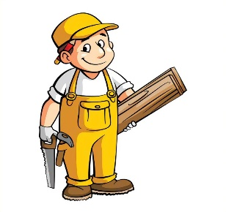



________________ __________________ __________________ __________________
- Classify the words:
clinic – mechanic – salesperson – school

Jobs | Place of work

- Circle the odd word:
- Jobs: chef – designer – gadget – teacher
- Place of work: hospital – restaurant – cameraman – store

- Match the opposites:
- agree a- bored
- interested b- difficult
. c- disagree

- Fill in the blank with the correct words in the box:
cook – drive – meet – sell – travel

- These store ……………. clothes and shoes.
- I will ………….. you at 10 o’clock.
- Ali is not old enough to …………….. a car.
- It is expensive to ……………… by plane.

- Grammar:
- Choose:
- A: (What – Where – Why) do you do?
B: I am a flight attendant.
- A: (What – Where – Why) do you want to be a doctor?
B: Because I want to help sick people.
- I like Math (and – but – or) I like history.
- I like coffee (and – but – or) I don’t like tea.
- I am sick, (because – so – or) I will take a painkiller.
- I want to be an architect (because – so – or) I like to design houses.
- A: What (do – does – are) she do?
B: she (do – does – is) a nurse.
- A: What (do – does – is) they do?
B: They are football players.
- Yasser (work – works – working) in the bank.
- My uncle (drive – drives – driving) a bus.
- Ali and Omar (play – plays – playing) tennis.
- Mothers (cook – cooks – cooking) the dinner for their children.

- Do as shown between brackets:
- Yara usually (write) a letter to her friend. (Correct the mistake)
……………………………………………………
- Deema and Rand are teachers. They (works) at school. (Correct the mistake)
……………………………………………………
- I like drawing, (and) I don’t like reading. (Correct the mistake)
……………………………………………………
- I have to study (so) I have an exam tomorrow. (Correct the mistake)
……………………………………………………
- for / writes / a magazine / Fahad (Rearrange)
……………………………………………………
- A: …………………………………………………? (Complete)
B: I am a bus driver.
- A: ………………………………………………….? (Complete)
B: Sami is a reporter.

