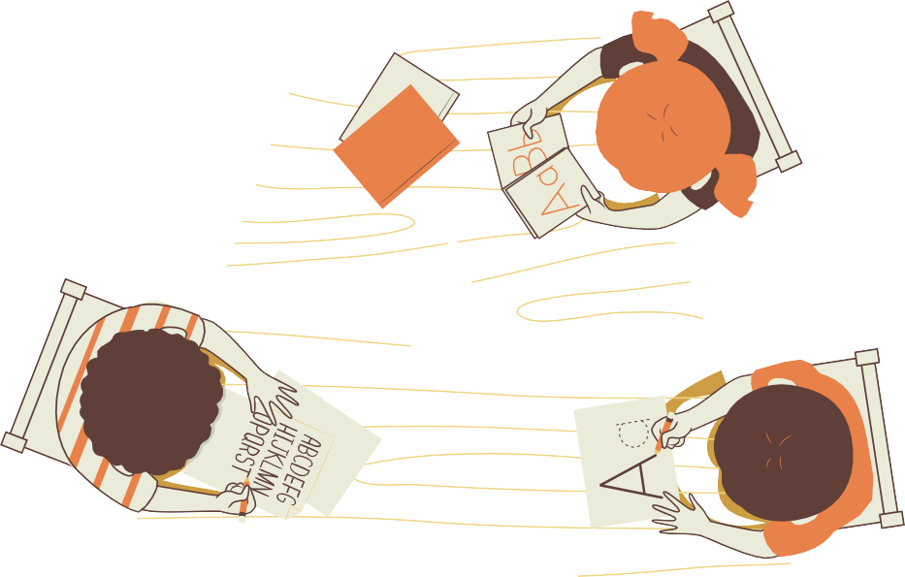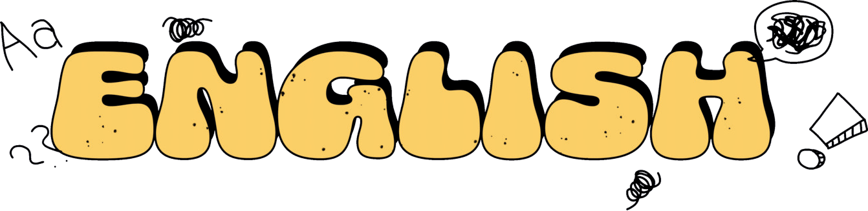

أوراق ﻋﻤﻞ
ﻟﺠﻤﻴﻊ وﺣﺪات اﻟﻔﺼﻞ اﻟﺪراﺳﻲ اﻟﺜﺎﻧﻲ ﻣﻦ اﻟﺼﻒ اﻟﺜﺎﻟﺚ ﻟﻠﺴﺎدس
)ﻟﻐﺔ اﻧﺠﻠﻴﺰﻳﺔ(

اﻋﺪاد اﻟﻤﻌﻠﻤﺔ: ﻋﺎﺗﻜﻪ ﻋﻄﻴﻒ

Nare:………………………………..
U:1
Yeeda¥ asd Tzda¥
¢zkhee

Dae: What time is it?

Da¢ he hz asd rise hasd zs each clzck z hz¢ he czec ire:

9:20

1:10
6:40

7:00

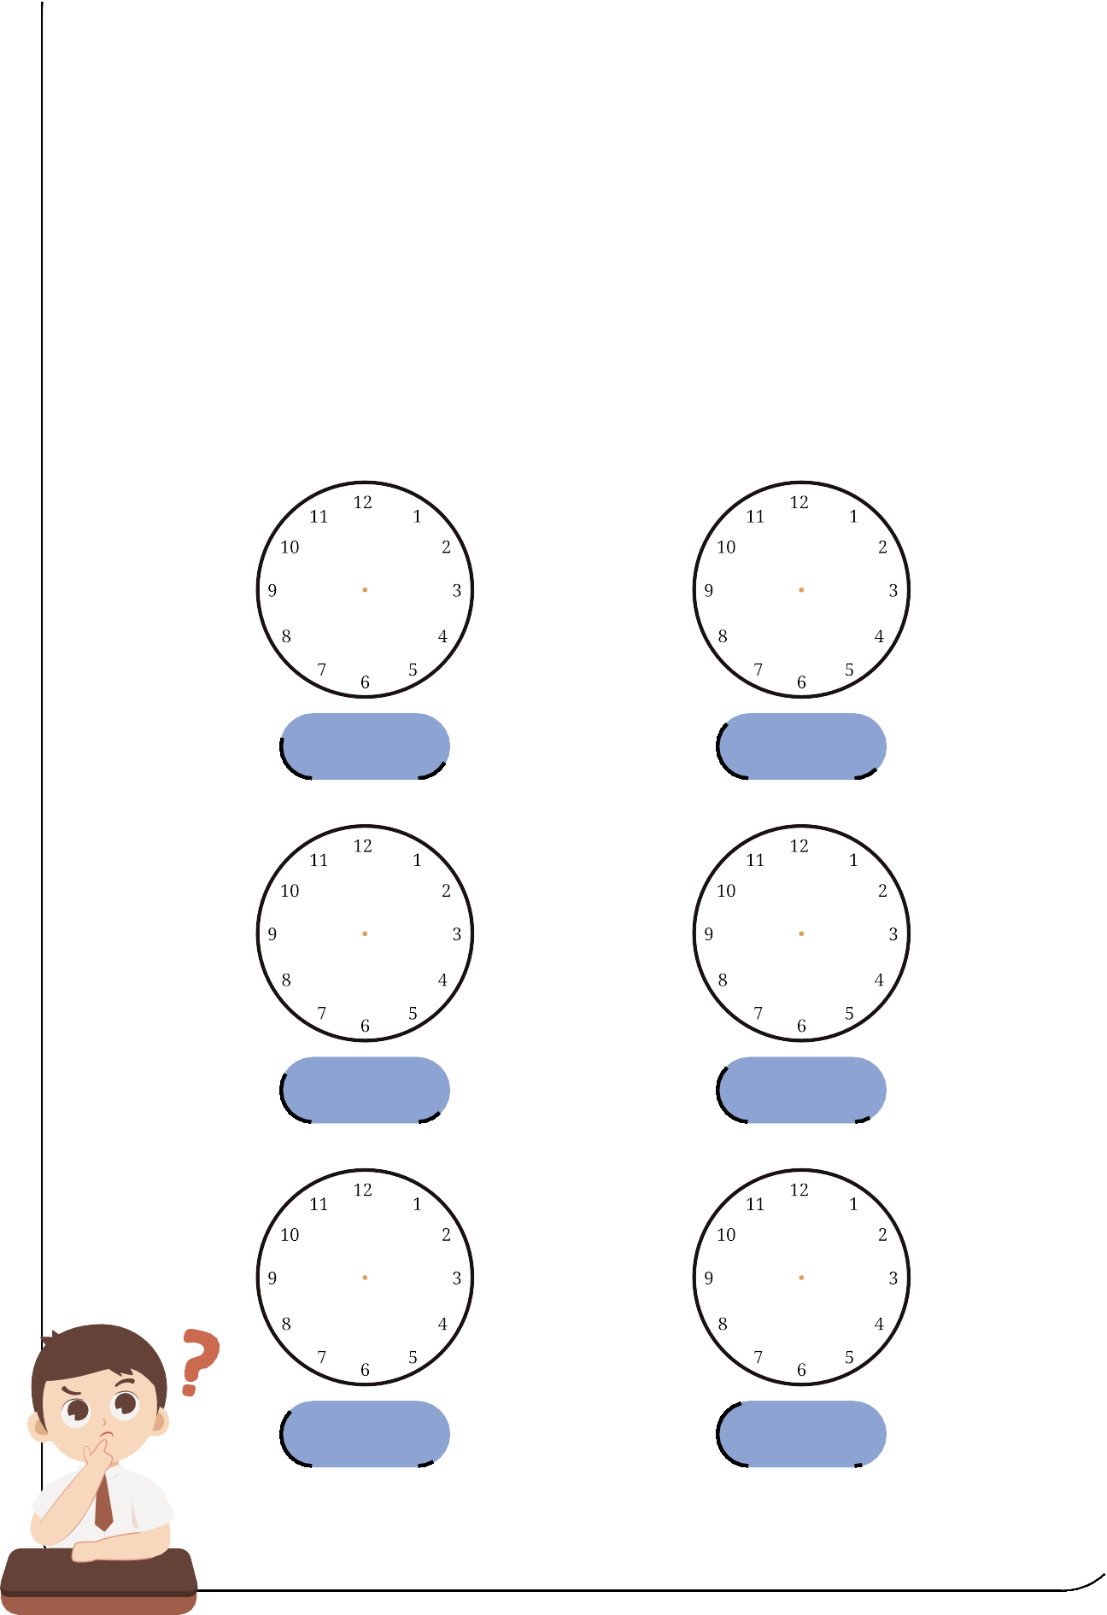

5:45 11:30

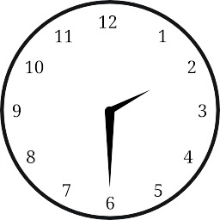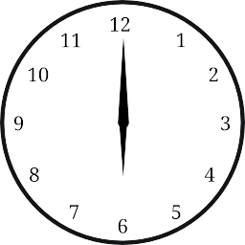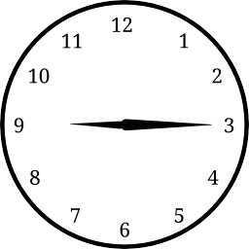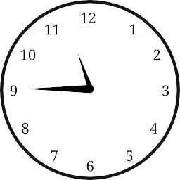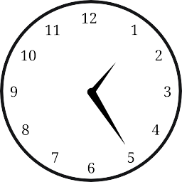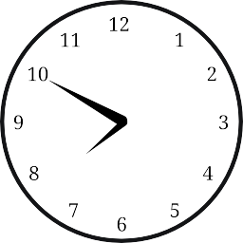U:1
Yeeda¥ asd Tzda¥
¢zkhee

Nare:………………………………..
Dae: What time is it?

Wie he ire:

: : :

: : :

U:1
Yeeda¥ asd Tzda¥
¢zkhee

Nare:………………………………..
Dae:
What time is it?

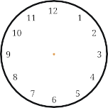
Choose the correct answer:

 | 11:30 | 4:15 | 1:20  
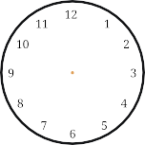 | 7:30 | 6:30   | 8:10  
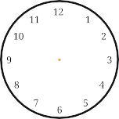 | 5:10   | 2:25 | 3:20  
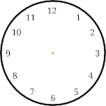 | 12:15 | 11:00   | 9:00
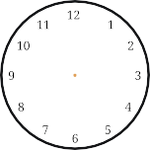 | 7:40   | 6:40 | 7:45


U:1
Yeeda¥ asd Tzda¥
¢zkhee

Nare:………………………………..
Dae:

What time is it?







Choose the correct answer:

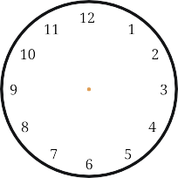 | 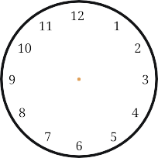 | 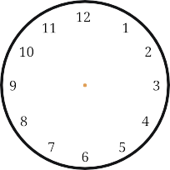
a quarter past three  a quarter past seven half past two | half past one six O’clock  half past twelve |  a quarter to nine   half past eghit  nine O’clock
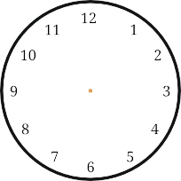 | 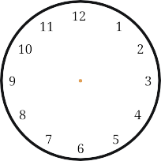 | 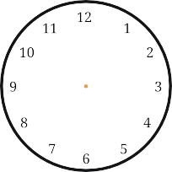
seven O’clock twelve O’clock  a quarter past seven |  a quarter past ten ten O’clock  half past ten | four O’clock half past five  a quarter to two

Name:………………………………..
Date:
U:1/L:2
Yesterday and Today worksheet

Choose the correct answer:

I usually at 6:00. | get up | got up

eat lunch ate lunch
Yesterday I at 2:00.

come home
Yesterday I at 12:00.
came home

do my homework

I usually at 5:00.
did my homework

Yesterday I at 7:00. | take a bath | took a bath

I usually at 10:00. | go to bed | went to bed


U:1/L:2
Yesterday and Today worksheet

Name:………………………………..
Date:

Write the past tense:

get up eat lunch come home
do my homework take a bath
go to bed
……………………………..

……………………………..

……………………………..

……………………………..

……………………………..

……………………………..

Name:………………………………..
Date:
U:1/L:2
Yesterday and Today worksheet

Match:

get up
did my homework
eat lunch
went to bed
come home
got up
do my homework
ate lunch
take a bath
took a bath
go to bed
came home

Name:………………………………..
Date:
U:1/L3
Yesterday and Today worksheet

What Time Do You Do It?
Choose the correct time:

10:00
6:00
1:00
2:00



At o’clock,
I jump out of bed And brush my teeth.

At o’clock
I finish school￼￼￼ And ride the bus home.

At o’clock
I eat my lunch
And meet my friends.

At o’clock
I jump into bed And dream a lot!

U:1/L:4
Yesterday and Today worksheet

Name:………………………………..
Date:

Choose , or to complete the words:
nk
ng
ck

swi…… |  |  | ro……   |  |  | ri……   |  |  | clo……
nk | ng | ck | nk | ng | ck | nk | ng | ck | nk | ng | ck

i…… |  |  | dri……   |  |  | spri…… |  |  | ba……
nk | ng | ck | nk | ng | ck | nk | ng | ck | nk | ng | ck



Choose the correct sound:
Ph
Wh
Sh
Ch



…..ocolate …..ale


…..ip tele…..one


U:2/L:1
Jobs worksheet

Name:………………………………..
Date:

Match:

1- doctor 2- housewife 3- astronaut 4- reporter

5- engineer 6- cook 7- pilot 8- firefighter
9- nurse 10- computer techni 11- lawyer 12- diver

13- businessman 14- teacher 15- architect





( ) ( ) ( ) ( ) ( )






( ) ( ) ( ) ( ) ( )






( ) ( ) ( ) ( ) ( )


U:2/L:1
Jobs worksheet

Name:………………………………..
Date:


Choose the correct answer:

He is….doctor.
a | an

She is….nurse.
a | an

He is….astronaut .
a | an

 He is….diver.
a | an

He is….engineer.
a | an

She is….teacher.
a | an

Name:………………………………..
Date:
U:2/L:3
Jobs worksheet

match:

1- teacher
2- baker
3- singer
4- designer

5- doctor
6- TV reporter
- writer
- presenter

- scientist






( ) ( ) ( ) ( )





( ) ( ) ( ) ( )

( )

Name:………………………………..
Date:
U:2/L:4
Jobs worksheet

Choose the correct sound:
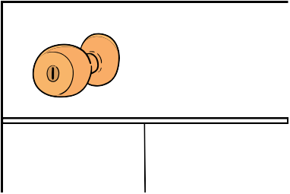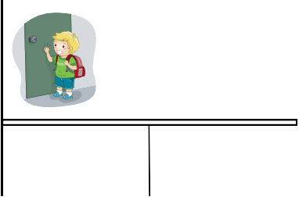
……ob
Kn
gh
ni……t
Kn | gh

li……t
Kn | gh

……ife
Kn | gh

……ock
Kn
gh
ri……t
Kn | gh

Choose the correct sound:
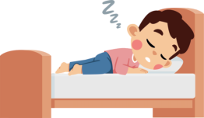


/Z/
/S/
/IZ/

sleeps……… watches……… goes………



teaches……… walks……… reads………

Name:………………………………..
Date:
U:2/L:4
Jobs worksheet



Write the missing numbers:

10 20 40

70 90

100 300 600

900

Name:………………………………..
Date:
U:3/L:1
Fun on the Weekend worksheet

Fill in the missing words in chart:

Verb Past tense -ed
………………………
clean
practice
watch
kick
play
study
cook
stay

………………………
………………………
………………………
………………………
………………………
………………………
………………………

Name:………………………………..
Date:

match:

Noura stayed home.
U:3/L:1
Fun on the Weekend worksheet

( )



- They played computer games. ( )

You practiced on the trampoline. ( ) 4-I cleaned my room.
( )

Ali cooked breakfast. ( )

- He kicked a ball for three hours. ( )

He watched a DVD about sharks. ( )

- Fahad studied for six hours. ( )

U:3/L:2
Fun on the Weekend worksheet
Name:………………………………..
Date:

Categorize the following verbs as pronounced:

practiced cleaned studied watched played cooked kicked stayed

for ed say /d/
for ed say /t/



Name:………………………………..
Date:
U:3/L:3
Fun on the Weekend worksheet

Fill in the blanks with How much or How many:

1/ flour do we need to make a cake? 3 cups.
2/…………………tomatoes are there in the fridge? 6 tomatoes.  3/ apples do we need for the apple pie? I don‘t know.
4/…………………milk do you drink in the morning? About 2 cups. 

Fill in the blanks with some or any:

1/We have………………sugar, but we don‘t have milk.

2/There is orange juice in the kitchen.

3/There isn’t oil in the bottle.

4/There are chocolates in the box.



Name:………………………………..
Date:
U:3/L:4
Fun on the Weekend worksheet

Choose the correct sound:

 sa…….
nd | nt

 pla…….
nd | nt


ha…….
nd
nt
pai…….
nd
nt



Name:………………………………..
Date:
U:4/L:1
Life’s Ups and Downs worksheet


Bad Things
Good Things
Categorize the following sentences good things or bad things :

1-We were stuck in an elevator. 2-I saw a rainbow.
3-I got first place in a race. 4-I caught a cold.
5-I made a rocket. 6-I broke my leg.

Name:………………………………..
Date:
match:
U:4/L:1
Life’s Ups and Downs worksheet

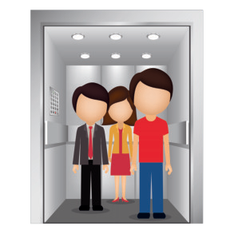
( )
1-We were stuck in an elevator.
( )
2-I saw a rainbow.
( )
3-I got first place in a race.
( )
4-I caught a cold.

5-I made a rocket. ( )

6-I broke my leg.
( )
7-I won a table tennis
game 21 to 3. 8 0
( )
- We lost a football game
8 to 0. ( )
- My dad had an operation. ( ) 10-I was team captain.

( )

Name:………………………………..
Date:
U:4/L:2
Life’s Ups and Downs worksheet

Categorize the following verbs to present and past tense:

get lost
won lose caught
made see
am,is was
win got

make
catch
had
broke
were

saw
break
are
have, has



Present | Past
 | 

Name:………………………………..
Date:
U:4/L:3
Life’s Ups and Downs worksheet

Write the past tense:

Present | Past
gets
comes
has
is
goes



Name:………………………………..
Date:

match:
U:4/L:3
Life’s Ups and Downs worksheet

Present
Past

gets comes has
is
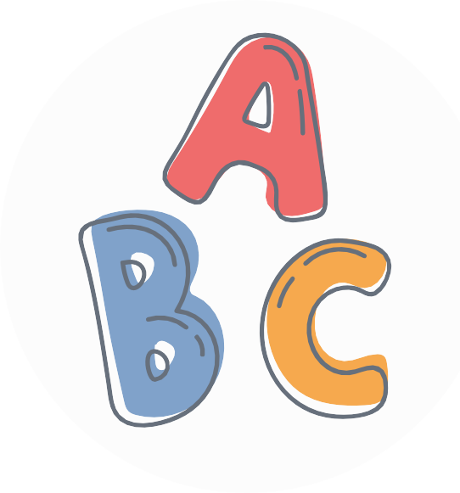
goes
went got was
had
came

Name:………………………………..
Date:
U:4/L:4
Life’s Ups and Downs worksheet

Choose the correct sound:
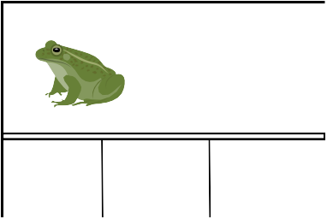
f
ph
gh
….rog
f
ph gh
…one
f
ph gh


ele…ant
f
ph gh
 lau…..
f | ph | gh



