
English Language
Intermediate Grade 1st
period Exam
………\20

Kingdom of Saudi Arabia
Ministry of Education
………..Education Directorate
………………… Intermediate School

Student's Name : class:
Reading comprehension ✦

……\ 5 marks
1-Read the following passage and answer the questions below:
My house is where my family lives. It is white. There are four bedrooms. We have a kitchen and three bathrooms. Our family room is where we like to watch television together. We have a playroom .There is a garden in the house and we have a swing there. Our house is near the elementary school.

1-What color is the house?
c- red | b- white | a- blue
2-Who lives in the house?
c- students | b- friends | a- family
3-How many bedrooms are in the house?
c- four | b- five | a- one
4-The house is …….. the elementary school.
c- next to | b- near | a- on
5-What is in the garden?
c- bicycle | b- football | a- swing
……\ 4 marks
Grammar ✦
A. Choose the correct answer.
1- Ahmad is the ( tall – taller – tallest ) student in the class.
2- We live ( in – on – for )the twelfth floor.
3- We read ( or – and – but ) write in class.
4-( Is – Am - Are )there curtains in the kitchen?
5-There ( is - are – am ) a car in the garage ..
6-Sami is ( smart – smarter – smartest ).
7-. Ali lives ( in – on – from ) Jeddah.
8-Healthy food is( good – better – best ) than fast food.

B. Do as shown between brackets.
1-Correct
a-Summer is the hotter time of the year. …………………
b-There are a Tv in the living room. ……………………….
……\ 2 marks

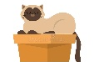
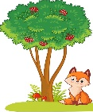
2-Choose the correct answer.
……\ 2 marks
a-The cat is ( in – far from - on ) the box.
b-2-the fox is ((across from - between – next to )the tree.

✦ Vocabulary
……\ 5 marks
A.Match the correct word for each picture.
stove bridge bathtub lake

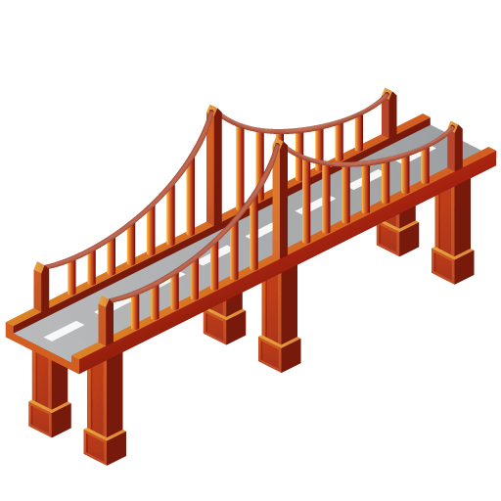
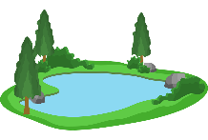
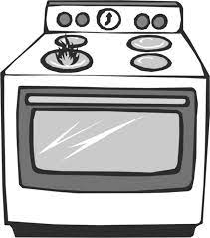
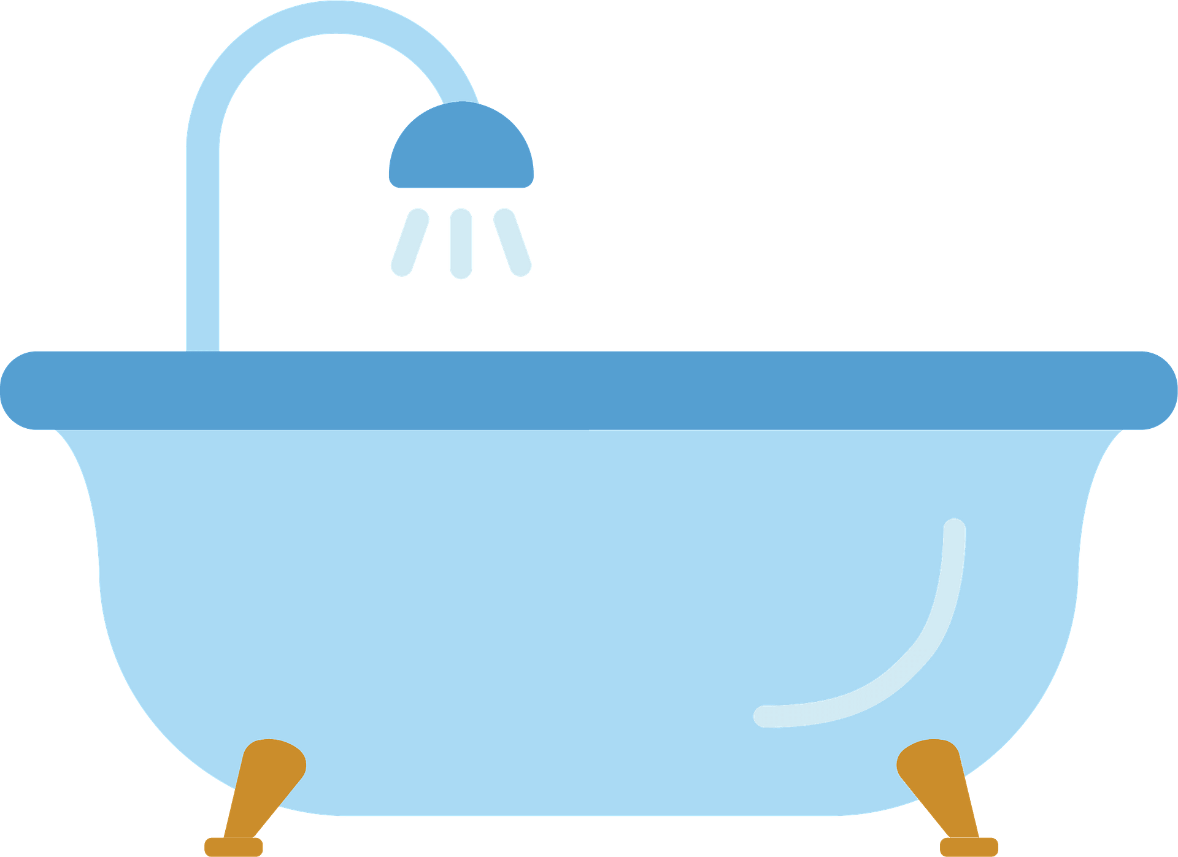
………………..
………………..
………………..
………………..

B-choose the correct answer.
1-a place to eat ( restaurant – bank - airport )
2-The opposite of small≠ ( big - tiny - happy)
3- The opposite of unusual ≠ ( cave – usual – bookstore)
4-a place to take a walk( (school- park – supermarket )
C-Find the odd words.
1- ( house parts ) : bedroom garage bank
2-(Laundry Room): washer laptop dryer
✦ Orthography
Choose the corre

……\ 2 marks
A-Write the missing letters.
1- Ar…..chair 2- Clo….et
B.Choose the missing letters.

1- a piz..eria is a restaurant that sells pizza.( z - o - k ).
2-He went to the museu… by taxi ( j – h – m ).
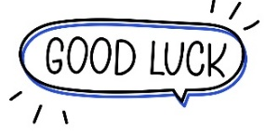

Your teacher …..:…………………………….

