Revision Unit 8 What are you doing ?
Name:……………………… Class: 1/..
vocabulary
- Match the words with the correct pictures:
( pack - food court – newspaper – hang out - surf the net)




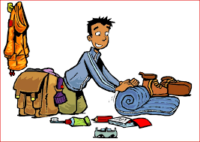

……………….. ……………….. ……………….. ……………….. ………………..

- Choose the correct answer:
( customer – drinking – break - comedy – what's happening? - watching)
- I'm ……………………………..TV.
- My favorite kind of film is……………………………..
- He's talking to a …………………………….
- They need a ……………………………. after work.
- She's ……………………………. coffee.
- "What's up?" means ……………………………..

Grammar
A) Choose the correct answer:
- I ( am reading – read – reads) a story now.
- My sister ( am – is – are ) watching a film.
- The children ( am – is – are) playing video games.
- Are you studying? Yes, ( I am – I am not – you are).
- I would like to (go –going – goes) to the mall.
- We (would like to - would like - would ) fries.

Orthography
- Choose the correct letter:
- c….. fé ( o- e- a) 4- ci…..y (r- t- m)
- wo….. k (r- b- t) 5- vi….. it (b- g- s)
- he…..p (m-l- v) 6- custo…..er (m-n-v)
Good luck

