EXAM SUPERGOAL1 TERM2 UNIT 6&7 NAME:………………………….
Comprehension
Read the text and answer the questions. Write T or F at the end of each question/statement.
My grandparents’ house is probably the home that means the most to me. It is more than 200 years old. There are seven rooms and two bathrooms in my grandparents’ house. There are three bedrooms upstairs and a big wooden staircase going downstairs. The living room has a red rug and a red sofa in it. There are also lots of big, comfortable armchairs in the living room. The dining room has a big wooden table and six wooden chairs around it.
1-The paragraph is about the writer’s grandparents’ house. ( )
2-There are two bedrooms upstairs. ( )
3-The living room has a red rug and a red sofa in it. ( )
4-The dining room has a small wooden table. ( )
Grammar
A-Choose the best answer to fill in the blank in each question.
1.___________ some flowers on the table. They look nice.
a. There is b. Is there c. There are

2. The airport is ………………….the city
a. on b. under c. far from

3.Amy: _____ a table in the kitchen? Mia: No, there isn’t.
a. Is there b. are there c. There are

4.I live ________ the third floor.
a. between b. next to c. on

5.The pharmacy is _________the bookstore.
a. next to b. near c. far from 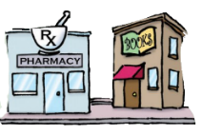
6- We read ……………….. write in the classroom
a.and b.but c.on
7- a- turn right b- go straight c- turn left 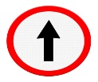

B-Complete the sentences with the comparative or superlative forms of the adjectives.
1-The bookstore is _____________than the library. (big)
2-That restaurant has the ___________ food in town. (bad)
3-The park is ______________________in the spring than in the winter. (beautiful)

Vocabulary
A-Choose the best answer to fill in the blank in each question.
1.The _____ are in the living room.
a. trees b. sinks c. armchairs

2.The pot is on the _____.
a. stove b. bathroom c. yard

3.The tree is in the _____.
bathroom b. garden c. bedroom

4.Is there a ____________ near here? I’m hungry.
a. airport b. gym c. restaurant

5.I buy vegetables from the ____________ on the corner of Main St. and Elm St.
a. supermarket b. bank c. subway station

B-write the correct word under the picture.
1 | Car | 2 | Washer | 3 | Health club
A |  | B |  | C | 
……………………..……………….. |  | ……………………..……………….. |  | ……………………..………………..
4 | Living room | 5 | armchair | 6 | closet
A | 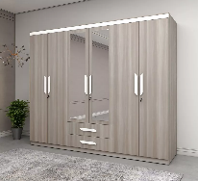 | B | 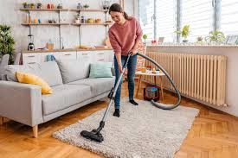 | C | 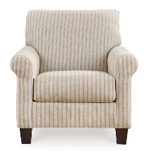
……………………..……………….. |  | ……………………..……………….. |  | ……………………..………………..

Orthography
1-gar….en (d- b)
2-lau…dry room (n- m)
3-p…armacy (h- f)
4-books…ore (t – v)
5-par… (k- c)
6-ya…d (r- i)

GOOD LUCK
T. Raedah

