Name: ……………………………………… Ms. Tahani
Class: 3rd Intermediate
Revision Sheet _ Unit ( 6 ) : Do You Know Where It Is?
- Vocabulary:
- Write the words under the pictures:
bullet train – bridge – commuters – fountain - suburb

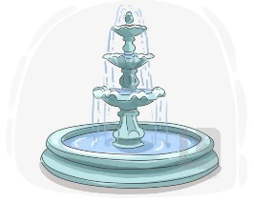
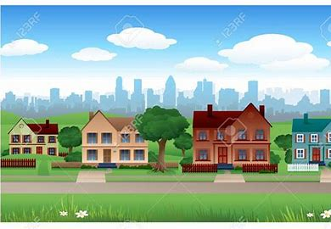



________________ __________________ ___________________ __________________
- Classify the words:
crime rate – taxis – kilometres

Vehicle | Measurement words | Features of town

- Circle the odd word:
- Vehicle: car – stadium – bus – taxi
- Features of town: green area – cost of housing – clean air – mile

- Match:
- run down a- holds
- consecutive b- an unbroken series
- leading c- in needed of fixing / not looked after
- combination d- popular
e- mixture

- Fill in the blank with the correct words in the box:
renovate – fare – survey – efficient – transportation

- There is public ………………………. available throughout the city.
- The ……………… questions were not very clear.
- The homeowners decided to ………………. their old kitchen.
- Ali is very ……………….. at his job.

- Match the word with its opposite:
- narrow a- high
- low b- cheap
- polluted c- wide
- cozy d- uncomfortable
e- clean

- Grammar:
- Choose:
- Fadi is (tall – taller – tallest) .
- Hatem is (tall – taller – tallest) than Samer.
- Rama is the (tall – taller – tallest) student in the class.
- The chair is (comfortable – more comfortable – most comfortable).
- The sofa is (comfortable – more comfortable – most comfortable) than the chair.
- The bed is the (comfortable – more comfortable – most comfortable) furniture.
- Leen’s marks are (good – better – best) than her friend.
- Dammam has the (bad – worse – worst) weather in Saudi Arabia.
- Your sister is as (smart – smarter – smartest) as you.
- Your mobile (is not as – is as not – not is as) new as mine.
- (A – An – The) sun rises in the east and sets in the west.
- The bird is flying in (the – a – an) sky.

- Do as shown between brackets:
- Where is the supermarket? (Make indirect question)
…………………………………………………..
- When does the shop open? (Make indirect question)
…………………………………………………..
- Wafa’s hair is long than Faten’s. (Correct the mistake)
…………………………………………………..
- Dana is in the Jeddah on vacation. (Correct the mistake)
…………………………………………………..

