Revision Unit 11 What time do you get up?
Name:……………………… Class: 1/..
vocabulary
- Match the words with the correct pictures:
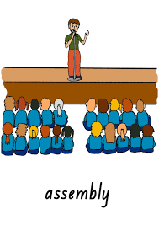
( study – martial arts – uniform - assembly – get up )
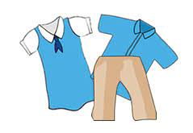




……………….. ……………….. ……………….. ……………….. ………………..

B) Choose the correct answer:
( before – absolutely not – begin – after – put on – wake up)
- They …………………………….. at 6 am. in the morning.
- The activities…………………………….. at 10 pm.
- The opposite of after is ……………………………..
- She brushes her teeth ……………………………. lunch.
- I ……………………………. my school uniform.
- No way means …………………………….

- Choose the odd word:
- wake up – art - ride – play
- morning – evening - before - afternoon
Grammar
A) Choose the correct answer:
- My friend goes to school ( in – at – on) 6:30 am.
- The party is ( in – at – on) the evening.
- We never go shopping ( in – at – on) weekdays.
- I go to work ( at – on – by) car .
- He usually goes to school ( at – on – by) foot.
- The boy always ( play – plays – playing) football in the park.
- She ( reads – is reading – are reading) a story at the moment.
- Look! they ( are swimming – is swimming – swim) in the pool.
Orthography
- Choose the correct letter:
- ch…..ck ( r- n- e) 4- stu…..y (d- r- t)
- bi…..e (k- m- d) 5- wo….. k (r- k- a)
- ge….erator (s-m- n) 6- r…..de (i -t -e)
Good luck

