Revision Unit 9 Where do you do?
Name:……………………… Class: 1/..
vocabulary
- Match the words with the correct pictures:

( player – cameraman – laptop - driver – smart phone - lawyer)


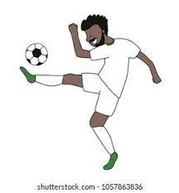
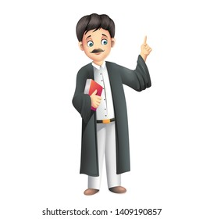


……………….. ……………….. ……………….. ……………….. ……………….. ………………..

( player – student – doctor – chef – flight attendant - grow up)
- The ……………………………..works in a hospital.
- When I ……………………………. I want to be a lawyer.
- He is the best ……………………………. In the team.
- Saleh likes to travel. He wants to be a …………………………….
- She works at a restaurant. She is a …………………………….
- Sandy is 13 years old. She is a …………………………….

- Choose the odd word:
- lawyer – sell - carpenter – waiter
- cook – write - drive - film
Grammar
A) Choose the correct answer:
- I ( works – work – working ) in a store.
- My father ( reading – reads – read) a story.
- I sleep late ( so – or – because) I am tired.
- I want a sandwich ( so – or – because) I am hungry.
- Jack and I ( go – going – goes) to a pizza restaurant on Thursdays.
- My cousin ( study –studies – studying) in her room in the afternoon.
- My uncles ( play – plays – playing) football in the yard.
Orthography
- Choose the correct letter:
- p….. ayer ( m- l- n) 4- t…..avel (n- r- m)
- ga….. gets (f- b- d) 5- str….. ker (e- i- a)
- web…..ite (s-k- c) 6- d…..eam (s - n-r)
Good luck

