Revision Unit 6 Is there a view?
Name:……………………… Class: 1/..
vocabulary
- Match the words with the correct pictures:
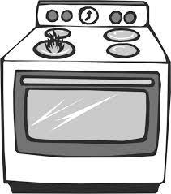
( bathtub- lamp – chair – house – flowers - bed – laptop- stove)



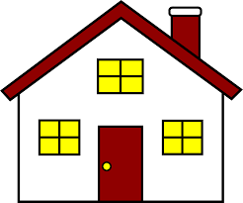
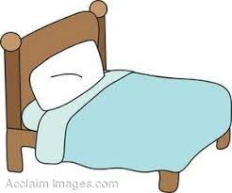
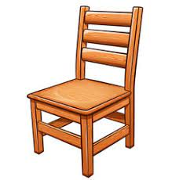


……………….. ……………….. ……………….. ……………….. ……………….. ……………….. ……………….. ………………..

- Choose the correct answer: ( view – bedroom- large – garage – under- shelf)
- I sleep in the ……………………………. with my sister.
- The car is in the …………………………….
- I put the books on the …………………………….
- The opposite of (on) is …………………………….
- The opposite of (small) is …………………………….
- The balcony has a beautiful …………………………….

- Choose the odd word:
- Bathroom – bedroom – rug – kitchen
- Mirror- shower- bathtub- sofa
Grammar
A) Choose the correct answer:
- There ( are – is – be) a table in the kitchen.
- There ( are – is – be) trees in the garden.
- ( Are – Is – Be) there a sofa in the living room?

- ( Are – Is – Be) there pictures on the wall?
- The ball is ( in – on – under) the box.
- You can read a book ( or – but – out) a story.
- She has a pencil ( bed – but – and) a bag.
- My room is small ( or – but – out) comfortable.
Orthography
A)Choose the correct letter:
- co….. d ( m- n- l) 4- hou…..e (s- v- m)
- d….. yer (r- b- q) 5- d….. sk (e- i- a)
- so….. a (n-f v) 6- di…..ing (m-n-d)

Good luck

