
Kingdom of Saudi Arabia
Ministry of Education
……..Education Directorate
………………… School
English Language
elementary Grade …..
period Exam
…………….\20
Student's Name : class:

……\ 4 marks

General questions

A.Answer the questions
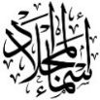
1-What does he do?
a-Good afternoon b- He's a lawyer c- No. he isn't.
2-What time did you get up yesterday?
a-Yesterday, I got up at 5:30 b- I usually get up at 5:30 c- Yes, I did.
3-What time do you take a bath?
a- She plays basketball at 3:00 b-I usually take bath at 10:00 c- No , I can't.
4-Where do they work?
a-They work in airport. b-She works in hospital. c-I am work in school.
Controlled Writing
……\ 1 marks

A-reorder.
grow up, - a firefighter – I want – When I – to be
……………………………………………………………………………………
……\ 4 marks

Reading short sentence
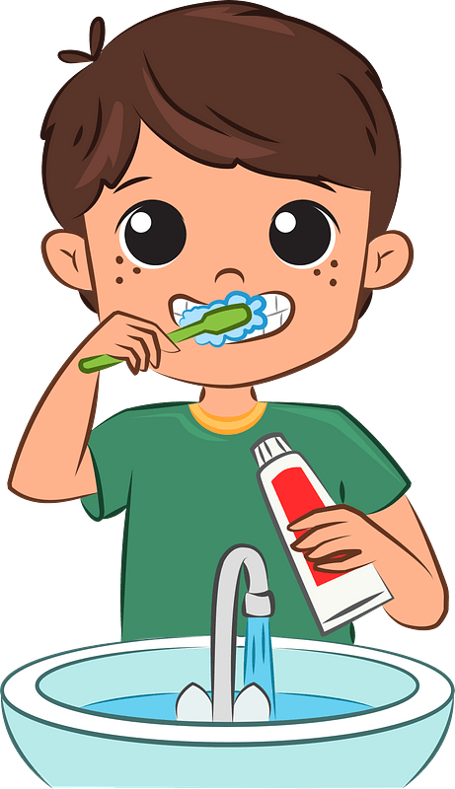 | 1- I usually finish the school at 1:30 ( )
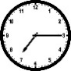 | 2- It's a quarter past seven ( )
A-Put ( ✔ ) or ( X )
B.Match

 |  | 1-It's 5 o'clock.
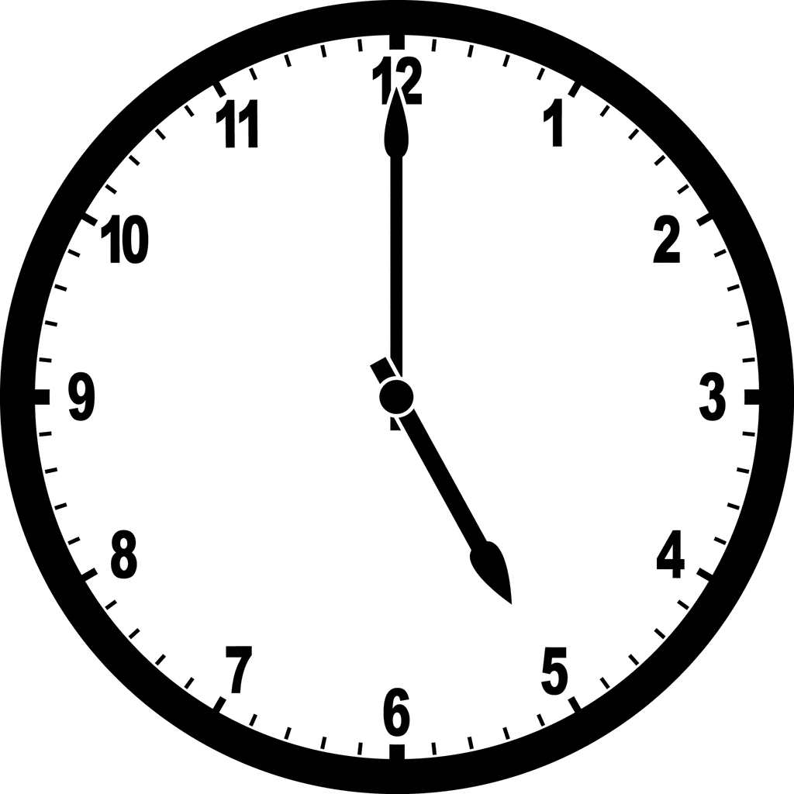 |  | 2-A doctor helps sick people and works in a hospital.

A-Choose the correct answer.

Grammar
……\ 4 marks
1- What does she ( do – does – doing ) ?
2- I usually ( eat – ate – eats ) lunch at 1:00.
3-Yesterday, I ( do – does – did ) my homework at ten o'clock.
4-Where do you ( work – works – working)?
……\ 5 marks

Vocabulary

A.write the correct word under each picture
( cheese – ink - clock - baker - astronaut )
)

 |  |  |  | 
Orthography
……\ 2 marks

A. Fill in the missing letters
Sh Kn ph gh




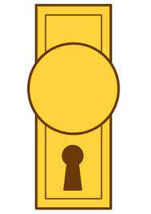

…..ob
….ip
Ni…..t
…..one

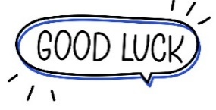
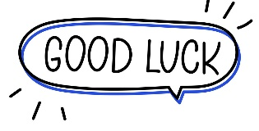
Your teacher …..:…………………………….

Your teacher:

