
Unit (2) You Are What You Eat Revision MG 2.3

Grammar
1 | I ………………. eating meat for a year ago .
A | load up | B | give up | C | catch up | D | come up
2 | Let's ……….. a restaurant to eat dinner tonight .
A | pick out | B | pick up | C | pick on | D | pick at
3 | No, there isn't …………. juice in the fridge.
A | no | B | any | C | some | D | few
4 | You need to ……………. The moldy cheese .
A | throw down | B | throw up | C | throw out | D | throw over
5 | My sister has gone ……………… too many crazy diets .
A | into | B | up | C | out | D | on
6 | Marathon runners often load ………………on pasta the night before a race .
A | up | B | over | C | off | D | for
7 | Could you ……………. a leaf of a bread from the store on our way home?
A | pick on | B | pick out | C | pick up | D | pick at
8 | I can't …………… the answer to this math problem .
A | figure on | B | figure out | C | figure up | D | figure into
9 | We are ………………… to trying new Indian restaurant .
A | looking out | B | looking down | C | looking forward | D | looking up
10 | The doctor says you must ……………… on sugar .
A | cut down | B | come down | C | get down | D | look down
11 | To stay healthy, you should try to eat as ……………… fruit as you can .
A | any | B | some | C | many | D | much
12 | After eating a big meal , I usually go running to try to burn it …………….. .
A | on | B | upon | C | off | D | about
13 | ……………….. bandanas do you eat per a day ?
A | How often | B | How many | C | How about | D | How much

14 | I need a ……..………… tomatoes to make salad .
A | few | B | some | C | little | D | any
15 | I need a ……………. cheese to make pasta .
A | some | B | any | C | little | D | few
16 | Let's ………………. the problem and maybe we can solve it .
A | talk up | B | talk over | C | talk out | D | talk down
17 | ……………. water do you drink per a day ?
A | How about | B | How many | C | How often | D | How much
18 | …………. , you mix the flour and the eggs . Then you add a little butter .
A | First | B | After that | C | Finally | D | Next
19 | Sam felt hungry so he ordered a pizza , a salad , ……………. fries and a juice .
A | the | B | a | C | some | D | an
20 | Yesterday , I came …………… peanut ice cream . It was delicious.
A | away | B | across | C | forward | D | back

1
\

Unit (2) You Are What You Eat Revision MG 2.3

Vocabulary

1 | A situation in which someone doesn't know what to do ……………………
A | hassle | B | quandary | C | aroma | D | gourmet
2 | I put a lot of sugar and milk in my coffee because otherwise it tastes too …………….
A | stuffed | B | fresh | C | bitter | D | sour
3 | The ………….. of fresh baked bread in the kitchen is making my mouth water .
A | aroma | B | delicacy | C | licensed | D | crumb
4 | Noor is such a gourmet that it's difficult to………... between her cooking and restaurant cooking .
A | fascinated | B | bothered | C | barked | D | distinguish
5 | A: I enjoy the cool refreshment of ……………… on a hot summer day . B: me too !
A | zalabia | B | popsicle | C | pastry | D | chips
6 | I can ……………….. the cookies ………. in no time . I make them all the time and it's very fast .
A | cut \ up | B | lock \ in | C | whip \ up | D | put \ out
7 | Would you like a piece of this chocolate cake ? Yes of course ! You know I ..…………….
A | cool down | B | get down to | C | come to think of it | D | have a sweet tooth
8 | Snails are eaten as a ……………… in some cultures .
A | delicacy | B | antioxidant | C | quandary | D | indulgence
9 | Someone who sells something ……………….
A | shell | B | husk | C | vendor | D | shipment
10 | The odd word is ……………….
A | salty | B | peak | C | sour | D | sweet

*Match the words with their meanings ( synonyms ) :

1 | staple | 1- d | a-delicious
2 | toxin | 2- c | b-the presence of something in reality .
3 | existence | 3- b | c-poisons .
4 | delectable | 4- a | d-a common or important item .
5 | substitute | 5- f | e- having legal permission to do something .
6 | licensed | 6- e | f-something that is used in a place of another thing .

*Match the words with their opposites ( antonyms ) :

1 | frozen | 1- b | a-rotten
2 | fresh | 2- a | b-heated
3 | bitter | 3- d | c-increase - grow
4 | reduce | 4- c | d-sweet

*Write the name of each picture :

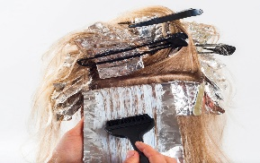
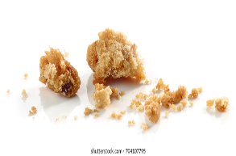

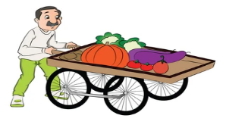


2
\
dyeing
melted
vendor
crumbs
popsicle

