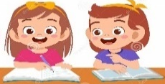

Unit (1) Lough Out Loud Revision MG 2.3

Grammar
1 | Noor was ………………. with her English exam result .
A | Satisfies | B | Satisfied | C | Satisfying | D | Satisfy
2 | I was ……….. amused that I cried with laughter .
A | so | B | such | C | too | D | enough
3 | I wish I had ………….the TV comedian . Everyone thought he was so funny .
A | saw | B | seen | C | see | D | seeing
4 | The new TV sitcom is ……………. a funny show that everyone in my class watch it .
A | too | B | so | C | such | D | much
5 | I wish the children would ……………… interrupting .
A | have stopped | B | stops | C | stopped | D | stop
6 | The more you read , the ………………you become .
A | smarter | B | smartest | C | smart | D | smart than
7 | The food was …………….spicy that it burned my mouth .
A | such | B | lots of | C | so | D | little
8 | The more practice , the …………… you get .
A | good | B | better | C | best | D | The best
9 | You know the winter is coming ,when it starts ………………… earlier .
A | get dark | B | got dark | C | getting dark | D | gets dark
10 | My parents ………………if I'm not at home by 10.00 .
A | get worried | B | gets worried | C | got worried | D | get worry
11 | I prefer to use the gym early in the morning . It ……………… in the afternoon .
A | get crowd | B | got crowed | C | getting crowded | D | gets crowded
12 | I did not see the match . I wish I …………….. it .
A | will watch | B | watch | C | had watched | D | watched
13 | My brother will leave for the collage now . If only he ……………….. .
A | can stay | B | would stay | C | will stay | D | stay

14 | She knew ……..………… people that nobody noticed she was missing .
A | So few | B | so little | C | so much | D | so a lot
15 | He couldn't ……………. the exam , he looks cheerful .
A | fails | B | failed | C | fail | D | has failed
16 | The company received ………………. complaints that they had to recall the product .
A | so a lot | B | so many | C | so much | D | so little
17 | If only I …………… enough money to buy this T-shirt .
A | had have | B | has | C | have | D | had
18 | I am very fascinated by the ………………….. 2030 vision projects .
A | amazing | B | amazed | C | be amazed | D | be amazing
19 | Jamal is …………… because he is working all the day .
A | be tired | B | had tired | C | tired | D | tiring
20 | There are many ………………. museums in my country.
A | interested | B | interesting | C | so interested | D | interests

1
\

Unit (1) Lough Out Loud Revision MG 2.3

Vocabulary

1 | Someone who can speak both Arabic and English is ……………………
A | irritated | B | bilingual | C | remarkable | D | frustrated
2 | Suzan decided to be a …………… because she loves children .
A | clown | B | laughter | C | Pediatric | D | hearty
3 | Something is said or done to cause laughter is …………..
A | joke | B | club | C | smile | D | fake
4 | Someone who is confused by something is ……………….
A | fascinated | B | bothered | C | barked | D | puzzled
5 | Something that is incredible can be also called …………………..
A | bilingual | B | remarkable | C | Irritated | D | astonished
6 | I am ………………….by the number of people who don't like school .
A | satisfied | B | puzzled | C | astonished | D | will have to
7 | Ali is a bit down lately . I will tell him some jokes and ……………….
A | tell him the truth | B | depressed him | C | getting to him | D | cheer him up
8 | I often feel ……………… when I am around my younger brother. He never stops bothering me .
A | irritated | B | puzzled | C | remarkable | D | bilingual
9 | Someone who is very interested in something is ……………….
A | barked | B | depressed | C | fascinated | D | frightened
10 | The odd word is ……………….
A | confused | B | interesting | C | excited | D | astonished

*Match the words with their meanings ( synonyms ) :

1 | cardiovascular | 1- d | a-to improve
2 | antibodies | 2- c | b-to increase energy or activity .
3 | stimulate | 3- b | c-substance produced by the body to fight germs and infection.
4 | enhance | 4- a | d-involving the heart and blood vessels .
5 | hearty | 5- f | e- to cause someone to do something .
6 | prompt | 6- e | f-strong and with feeling .

*Match the words with their opposites ( antonyms ) :

1 | bilingual | 1- b | a-fake
2 | genuine | 2- a | b-monolingual
3 | remarkable | 3- d | c-different
4 | equivalent | 4- c | d-unremarkable

*Write the name of each picture :

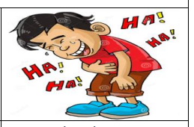

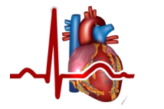
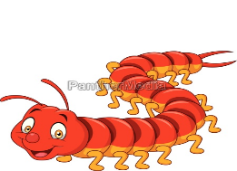
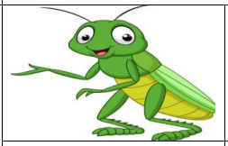

laughter
2
\
cardiovascular
centipede
penguin
grasshopper

