MG 2.2 Unit (2) Going Green Revision
( full infinitive → to + Vinf )

( gerund → Ving )

{ verbs come after it gerund}
advise / enjoy / finish / go /
imagine / keep / quit /
recommend / stop / suggest
{ verbs come after it full infinitive}
agree / ask /attempt / decide /
expect / forget / learn /need/ offer /
plan/promise/remember/try/want

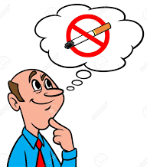


My boss stopped smoking 3 months ago
Go shopping with your sister
I decided to take a day off
He wants to finish the project by himself
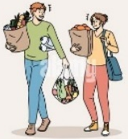


Subject  pronoun | Object  pronoun
I | me
he | him
she | her
it | it
we | us
they | them
you | you

{verbs followed by object
before the full infinitive}
ask / expect / need / want
{verbs with either gerund and full infinitive}
begin / can't stand / continue / intend /
hate / like / love / prefer / start



I want to buy a new toaster
I want him to buy a new toaster

We love playing / to play with dad.
Start making / to make a list before shopping
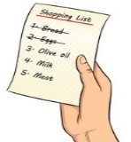

1 | Do you want …………..……a positive impact on the environment?
A | have | B | to have | C | having | D | had
2 | You should consider ……………clothes that no longer fit you to others who can wear them
A | give | B | gave | C | giving | D | gives
3 | I advise you to stop ……………things you don’t need
A | buy | B | bought | C | buying | D | buys
4 | We asked ………………. to move the car away
A | she | B | they | C | them | D | I
5 | Keep ……………your supermarket bags
A | use | B | reuse | C | reusing | D | reused
6 | They offer…………….. together for the test
A | study | B | studies | C | studied | D | to study
7 | Please don’t forget ………….. your food as a fertilizer for the soil
A | recycle | B | to recycle | C | recycling | D | recycled
8 | My brother promised …………….his math exam.
A | pass | B | passing | C | to pass | D | passed
9 | Can you imagine ……………… as a crime site cleaner?
A | work | B | works | C | worked | D | working
10 | I like to ……………. chocolate ice cream.
A | eat | B | ate | C | eating | D | eats
11 | Where did you learn …………….English?
A | speak | B | speaks | C | to speak | D | speaking

Tr. Amal Al Sulami

MG 2.2 Unit (2) Going Green Revision
Present simple
S + Vs / Vinf

Present progressive (continuous)
S + be ( is /am /are ) + Ving

(I'm)
I
you
They
we
I am
She
He
it
you
They
we
She
He
it
playing
are
is
play
plays
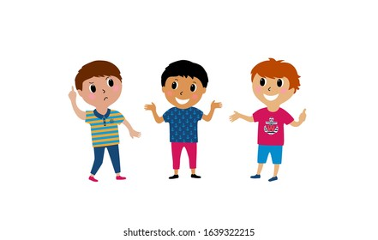
studying

Verbs end with y before it consonant Study → studies
Verbs end with y before it vowel play → plays
Verbs end with ( o- sh - ch -ss-x ) ad es
go→ goes /watch → watches /mix →mixes /pass→ passes

Study → studying play→ playing
live → living singe → singeing Lie →lying
agree → agreeing stop→ stopping

Ali is playing tennis this week

She plays cards every week
He isn't playing cards
She doesn't play cards every day

YesNo
Is he playing cards ?
Does she play cards every week ?
What is he playing ?

What does she play every week?
Whq
When is he playing tennis ?
When does she play cards ?
Who plays cards every week?
Who is playing tennis this week?

They are studying E these days

They play games once a week
They aren’t playing .
They don’t play cards every week
YesNo
Are they studying Math ?
Do they play cards every week?
What are they studying ?
What do they play once a week?
When are they studying E ?
When do they play games ?
Whq
Time expression ( key words )
Usually, always, often , On Mondays
every day, week , month , Sunday …..
once a / twice a / 3 times a + week , day…
Who play games once a week ?
Who are studying E these days ?
Time expression ( key words )
now / right now / at this moment , today .currently
this + week/ weekend ( I am not working this week ) these + days / nights / At present Look ! / listen

1 | Ali ……………. to work every morning.
A | go | B | went | C | goes | D | gone
2 | He ……………….. in new York
A | live | B | lives | C | living | D | lived
3 | Omar is ……………….his father now
A | call | B | calls | C | calling | D | calling
4 | A: ……………. are they doing? B: They are watching the game.
A | When | B | Why | C | What | D | Who
5 | The poster ………… hanging on the wall
A | am | B | is | C | are | D | do
6 | Look! Ahmad and Ali ……………..playing with their friend .
A | am | B | is | C | are | D | was
7 | He ………………… football .
A | don’t play | B | doesn’t plays | C | doesn’t play | D | play
8 | Do ………….. watch the game in the TV
A | they | B | she | C | he | D | It
Tr. Amal Al Sulami

MG 2.2 Unit (2) Going Green Revision
Present simple
( permanent )
Present progressive
( temporary )
Ali lives in Makkah but he is studying in France this year .

I don’t understand the story.
No stative verbs with the progressive
( like ,love , hate , want ,see , smell ,taste , hear , Know , understand )

I am not understanding the story.

If clause

main clause

If conditional present / future

Present facts  (zero conditional) | If + s + Vs / Vinf , s + Vs / V inf
Present facts  (zero conditional) | If she heats water , It boils
Future facts  (first conditional) | If + s + Vs / Vinf , s + will / be going to + Vinf
Future facts  (first conditional) | If I have the money , I will / am going to buy the car
May/Might (possible) | If + s + Vs / Vinf , s + may /might + Vinf
May/Might (possible) | If I have the money , I may buy the car  If she doesn’t have the skills , she may not get the job  If I don’t have the skills , I may not get the job
You will pass the exam if you study hard

If you study hard , you will pass the exam


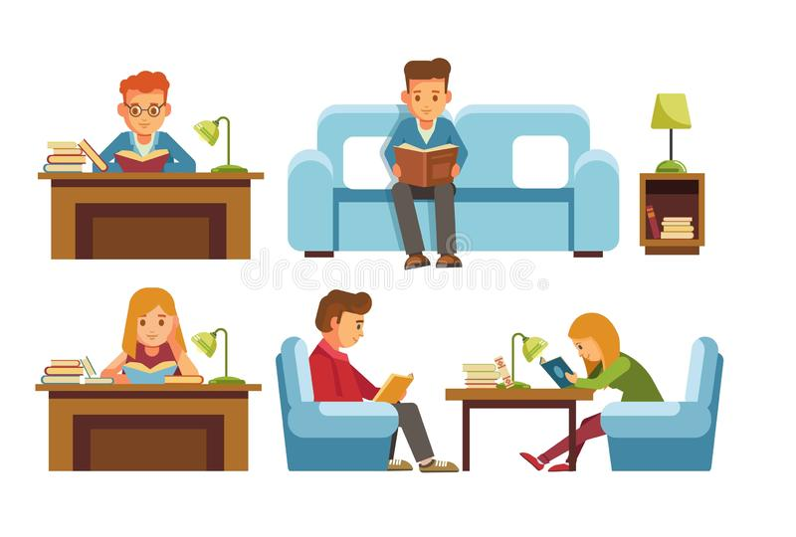
I'd rather + V inf ( to talk about preference)

Would you rather study at home or in a library ?

I'd rather study at home.

1 | If you don’t water plants , they die
A | present fact | B | future fact | C | possible form | D | imaginary form
2 | If she …………….junk food a lot , she will put on weight .
A | eat | B | ate | C | eats | D | eating
3 | If you don’t study hard , you …………. not pass the exam ( future fact )
A | can | B | will | C | might | D | should
4 | If we have time . we ……………..go shopping ( talk about possibility )
A | can | B | will | C | might | D | should
5 | If we …………….a little longer , the bus might come .
A | Will wait | B | waiting | C | waited | D | wait
6 | If I freeze water , it ………………..ice .
A | become | B | becomes | C | became | D | becoming
7 | Our team ……………..if we don’t play well tomorrow
A | lose | B | will lose | C | lost | D | losing
8 | If we hurry, we……………..the museum opening .
A | will miss | B | won't miss | C | doesn’t miss | D | didn’t miss
9 | Would you rather ………………….. coffee or tea ?
A | drink | B | drinks | C | drank | D | drinking
10 | I would rather …………..in a big city than a small one .
A | live | B | lives | C | lived | D | living

Tr. Amal Al Sulami

MG 2.2 Unit (2) Going Green Revision Vocabulary
1 | Pollution is the ……………..of many environment problems
A | air conditioner | B | source | C | organic | D | pesticides
2 | ………………..food is produced entirely without chemicals
A | pesticides | B | source | C | organic | D | recycle
3 | It’s a ……………….and brave decision to live off the grid .
A | bold | B | weak | C | low | D | poor
4 | Every parents should be …………………..and dedicated to their children
A | careless | B | uncommitted | C | committed | D | ignoring
5 | Circle the odd advice
A | eat organic food | B | don’t recycle | C | conserve water | D | save energy
6 | How about going out in a restaurant for dinner?
A | make a suggestion | B | ask for inf | C | answer what | D | a questionnaire
7 | A: It's not working B: ………………you need a password to open it
A | a hassle | B | chuck | C | I guess | D | lame
8 | Ss: Sorry I miss the bus cuz I was sleeping Tr: Really, this is a very …………excuse indeed
A | suitable | B | lame | C | right | D | appropriate
9 | Ali : How did you solve it so easily . Bader : It's ……………..
A | a piece of cake | B | a hassle | C | difficult | D | hard
10 | A: They offer me a full scholarship, what do you think? B: Really this is a ………, take it.
A | lame | B | no-brainer | C | hassle | D | chuck
11 | A:I can't sort every material for recycling, this is a ……. B: But it's a good effort to your planet
A | simple | B | organic | C | hassle | D | easy
12 | How dare you …………. away my old letters in the bin without asking me?
A | lame |  | no-brainer |  | hassle |  | chuck
Classify the items into the correct category :
( enjoy – go – keep – stop – suggest - try – decide – forget – learn – plan – start - love- like – hate – can't stand )

Verb + gerund | Verb + full infinitive | either gerund or full infinitive
1 | relying | ( ) | dedicated
2 | committed | ( ) | depending on
3 | harsh | ( ) | basic service
4 | utility | ( ) | severe, difficult

Match the words with their meaning

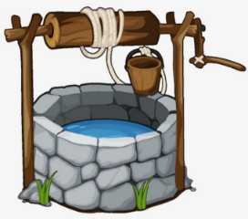
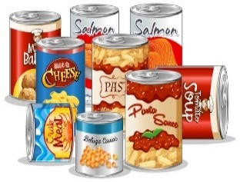
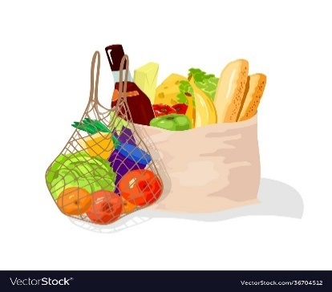

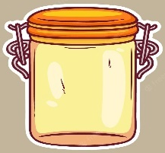

Packaged food
Solar panels
jar
groceries
well
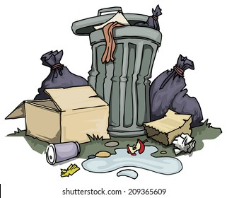
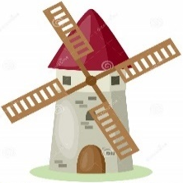

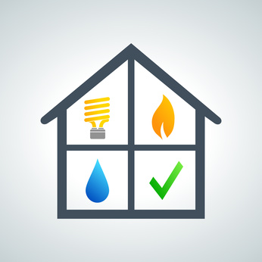
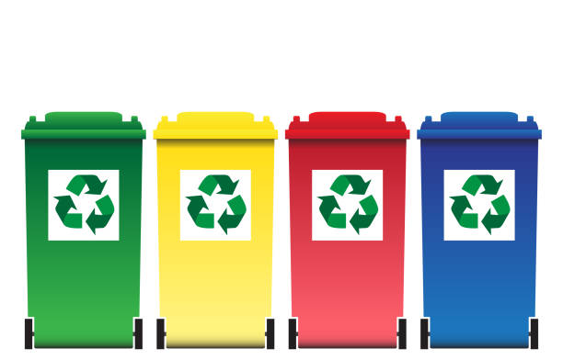

garbage / waste /
landfill
utility
windmill
grid
recycling bin
Tr. Amal Al Sulami

