10
(MG2.2 ) Midterm Exam 2nd Grade 2st Term unit 1 No.1
Name:__________________________________________ Class: _________
2
Read the text then answer:
Mona is interesting in Geography books She has read many books on China, India and Korea. Mona
Visits the school library twice a week and the librarian is always ready to help her. Last week, she wrote
a very good note in the school Magazine. The headmistress gave her some books as a present for that note.

- What does Mona like to read? ……………………………………………………………….
- '' She '' refer to ………………………..
( Q 1 ) Grammar:
2
A) Shade the correct answer for each sentence :
1-
 | d) | c) | b) | a)
2-
 | d) | c) | b) | a)
3-
 | d) | c) | b) | a)
4-
 | d) | c) | b) | a)


B) Choose the correct sentence:
2
a- He insisted that his mother teach him English.
b- He insisted that his mother teaches him English.

C) correct the mistake: ( )
………..……………….……………………………………………………………………………………….
( Q 2 ) Vocabulary:
2
A) Circle the correct letter for each sentence:
 | 1-
d) |  | c) | b) |  |  | a)
 | 2-
d) |  | c) | b) |  |  | a)
 | 3-
d) |  | c) | b) |  | a)
 | 4-
d) |  | c) | b) | a)
2
B) Classify ( / / / )
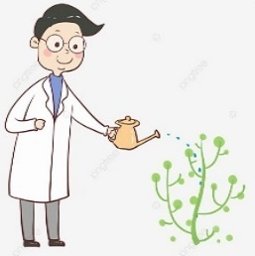
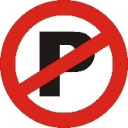
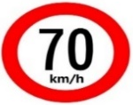

C) Match : ( / / / )

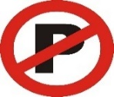

………………………… …………………………….. ……………………………. …………………………….

10
(MG2.2 ) Midterm Exam 2nd Grade 2st Term unit 1 No.2
Name:_____________________________________________ Class: _________
2
Read the text then answer:
Mona is interesting in Geography books She has read many books on China, India and Korea. Mona
Visits the school library twice a week and the librarian is always ready to help her. Last week, she wrote
a very good note in the school Magazine. The headmistress gave her some books as a present for that note.

- Who gave Mona a present? ……………………………………………………………….
- How many times does Mona visit the library? …………………………………………………………..

( Q 1 ) Grammar:
2
A) Shade the correct letter for each sentence:
1-
 | d) | c) | b) | a)
2-
 | d) | c) | b) | a)
3-
 | d) | c) | b) | a)
4-
 | d) | c) | b) | a)


B) Choose the correct sentence:
2
a- it is important that the doctor clean his hands before the surgery.
b- It is important that the doctor cleans his hands before the surgery.
C) Correct the mistake: ( )
…………………………..……………………………………………………………………………….
2
( Q 2 ) Vocabulary:
A) Circle the correct letter for each sentence:
1-
d) | c) | b) |  |  | a)
2-
d) | c) | b) |  |  | a)
3-
d) | c) | b) |  | a)
4-
d) | c) | b) | a)

B) Classify ( / / / )
2

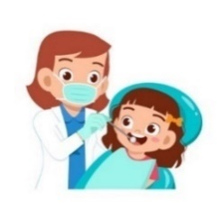
C) Match : ( / / / )



   

