MG 2.2 Unit (1) Working 9 to 5 Revision
(subjunctive ) we use it to stress the importance or urgency of an action (use the base verb ( V inf )
subjunctive
verbs
expressions
ask /demand / insist / recommend
request / require / suggest /urge
It is essential / It is imperative
It is important / It is necessary

S + V + that + s + V base form ...
Expression + that + s + V base form ...
The doctor insisted that he eat healthy food.
it is essential that he eat healthy food.
it is essential that he not eat fast food.
The doctor insisted that he not eat fast food.

(I'd like you to / I want you to + V inf ) express a desire that someone do something
I’d like you to read this story. (I'd ) I would
I'd like you to not read this novel.
I want you to finish the report today.



1 | I would like you to ……………….my friend Maha next week.
A | meet | B | meets | C | met | D | meeting
2 | I want you ……….. read this book.
A | for | B | to | C | at | D | that
3 | It is imperative ………….the doctor wash his hands before entering the operating room
A | for | B | to | C | at | D | that
4 | It is essential that you ……………. quit your job before you find a new one.
A | not | B | doesn’t | C | didn’t | D | don’t
5 | I want you to ……………… the report tomorrow.
A | finishes | B | finish | C | finishing | D | finished
6 | The teacher urged that we ………………hard for the exam.
A | study | B | studies | C | studied | D | studying
7 | I would like you to not …………….too fast.
A | drives | B | drive | C | driving | D | drove
8 | It is important that we not …………….late for the meeting.
A | is | B | were | C | be | D | are
9 | I asked her to …………….. here on time.
A | be | B | is | C | was | D | were
10 | We recommend ………………put your educational background on it.
A | you that | B | that you | C | are you | D | you that not
11 | I want ………………call me if you have any problem.
A | to you | B | it you | C | you to | D | that you
12 | I …………….like you to help with this project.
A | will | B | would | C | could | D | should
13 | The boss demanded that he …………. late again.
A | is not | B | be not | C | not be | D | not is

MG 2.2 Unit (1) Working 9 to 5 Revision
(Tag questions ) we use it to check information if it's correct or not and start a conversation

Auxiliary verbs ( helping verbs )
am / is /are have /has can /could will /would
was /were had must /should
If the statement is positive , the question tag is negative
If the statement is negative , the question tag is positive

No, it wasn't.
wasn’t it
It was good, ……………..…………?
was it
Yes, it was
It wasn’t good, ………..…. ?

Yes, I am.
No, she didn't.
She didn’t study hard, did she?
You are from Riyadh , aren't you ?


Yes, he did
didn’t he
He finished it, ……………..……..………?

Present simple |  |  |  | Past simple
do | I /you / they /we | does | She / he /it | did | I / you / they /we/ she/ he/ it

1 | The book wasn’t very good, ……………?
A | was it | B | was the book | C | were it | D | wasn’t it
2 | It's too hot today, …………….?
A | is it | B | isn’t it | C | wasn’t it | D | isn’t she
3 | You are the new teacher, ……………….?
A | were you | B | are you not | C | are you | D | aren’t you
4 | You didn’t break her vase, ……………?
A | did you | B | does you | C | didn’t you | D | wasn’t you
5 | Alex is working in a bank now, …………………...?
A | is he | B | isn’t he | C | is Alex | D | aren’t he
6 | Mary made this cake, ……………?
A | did she | B | doesn’t she | C | didn’t she | D | don’t she
7 | You miss your father, ………………...?
A | don’t you | B | do you | C | did you | D | didn’t you
8 | She works out every day, ……………………?
A | does she | B | doesn’t she | C | don’t she | D | didn’t she
9 | you hadn’t cook dinner, ………………?
A | haven't you | B | hasn’t you | C | had you | D | hadn’t you
10 | Eat your food,……………..? ( start with a verb as a demand )
A | doesn't you | B | will you | C | won't you | D | did you
11 | Give me that pen,…………….? ( start with a verb as a request )
A | doesn't you | B | will you | C | won't you | D | did you
12 | Let's play a game, …………………? ( start with a suggestion )
A | will we | B | shall we | C | won't we | D | don’t we
13 | I am late, …………….?
A | I am not | B | aren’t I | C | am I | D | aren’t me
14 | I am not late, ………...?
A | I am not | B | aren’t I | C | am I | D | Aren’t me

MG 2.2 Unit (1) Working 9 to 5 Revision
1-polite ways to ask for information with Can, Could, Would, Would you mind
When you ask people you don’t know
When you ask Family and friends
( people you know)

Can you tell me where the mall is?
Where is the mall?
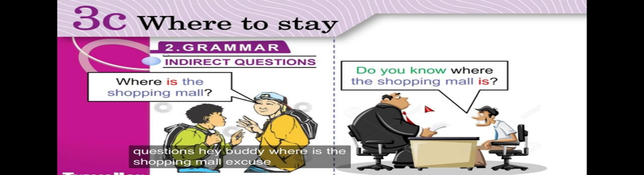


Can / Could / Would
Can you tell me where the bank is?

Would you mind telling me where the bank is?
Would you mind + Ving

2-polite ways to make requests with Can, Could and Would + inf
Certainly.
Of course.
Sure.
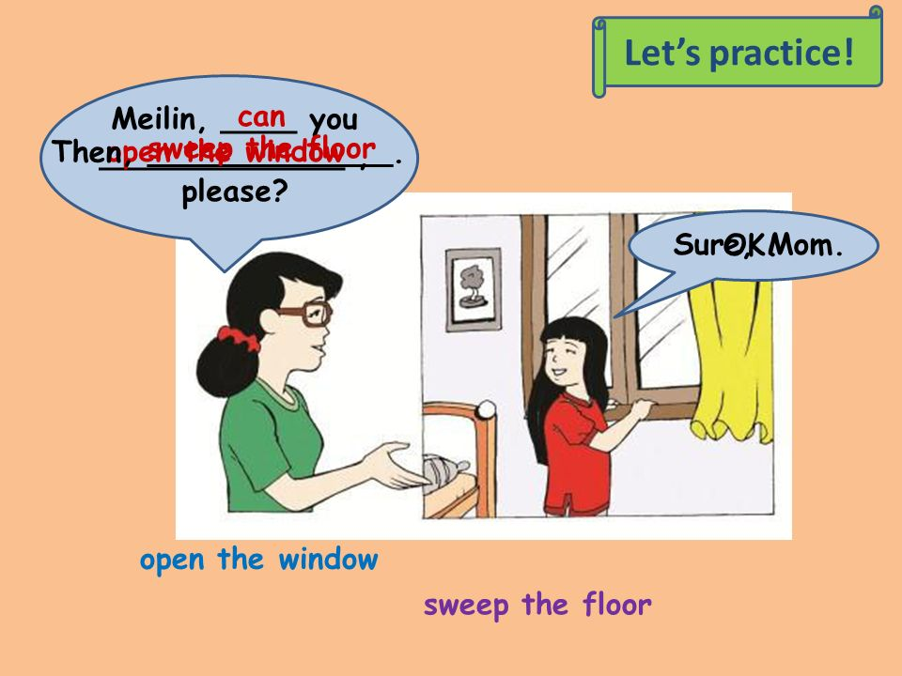
Can you open the window, please?

Can / Could + you I
Would + you I

3-express ( obligation / necessity / lack of necessity ) + V-inf

obligation | necessity | Lack of necessity
must ( personal duties )  have to (obligations to help others)  mustn’t (not allowed to do it ) | I, you, we, they have to  she, he , it has to  (past→ had to) (future→ will have to)  need to  (past→ needed to) (future→ will need to) | I, you. we, they don’t have to  she, he, it doesn’t have to  didn’t have to / need to  don’t / doesn't need to  needn’t to

1 | You ……………………pray 5 time a day.
A | must | B | mustn’t | C | will need | D | had to
2 | Would you mind ……………me with my resume?
A | help | B | helps | C | helping | D | helped
3 | Can I …………..to the manager?
A | speak | B | speaks | C | speaking | D | spoke
4 | I …………… write a report, so I didn’t hang out with my friends yesterday.
A | will need to | B | had to | C | have to | D | mustn’t
5 | He ………………….. go to work yesterday, it was Friday.
A | didn’t need to | B | don’t need to | C | doesn't need to | D | aren’t need to
6 | Tomorrow we ………………….get up early to catch the school bus.
A | had to | B | have to | C | will has to | D | will have to
7 | It's not allowed to smoke in the waiting room, you ………………. smoke here.
A | have to | B | mustn’t | C | need to | D | has to
8 | Adel ……………………. be patient with the customers all the time.
A | has to | B | have to | C | had to | D | needed to
9 | The people in line will ……………wait for their turn.
A | has to | B | have to | C | had to | D | needed to
10 | Mum ………….. cook tonight because we are going out for dinner.
A | has to | B | have to | C | had to | D | needn’t to

MG 2.2 Unit (1) Working 9 to 5 Revision
Vocabulary
1 | To be a ……………….is a job requires a person have kindness and consideration.
A | race car driver | B | zoologist | C | nurse | D | lawyer
2 | I spend a lot of time cutting and sewing, but I don’t work with fabric, I am ………………..
A | surgeon | B | zoologist | C | race car driver | D | air traffic controller
3 | ……………………is someone who helps people in need, poor or disabled.
A | Social worker | B | Vet | C | zoologist | D | Screen writer
4 | An arborist is a doctor for ………………….
A | children | B | animals | C | trees | D | old people
5 | A pediatrician is a doctor for ……………..
A | children | B | animals | C | trees | D | old people
6 | Circle the odd word.
A | Doctor | B | No Parking | C | Cashier | D | telemarketer
7 | Circle the odd word.
A | No Entry | B | Speed Limit | C | No Parking | D | engineer
8 | I'm in a ……………… the test is tomorrow and I can't understand it.
A | jump ship | B | cover | C | bind | D | captive
9 | A: I wanna tell you something but I need you to …………… B: you can trust me, it’s a secret.
A | keep it to yourself | B | tell every one | C | spared it | D | tell your family
10 | Ali: I won 5000 in the competition. Bader: ……………..
A | certainly | B | no kidding | C | yes | D | sure
11 | Ali: Did you Know that Imad ……………. Bader: He did! Where is he going to work now?
A | jumped ship | B | in a bind | C | will not do it | D | No kidding
12 | Ali: I am going to ……………now. Bader: OK. See you later.
A | no kidding | B | in a bind | C | take off | D | help you out
Classify the items into the correct category:
( trend – fabric – sketches – style – natural – artificial – food – taste – trim – file nail – feet – captive )

doll fashion designer | flavorist | elephant pedicurist
1 | identical | (2) | free
2 | captive | (1) | different
3 | methodical | (4) | usual
4 | 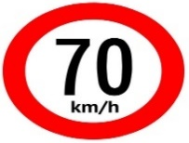  unusual | (3) | disorganized

Match the words with their opposites

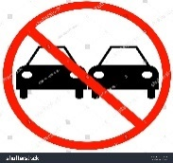

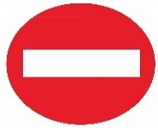
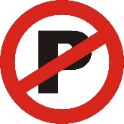

No Entry
Speed limit
Dentist
No parking
No passing


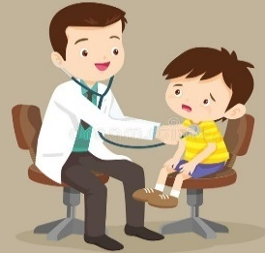
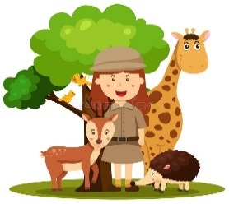


firefighter
arborist
surgeon
Pediatrician
zoologist

