اختبار الفترة الأولى لصف الثاني متوسط

Name …………………………………. Class ………………..

Comprehension

My favourite colour is pink . I am going to my aunt's house for a party . I'm wearing a pink skirt and blouse . I'm looking for my pink shoes and a bag but I can't find them . I think I'll have to wear my white sandals instead .

A-Questions :

------
3
- What is your favourite colour ?
……………………………………………………………………..

B-Choose:
I'm wearing a …………..……. Skirt and blouse .
Pink yellow green
C-Put ( ) or ( ) :-
1- My favourite colour is pink ( )
2- I can find my pink shoes and bag ( )

…………………………………………………………………………..

Grammer ;

------
8
- I ( was - were ) at home last night .
- They ( go - went ) to school yesterday .
- I didn’t hear ( anything – nothing ) I was sleep .
- I am happy ( so am I – so do I )
- I didn’t watch the news ( so did I – neither did I )
- The driver was sleepy ( so – because ) he didn’t see the stop sign .

--------------------------------------------------------------------------------------

Write the past

- do ……………… 2- eat ……………… 3 – meet………………….

-------
9
make negative

There was an accident .

………………………………………..

Vocabulary

Write a word under the picture

------
10

( stomachache --- headache --- toothache --- scared )

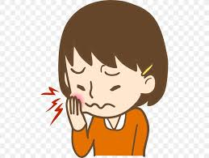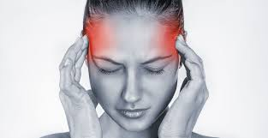

………………….. …………… ….………. …………..

Match :

- What's up ( ) a- it's going to be quick .
- The thing is ( ) b- The problem is .
- it'll only take a minute ( ) c- what happing .

________________________________________________________

write the missimg letter :-

 | 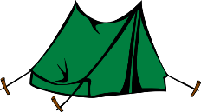  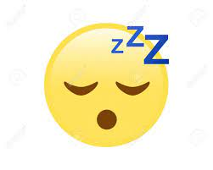 | 
An--ry | Slee--y | Happ---

Best wishes ..
T / Areej Alhausoni

