


المملكة العربية السعودية عدد الأوراق:4

وزارة التعليم الزمن :ساعة ونصف

إدارة التعليم الصف- أول متوسط

مدرسة
الاختبار النهائي لمادة اللغة الإنجليزية المرحلة المتوسطة الفصل الدراسي الثاني الدور الأول للعام الدراسي1444هـ

اسم الطالبة: ............................................ .................. رقم الجلوس : ...................

Total  Written | 5  Orthography | 4 Vocabulary | 3  Grammar | 2  reading  comprehension |  | 1 composition | Q. NO.
 |  |  |  |  |  |  | Mark Given
30 | 4 | 7 | 7 | 6 |  | 6 | Mark
 |  |  | Reviser |  |  |  | Corrector

I -Composition:

Write a paragraph about ( Your house ) using the Guide words:
( parents- quite- bedrooms - kitchen – living room-bathrooms- favorite - comfortable - enjoy - garden )

…………………………………………………………………………………………………………………………………………………………………………………………………………………………………………………………………………………………………………………………………………………………………………………………………………………………………………………………………………………………………………………………………………………………………………………………………………………………………………………………………………………………………………………………………………………………………………………………………………………….

( 1 )

II-Reading Comprehension:
Read the passage and answer the questions:
Mona is interested in Geography books . She has already read many books on India, Indonesia , Bangladesh and Japan . She learned a lot about these countries . Mona visits the school library almost every day where she can read a lot of Geography books . The librarian is always ready to help her choose any book which she likes to read about it . Last week , Mona wrote a very good note in the school Magazine and the headmistress was pleased to read that note . She gave her some books as present.
A-Questions:
1- Does Mona like reading books?
……………………………………………………………………………
2- Which books is Mona interested in?
……………………………………………………………………………
3- Why did the headmistress give Mona a present?
…………………………………………………………………………………………………………
B- Choose the right answer:
1- Mona is ………………
a- a headmaster b – a teacher C- a student d-artist
2- ………………………. helps Mona to choose the right books.
a- The librarian b- The teacher c-The headmistress d-Father

C- Put ( √ ) or ( × )
1-The headmistress was sad to read that note. ( )
2- In line 5 “ She” refers to Mona. ( )
3-Mona didn't write good note in the school . ( )
4- Mona visits the school library almost every day .( )

III- Grammar:
A-Choose the correct word:

1- I live …….Jeddah. | a- on | b- in | c- at | d- under
2-…….you studying now? | a-Are | b- Is | c- It | d- Am
3- Why is he taking a nap? ………he is tired | a- So | b- Because | c-neither | d- but
4- Do you write with a pencil….a pen? | a-and | b-but | c-or | d-am
5- would you ………fries? | a-liking | b-like | c-likes | d-liked
6- Faisal ….a red backpack. | a-has | b-have | c- is | d-are
( 2 )

B-Do as shown between brackets:

1-Ahmad doesn’t speaks English. ( Correct )
………………………………………………………..
2-I live in Main Street. ( Correct )
………………………………………………………..
C-add ( er ) 1-big ……………… 2- cute …………………. 3- old ………………. 4-cold…………….

IV -Vocabulary:
A-Put the correct word for each picture:
stove – chef – rug – lamp – chatting– bathtub– confused – laptop- sofa

 |  | 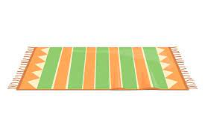 | 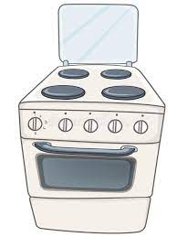

………………… ………………. ……………… …………………
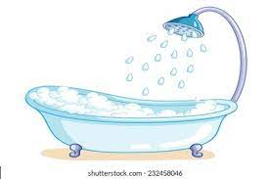 | 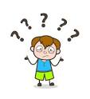 |  | 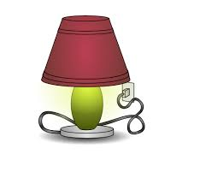

……………….. …………….. ………………. ………………
B-Match the following words with their meaning:
1- | Hard |  | a-what's happening?
2- | Trust me |  | b- believe me
3- | "What's up?" |  | c- difficult
4- | Awesome |  | d- really great
 |  |  | e- interesting
( 3 )

C-Choose the odd words:

a-hotel | b-window | c-restaurant | d-bank
a-left | b-right | c-straight | d-city

V- Orthography:
A-Choose the corect letter:
k - d - h - i - r – p

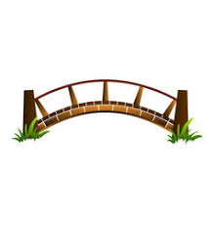 |  | 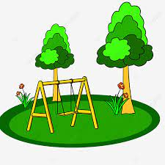 |  | 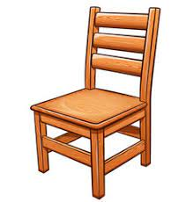

Bri….ge pha….macy par… news pa…er c…air

B-Choose the correct letter:

1- We rented an apartm__nt. | 1-( o ) | 2-( e ) | 3-( n ) | 4-( y )
2- The s__bway is crowded at this hour. | 1-( u) | 2-( d ) | 3-( a ) | 4-( m )
3- I bought a glass v__se. | 1-( a) | 2-( e) | 3-( s ) | 4-( t )
4- Pr__ces are rising. | 1-( t ) | 2-( i ) | 3-( k ) | 4-( u )
5-The h…alth Club is near the bank | 1-( a ) | 2-( f ) | 3-( i ) | 4-( e )
6-They are talking to custo…er | 1-( m ) | 2-( a ) | 3-( u ) | 4-( j )
7-My mother gets up earl… | 1-( g ) | 2-( o ) | 3-( y ) | 4-( a )
8-I read all your te__t messages. | 1-( m ) | 2-( p ) | 3-( u ) | 4-( x )
C-Choose the Correct word:
1 | a-srpemkuatre | b-supermarket | c-superarketm | d-marketsuper
2 | a-smart | b-marst | c-tsram | d-smrat
3 | a-lmla | b-mlla | c-mall | d-amll

( 4 ) Good luck /

