Write the activities under the right pictures :
(reading magazine – drinking coffee – surfing the internet – chatting )

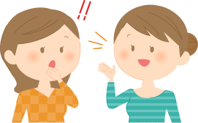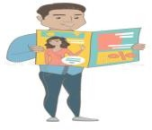

Match the words with their meanings :
1-What's up ? ( ) a)Looking for information 2-Checking out ( ) b) player.
3-Plays tennis ( ) c)What's happening?
4- teaches at school ( ) d) teacher.

Correct the underlined mistake:
  - He cook at night . ……..……………
  - They is playing games …………………….
  - We works in an airline . ………………………
4- She is read now . …………………….

Make a (yes/no) question then answer :
They are studying .
………………………………………………………….? Yes, they are
She is driving .
…………………………………………………………? No, she isn't .
What do you want to be ? ………… …………. ……….. ………… a doctor .
Fill the blanks with suitable personal pronouns :
( because – he – they – so - Why )
1-My father is a doctor . ………………………….. works in a hospital.
2-My sister is studying ……………………………. She has a test .
3-Ahmad and Mona are at the mall…………………………..are shopping.

4- Today is weekend , ……………………. i am happy .

5 - …………………. is he taking a nap ? Because he is tired

