

Kingdom of Saudi Arabia
Ministry of Education
Omran Intermediate School
1st Grade English Exam ( Second Term ) for the first period
Name: ……………………………………………………… Class: ……………………….

A\ Listening:
Listen to the track and choose the correct answer:
1\ In the north, the weather is (dry – windy – sunny).
2\ In the east, the weather is (cloudy – cold – rainy).
3\ In the west and middle, the weather is (sunny – dry – rainy).
4\ The temperature is around (8 – 9 – 10) degrees in the west.
5\ The south has the (best – worst – beautiful) weather.
6\ The temperature is around (15 – 16 – 17) degrees in the south.

B\ Comprehension:
Read the following passage and answer the questions below:
Jack has three new friends. Maria has short brown hair and she is 9 years old. Maria’s school bag is purple and her shoes are pink. Jeremy is 8 years old and has small eyes and a big head. Jeremy’s school bag is blue and his pants are blue too. Peter is 9 years old and has curly black hair. Peter has got a basketball, green shorts and a gray shirt.

A\ How many new friends does Jack have?
……………………………………………………………………………………………………….
B\ Choose the correct answer :
1- Maria’s ( bag – shoes – pants ) are pink .
2- Jeremy is ( 7 – 8 – 9 ) years old .
3- Peter has curly ( brown - black – gray ) hair .
4- Peter has got a ( football - basketball – volleyball ) .

C\ Choose (True) or (False) |  | True √ | False x
1 | Jeremy's pants are white.
2 | Maria is 9 years old.

C\ Grammar :
A\choose the correct answer:
1\ There ( is – are - am ) a sound system in the living room.
2\ There is ( a dryer – dryers – two dryers ) in the laundry room .
3\ There ( is – are - am ) cabinets in the kitchen.
4\ There ( aren’t – not are – is not ) roses in the garden.
5\ You can use a pencil ( and – but – or ) a pen to write the homework.
6\ We write ( and – but – or ) read in the class.
7\ I can speak English ( and – but – or ) I can’t speak French.
8\ Is There a sofa in your apartment ?
( Yes, is there – Yes, there is – There is yes )

B\ Choose the right answer:
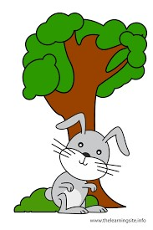  4\ The rabbit is …………………... the tree. | 3\ The dog is ……………..the box.   | 2\ The apple is………….. the box.  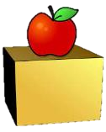 | 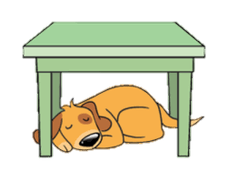  1\ The dog is ………….. the table.
a. on | a. on | a. on | a. under
b. in front of | b. under | b. in front of | b. behind
c. in | c. in | c. in | c. on

D\ Vocabulary
Choose the right answer:
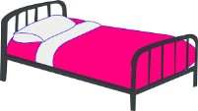 | 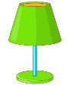 |  | 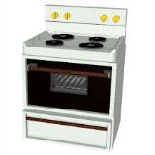 | 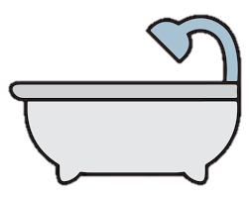
a. bed | a. desk | a. garage | a. dish | a. bathtub
b. curtains | b. lamp | b. garden | b. stove | b. car
c. closet | c. dryer | c. upstairs | c. chair | c. table
 | 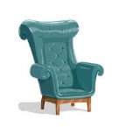 | 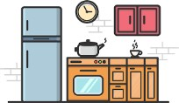 |  | 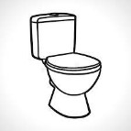
a. dryer | a. mirror | a. bedroom | a. laptop | a. rug
b. TV | b. armchair | b. kitchen | b. dish | b. sink
c. radio | c. vase | c. living room | c. chair | c. toilet
E\ Orthography
Complete the spelling of the words:
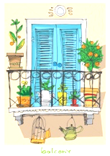

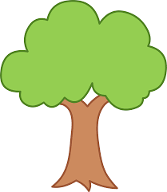

f _owers t_ee _ase ba_co_y

Good luck
T. Anwaar Al-Gharrash

