اختبار الفترة الأولى لمادة اللغة الانجليزية للصف الأول المتوسط الفصل الدراسي الثاني لعام 1443هـ

20

Super goal 1 . The 1st Mid Exam. 2nd Term. Name.......................................................

- Comprehension

Read this passage and complete the sentences

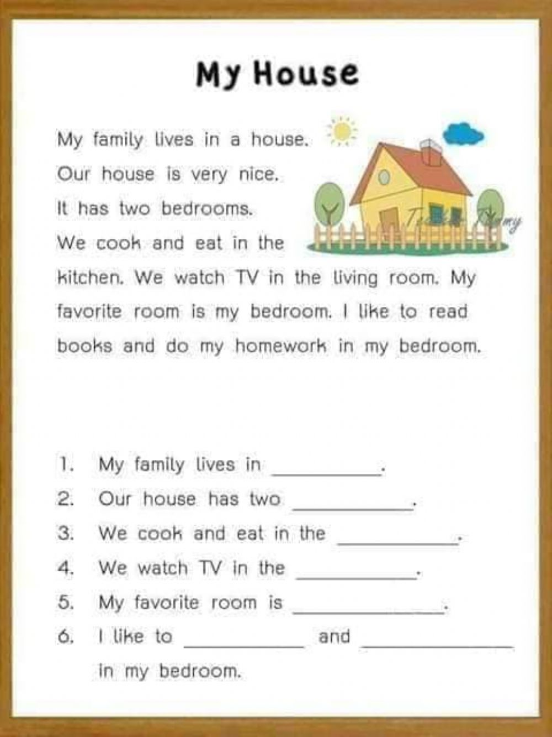

5

II-Grammar

6

Choose:-

1-There ( is - are – isn't ) six boys at the table.
2-We read ( and - but - for ) write in class.
3-I live ( in - on - at ) Jeddah.

4- The lamp is ( between – next to – far from ) the armchair.
5- Ali is ( tall- taller – tallest ) than Khalid..
6- Mona is the (most – more – many ) beautiful girl in the class.

III-Vocabulary

7

A-Match A with B :
B | A
( ) sink, stove and microwaves | 1- bedroom
( ) sofa, TV and armchair. | 2- kitchen
( ) bed, rug and desk | 3- bathroom
( ) toliet, shower and bathtub. | 4- living room

B: Choose:-

1-The ( restaurant - post office – pharmacy ) is a place to eat.
2-The ( health club - hotel - bookstore ) is a place to buy books.
3-There is a car in the ( garage – dining room - bathroom ).

2
V-Orthography
Rearrange the letters to form correct words:
GOOD LUCK Tr. Nora

1- k.a.r.p ____________
2- k.b.n.a ____________

