أسئلة الفاقد التعليمي للفصل الدراسي الثاني 1443
للصف الثالث متوسط
لا تكتب المهارة في نموذج الاختبار فقط للمعلمة لسهولة الحصر
درجة واحدة لكل فقرة = 10 درجات

1 | Recognize various intonation patterns:
"You are leaving now, aren't you?"
The intonation in” aren't you” is:
 | a- rising ↑ |  |  |  |  |  |  |  | b- falling ↓
2- | -Understand information in short messages and announcements which are delivered slowly and clearly
 | Choose the correct information:
 | "Attention Please. The Saudi Airlines "Saudia" flight SV79 is now boarding to Jeddah. Passengers, please proceed to gate B10."
 | a- The light boarding is Flynas. |  | b- The flight is late. |  |  |  |  |  |  | c- The flight is going to Jeddah.
3- | 3-Link ideas with” and, then, but, because”:
 | Choose the correct answer:
 | 1-They bought a house in Riyadh 3 years ago, since ……….. they have lived there.
 | a-then |  |  |  |  |  |  | b-this |  |  |  |  | c- and
4- | Produce a short series of sentences to describe likes/ dislikes:
 | Choose the correct answer that shows the message of the sentence:
 | I like burgers.
 | a- opinion |  |  |  | b- daily routine |  |  |  |  |  |  |  | c- likes and dislikes.
5- | To agree and disagree with others :
 | Choose the correct answer to show agreement:
 | Can you help me?
 | a-Sorry I can't. | b- Not now. |  |  |  |  |  |  |  |  | c- Sure no problem.
6- | Transfer from verbal to visual information:
 | Choose the correct answer that matches the information in the picture:
 | 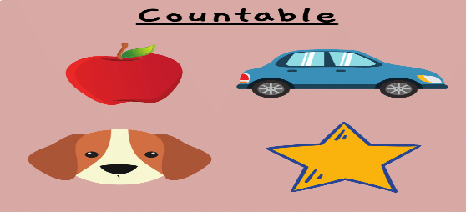
 | a- many, a lot of, a few |  |  | b- irregular verbs |  |  |  |  |  |  |  | c- frequency adverbs
7- | Transfer information from a text to a table:
 | Read the paragraph, then choose the correct main idea:
 | Sara invites her friends to her house. They will have lunch together. She prepares chicken soup and a green salad as appetizers. She cooks rice and chicken as a main dish. As for dessert she bakes a lemon cake.
 | a-Appetizer: chips  Main dish: pasta  Dessert: orange cake |  |  |  |  | b-Appetizer: salad  Main dish: rice and chicken  Dessert: lemon cake |  |  |  |  |  |  |  | c- Appetizer: soup  Main dish: rice and beef  Dessert: pancake.
8- | Understand text cohesion (personal pronouns used as reference items):
 | Choose the correct answer:
I bought new stories from a bookstore. They are on sale.
"They" refers to:
 | a- I |  |  |  |  |  | b- stories |  |  |  |  |  |  |  | c- bookstore
9- | Write about everyday aspects of their environment (people, animals, places, living conditions, etc):
 | Read the following then choose the correct information that completes the passage:
Ali is really into fitness. He works out at ………….. regularly. He
…………. frequently, and he plays tennis ………….. a week. From time to……….,
Ali goes rock climbing.
 | - -The gym  - runs  - once  - time |  |  |  |  |  |  | b- - the supermarket  -sleeps  -never  - day |  |  |  |  |  |  |  | c- -the mosque,  - cooks  -three times  -night
10- | Write short simple informal letters and e-mails (giving news, thanking, apologizing, inviting, accepting or refusing an invitation, describing experiences):
 | Read the following then choose the correct information to complete the email:
……….. Mom and Dad,
It was so nice to hear ……… you. I think of you all the time, too. It was a little difficult for me to adjust at first because the …….. is cold, it is snowing and the temperature is -0. As for my ……….., they are really interesting and the teachers are extremely helpful. I have four hours of English every day.

 | - Dear,  From  Weather  classes |  |  |  |  |  | b- Hi,  in  food  flight |  |  |  |  |  |  |  |  |  | - What  Above  Clothes  Computer

