S.G 3.2 Revision U.7 It is a good deal isn’t it ?
A) Choose the correct answers :
1- You were in Jeddah, ( wasn't- weren't- aren't ) you?
2- She studied in Dammam, ( didn't- don't - doesn't) she?
3-They aren't from Abha, ( are they - are not they – do they) ?
4- She hasn’t finished her job yet . ( has she – wasn’t he – hasn’t she ) ?
4- Majed is able to ( drive – drives – driving ) a car.
5-what should I ( do – does - doing ) tonight ?
6- -you could (make – makes –making ) pasta ) B)Correct :
Spanish speak 1-They are able to
2-Lets going to the restaurant . go
3- He is a good reader , aren’t he ? isn’t he
C) Do as shown between brackets :
1- Go / lets / shopping. Let's go shopping . ( reorder )
2- We travel to Dubai . why don’t we travel to Dubai ( Use why don’t )

Vocabulary:

D) Match the words with their meanings :
Genes from generation to another | 4 | 1- Triplet
Child who has lost his parent . | 3 | 2- coincidence
3 baby born at the same time | 1 | 3- Orphan
By chance | 2 | 4-heredity

E) Match the expression with correct meaning :
1-That’s a good idea . …2.. refusing suggestion
2-Sorry, I cant …3.. introduction
3-How do you do ? …1….. accepting suggestion
F) Match the word with opposite :
( cry - sell - - build )
1-buy ………… 2- Laugh...
3-destroy ……………
G) Write the correct word under each picture( plate- spoon –knife- saw- hose – hammer ) 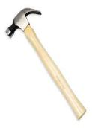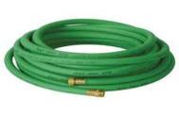 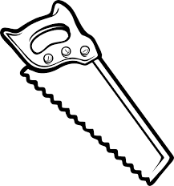   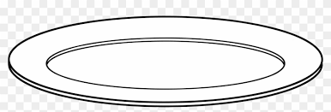

Hammer hose saw knife spoon plate
:
Best Wishes :T. Mayadh F. Abohamad

