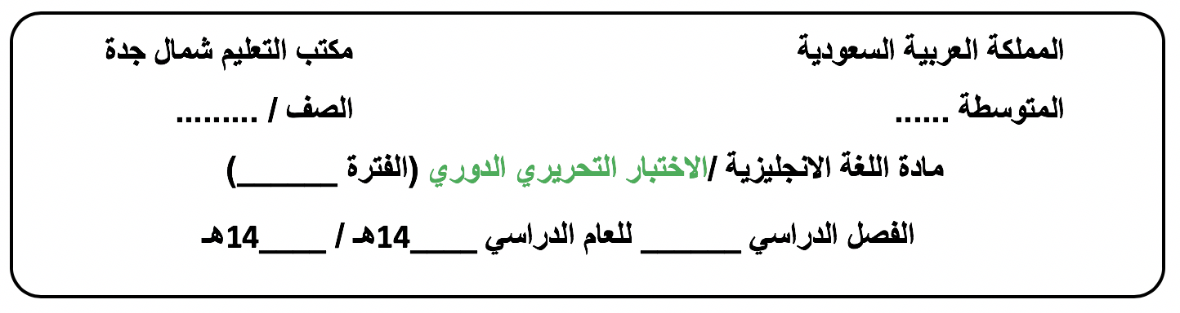
الثالث متوسط
الأولى الوحدة 5
44
43
الثاني

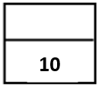
Day/ ………………………. Date/ …… / ….. / 1444H

Name /…………………………………………………………………..…………….Class/ 3 - …….
-------------------------------------------------------------------------------------------------------------------------------------------------------------------------------------------
Vocabulary: ½ for each
A. Choose the correct answer:
1.………………. have made our lives easier.
a-Films b- Addictions c-Inventions d-Witnesses
2. I noticed that my mom never uses the ………to make the cookies.
a-computers b-camera c- micro wave oven d-printer
3.You don’t need films for ……….. cameras.
a- digital b- old c-bad d-mass
- Nowadays, small and ……………….printers can be found in offices and homes everywhere.
a-traditional b-high-tech c-proud d-different
5.Earlier cell phones models were called ……………..because they were so heavy.
a-Recharge b-device c- phone d-brick
6.The buzzer ……………………. his thoughts.
a-interrupted b-went c-appeared d-offered

B. Match the word with its meaning (synonym), antonym( opposite ) or definition:
7.Children dressed as miniature adults. |  | a.The synonym is inelegant and solid.
8.My father’s cell phone was big and clumsy. |  | b.The meaning is a way of doing something.
9.Mass printing has been around since 1440 in Germany. |  | c.It means small models.
10.The techniques of short films form the art of special effects. |  | d.The antonym is movable .
 |  | e.The antonym is small .

Grammar + Orthography ½ for each
Choose the correct answer:
11. Laptop computers have become smaller and faster and they contain a greater number of f_atures.
a- ( o ) b- ( e ) c- ( a ) d- ( i )
- There was wi_espread support for the war .
a- ( b ) b- ( f ) c- ( d ) d- ( c )
13……………has she known her friend in London ? (Grammar )
a- Where b-How long c-How much d-What
14.Saeed …….tried to learn French for three years.
a-have b-had c-has d-having
15.He has played tennis …………2008.
a-for b-so far c-since d-already
16.I have …………….the Great Wall.
a-see b-saw c-seeing d-seen
- The window ………………….. in my neighborhood.
a- has been broken b-have broken c- have been broken d-broken
- Ask Yes/ No question :
She has taken an English Course . ……………………………………………………………
19. I’ve had ……….. car for about two years.
a-me b- I c- my d-mine
20.Change into passive voice. :
Ali changed the flat tire 2 hours ago.
….……………………………………………………………

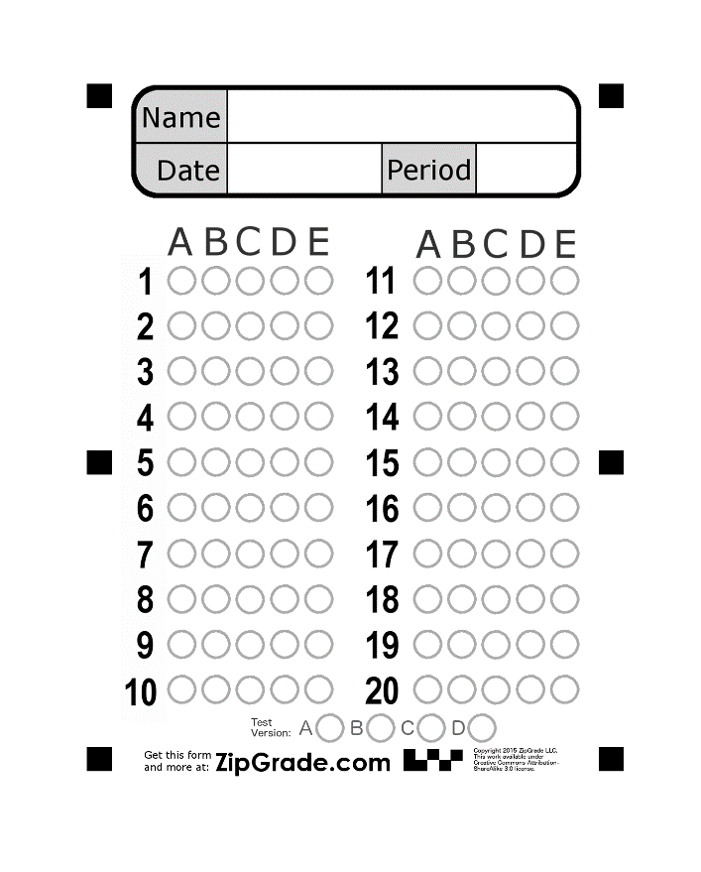

Good luck.

