


الاختبار النهائي لمادة اللغة الانجليزية الفصل الدراسي الاول الدور الاول للعام الدراسي 1445هـ

اسم الطالبة:........................................................... الصف :الثالث متوسط ( )

رقم الجلوس :....................................................

اليوم :....................................... التاريخ : \ \ 1445هـ عدد الصفحات : 3

"اللهم لا سهل إلا ما جعلته سهلا و انت تجعل الحزن إذا شئت سهلا"

signature | Checked by | signature | The reviser | signature | The corrector | Student’s Mark Written | Student`s Mark Number | Question |  | Number
 |  |  |  |  |  |  |  | Mark | Question | Number
 |  |  |  |  |  |  |  | 6 | Guided composition | Q1
 |  |  |  |  |  |  |  | 6 | Reading Comprehension | Q2
 |  |  |  |  |  |  |  | 7 | Grammar | Q3
 |  |  |  |  |  |  |  | 7 | Vocabulary | Q4
 |  |  |  |  |  |  |  | 4 | Orthography | Q5
 |  |  |  |  |  |  |  | 30 | Total
 |  |  |  |  |  |  |  | 10 | Listening and speaking
 |  |  |  |  |  |  |  | 40 | Total

Q1:Guided Composition:
6

Write a paragraph about ( your lifestyle ) you can use these guide words
( name – wake up – brush – on time – help – watch – sleep )
……………………………………………………………………..
……………………………………………………………………………………………………………………………………………………………………………………….……………………………………………………………………………………………………………………………………………………………………………………………………………………………………………………………………………………………………………………………………………………………………………………………………………………………………………………………………………………………………………………………………………………………………………………………………………………………………………………………………………………………………………………………………………………………………………………………………………………………………………………………………………………………………………………………………………………………………………………………………………………………………………………………………………………………………………………………………………………………………………………………………………………………………………………………………………………………………………………………………………………………………………………………………………………………………………………………...

Q2:Reading Comprehension:
6
Read the following passage then answer the question below:-
Ahmed has got a small shop .Everyday he goes to the shop at six o’clock in the morning .There are eggs, milk, fruit and cheese at the Shop. Every Sunday he closes his shop and goes to e farm to buy new things for his shop .People come to Ahmed’s shop to buy there things because he has clean and new things. they like Ahmed. He is a good Shopkeeper .Ahmed comes back home at eleven o’clock at night .He has Dinner and goes to bed.
A: Tick ( ) or (X):
1-People don’t like Ahmed. ( )
2-Faud goes to bed very late. ( )
3-Oranges and apples are fruit. ( )
B: Choose the correct answer:

1- Ahmed ------------------ his shop every Sunday.
a) opens b) closes c) goes
2- I have fish for --------------------- tonight.
a) breakfast b)lunch c) dinner
3- we can keep tame animal on the ----------------------
a)shop b) form c)bed

1

Q3:Grammar:

A:Choose the correct answer:
7
1-I always ( do – does – doing ) my homework in the afternoon.
2-(Neither – all – both ) of them is a teacher.
3- Ali is ( write – wrote – writing ) the lesson.
4-There is ( some – any – a ) juice.
B- Do as shown between brackets:
1-He is going to Paris to studying French. ( correct )
………………………………………………………………………………………………………
2-Omar will go to school tomorrow. ( make a negative )
……………………………………………………………………………………………………
3-you \ need \ do \ eggs \ ? (use How many )
…………………………………………………………………………………………………….

Q4:Vocabulary:

A:Find the ode words:
7
1-Salmon – crab – taxi
2-Car – carrot – onion
3-Beef – spoon - chicken
4-mango – orange – pen
B:Write the correct word under each picture:
Salad – shrimp – suitcase – passport – infant – cheese – cheesecake

 | 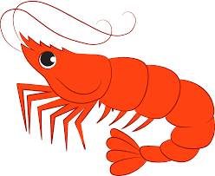 |  | 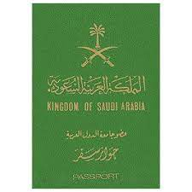 | 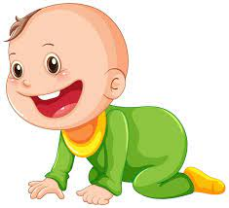 | 

2

Q5:Orthography

A:Choose the missing letter:
4
1-toma__oes ( t – r – q ) 3-pi__ot ( r – m – l )
2-a__ocado ( r – v – x ) 4-gy__ ( m – t – k )
B-Write the missing letter:
r - t - g - u - m

 | 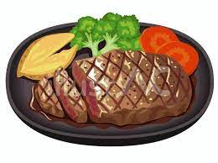 |  | 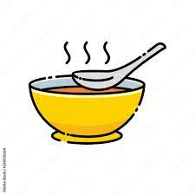
Yogu__t | S__eak | Bagga__e | so__p

3
Tr.Najah Aljuhani
Good luck

