
Super Goal 1 - English Language
First Intermediate Grade
First Term Final Exam 1444-2022
First Round | Time: 1.5 hour

Kingdom of Saudi Arabia
Ministry of Education
………. Education Directorate
………….. Intermediate School

الدرجة كتابه
Written
المصحح المراجع
Checker corrector
قسم اللغة الإنجليزية بالمدرسة
المجموع
Total / 30
Q16
Q26
Q37
Q4
4
Q57

رقم الجلوس
اسم الطالب

اللهّم لا سَهلَ إلا ما جعلتُه سَهلاً فإنكَ تَجعَلُ الحزنَ إذا شِئتَ سَهلاَ " "
- Write about ………………………:
• ………………….. ?
• ………………….. ?
• ………………….. ?
• ……………………?

..................................................................................................................................................................................................................
..................................................................................................................................................................................................................
..................................................................................................................................................................................................................
...............................................................................................................................................................................................................
..................................................................................................................................................................................................................
..................................................................................................................................................................................................................
..................................................................................................................................................................................................................
..................................................................................................................................................................................................................
..................................................................................................................................................................................................................
..................................................................................................................................................................................................................

Composition

6

اقلب الصفحة
Comprehension

- Read the following passage and answer the questions below:



6
……
………………………………………………………………………………..
…………………………………………………………………………………………
……………………………………………………………………………………………………………………………………………………………………………………………………………………………………………………………………………………………………………………………………………………………………………………………………………………………………………..

- Answer with (T) for True and (F) for False:
- ……………………………………

- …………………………………..

- …………………………………..

- …………………………………..

- Choose the correct answer:
- …………………………………….?
A. ………... B. ……….. C. ………... D. ………..
- What is the date in the story?
A. ……….. B. ……….. C. ……….. D. ………..

- Fill in the blank with the correct answer:
- …………………………………….?
A. ……….. B. ……….. C. ………..
- …………………………………….?
A. ……….. B. ……….. C. ………..
اقلب الصفحة

- Choose the correct answer:

V

Grammar

7
- Choose the correct answer:
- ……………………………….. ?
A. ………. B. ………. C. ………. D. ……….
- ……………………………….. ?
A. ………. B. ………. C. ………. D. ……….
- ……………………………….. ?
A. ………. B. ………. C. ………. D. ……….
- ……………………………….. ?
A. ………. B. ………. C. ………. D. ……….
- ……………………………….. ?
- ………. B. ………. C. ………. D. ……….
- ……………………………….. ?
A. ………. B. ………. C. ………. D. ……….
- ……………………………….. ?
A. ………. B. ………. C. ………. D. ……….
- Fill in the blank with the correct answer:
- ……………………………….. ?
A. ………. B. ………. C. ……….
- ……………………………….. ?
A. ………. B. ………. C. ……….
- ……………………………….. ?
A. ………. B. ………. C. ……….
- Choose (A) for the correct or (B) for incorrect sentence:
- They are in the same class.
A. Correct B. Incorrect
- ……………………………….. ?
A. Correct B. Incorrect
- ……………………………….. ?
A. Correct B. Incorrect
- ……………………………….. ?
A. Correct B. Incorrect
Orthography

4

- Choose the correct letter:
- This is my fam__ly.
A. s B. o C. p D. i
- ………………………………...
A. ….. B. ….. C. ….. D. …..
- Fill in the blank with the correct answer:
- ………………………………...
A. ….. B. ….. C. …..
- ………………………………...
A. ….. B. ….. C. ….
اقلب الصفحة
- Choose (A) for the correct or (B) for incorrect sentence:
- …………………
- I b. e c. u d. o
- …………………
a. p b. v c. f d. m
- …………………
a. o b. a c. i d. e

- The missing letter in this word (Good __vening,) is (e)
A. Correct B. Incorrect
- ………………………………..
A. Correct B. Incorrect
- ………………………………..
A. Correct B. Incorrect
- ………………………………..
A. Correct B. Incorrect
Vocabulary

7
- Choose (A) for the correct or (B) for incorrect sentence:
- It's 4:30 pm in the evening .
A. Correct B. Incorrect
- ………………………………...
A. Correct B. Incorrect
- ………………………………...
A. Correct B. Incorrect
- ………………………………...
A. Correct B. Incorrect
- Choose the correct answer:
- ………………………………...
A. ………. B. ………. C. ………. D. ……….
- ………………………………...
A. ………. B. ………. C. ………. D. ……….
- ………………………………...
A. ………. B. ………. C. ………. D. ……….
- ………………………………..
A. ………. B. ………. C. ………. D. ……….
- ………………………………..
A. ………. B. ………. C. ………. D. ……….
- ………………………………...
A. ………. B. ………. C. ………. D. ……….

- Match:
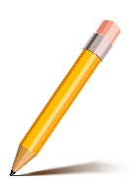  1. | 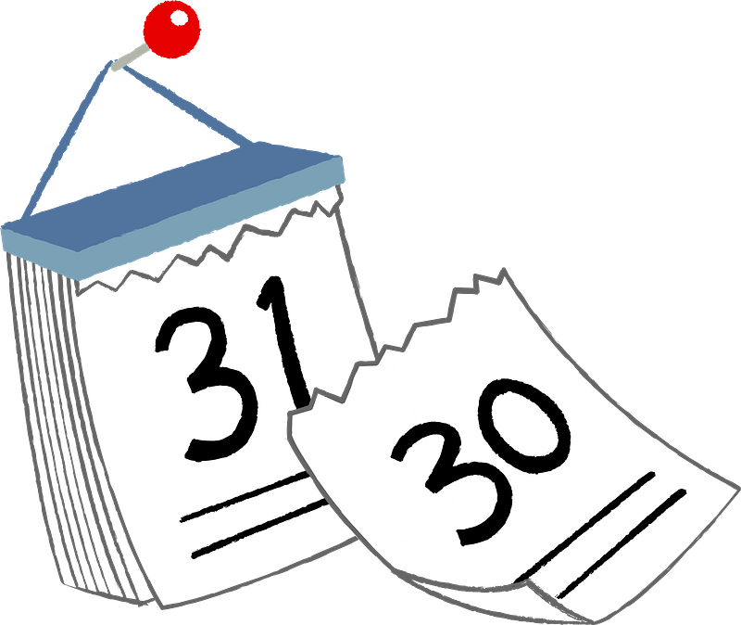  2. | 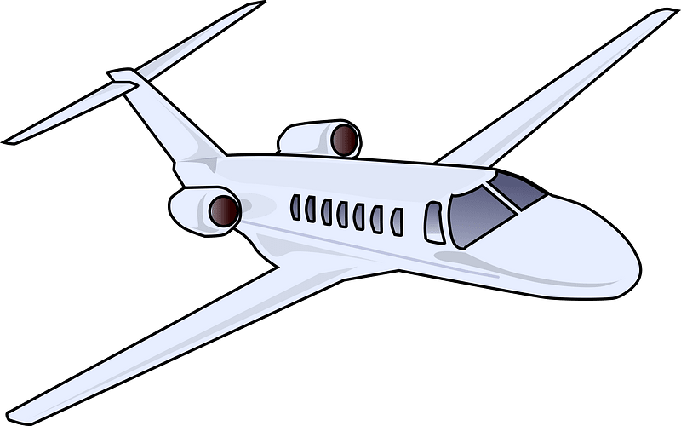  3. | 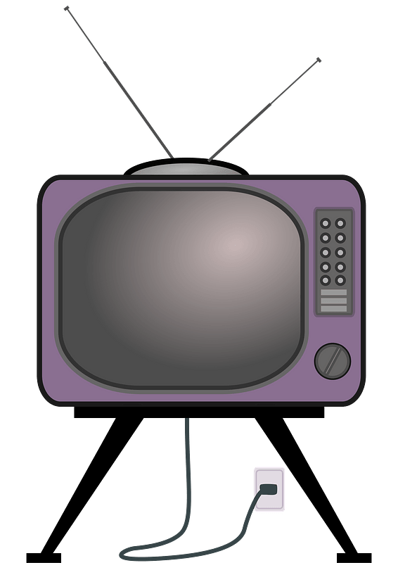  4.
A: TELEVISION | B: AIRPLANE | C: CALENDUR | D: PENCIL

انتهت الأسئلة....
وبالله التوفيق والنجاح ..
الأستاذ / راشد السلمي

