المملكة العربية السعودية  وزارة التعليم  الإدارة العامة للتعليم ب.....  ابتدائية .... |   بسم الله الرحمن الرحيم  اختبار الفصل الدراسي الأول  للعام الدراسي 1444 هـ | المادة | لغة انجليزية
 |  | الصف | السادس
 |  | الزمن | ساعة ونصف
 |  | الدور
الاسم: .............................................................................................................
Total | 6 | 5 | 4 | 3 | 2 | 1 | Question
 |  | Revised by: |  |  |  | Corrected by:

Q1General Questions:

6
A. Choose the suitable answer:
- Where do you live ?
- I live in Qassim. b- I’m eleven years old. c- My name’s Ali.

- Whose shoes are these?
- They’re Steve’s. b- My name’s Hashim. c- Thank you.

- How do you go to school?
- I have one brother. b- I live in Makkah. c- by school bus.

- How old are you?
a- I’m 13 years old. b- Thank you c- welcome

- What sport do you like?
a- I like tennis b- Yes, I do c- I like English
- What chores do you like?
a- No, I don’t b- I like washing dishes c- Nice to meet you
- Nice to meet you.
a- thank you b- nice to meet you too. c-. Yes, I do

- What do you think about sharks?
a- I think they’re scary b- yes, they are c- No, they aren’t
B. Answer
1- Do you like playing football? ……………………………………..
2- What do you think about seals? I think they’re ……………………..
Q2.Controlled writing:

5
A-Match:
feed |  | 1-I think dolphins are _________.
golf |  | 2-I’d like to try photography but I have no_______.
fast |  | 3I usually ______________ the fish
camera |  | 4- Does your brother play_______________.
B-Rearrange
- Riyadh – in – I – live . ……………………………………………………………
- Like - basketball – I. …………………………………..….……………………..
- is – think – I – seahorse – slow. ……………………………………………………

5

Q3-Grammar:
- Choose the correct answer:
- Seals are (cute – cuter – cutest) than starfish.
- (Who – What – How) do you go to school?
- Dolphins ( is – are - am ) cute.
- A whale ( is – are - am ) big.
- I ( have – has - is ) a bicycle.
- Whose skirt is this ? It is ( Nura – Nura's).
- My sister is a doctor. ( Her – His -My ) name is Nora.
- They are my sisters. ( My - Their – its ) names are Nora and Alia.
- She ( have – has – am) a doll.
- I think the whale is the ( big – biggest – bigger) sea animal.

6
Q4: Vocabulry:
Write the correct number under each picture:

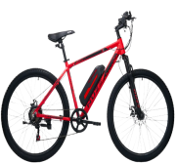
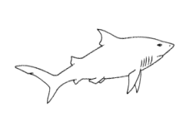
1.bicycle 2. Shark 3. Rain 4. Tie 5. Scuba diving 6.jellyfish


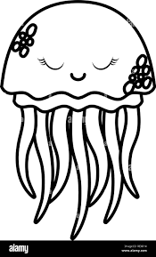
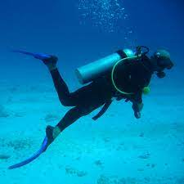

( ) ( ) ( ) ( ) ( ) ( )
Q5: Reading:

4
- Write the correct number under each picture:

- I am washing the dishes.
- I like playing tennis.
- I think whales are the biggest sea animals.
- Bungee jumping is a dangerous sport.
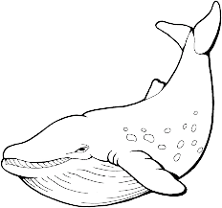
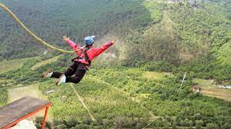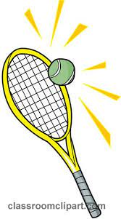
( ) ( ) ( ) ( )

4

Q6: Orthography
- Complete the missing letter :
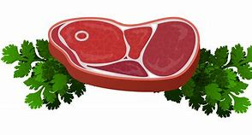

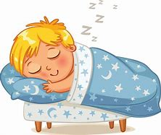
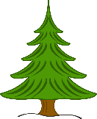
[ ee / ea / ie / i-e ]

1) m__ __ t 2) p __n __ 3) sl__ __ p 5) p__ __
- Fill in the missing letters with [ oi / oy ]
1. b____ 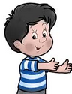 | 3. c____n 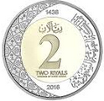

- Unscramble

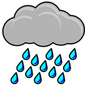
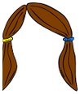
(nair) ……………… (aihr)………….

Best Of Luck

