3
I. CHOOSE
المملكة العربية السعودية |  | اسم الطالب/ ......................................
وزارة التعليم |  | اسم الطالب/ ......................................
إدارة التعليم بمنطقة |  | المادة : انجليزي
مكتب التعليم |  | الزمن :
مدرسة : |  | الصف : فصل ( )
 |  | / 20
اختبار الفترة للفصل الأول - للعام الدراسي 1445– لغة انجليزية –– للصف ...................
اسم الطالب / هـ الفصل /


1 – What is that?
A . It's a seahorse. B . It's a seal.
2 – where do you live ?
A. I like some juice. B. I live in Riyadh .
3 – What is your name ?
A . I am 13 . B. My name is Nora .
4 – Which of the following is a sea animal ?
A . seahorse . B. horse .

II. CHOOSE OR
3

1. He can swim.

This is a computer. .2
3. The whale is small.






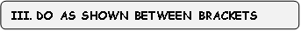
3

___________________ |  |  |  | 1– to - nice – you – meet . ( rearrange )
where | whose | who |  | 2- ______ skirt is this? It's mine. ( choose )
slow | scary |  | fast | 3. Seahorse is ___________ . ( choose)

2
IV. CHOOSE
your | my | his | 1 – I am a teacher , _____ name is Nora .
has | as | is | . As fast ___ a dolphin .2

______________________________________________________________________________________________________________________________________________________________________________________________________
V. CHOOSE
5

Sandals - T-shirts – cap -computer - seal - seahorse – crab -starfish

 | 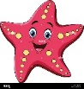 | 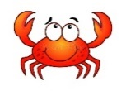 |  | 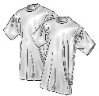


4

Choose the correct letter: ( ai - ea - ow - ee - oa - ou ) )

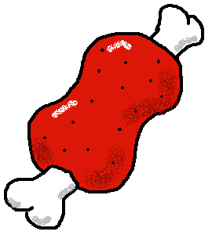 | 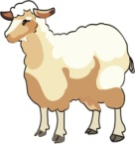 | 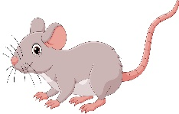 | 
m_ _t | sh_ _ p | m_ _se | c_ _

___________________________________________________________________________________________________________________________________________________________________________________________________________________________________
Controlled writing

4
III. DO AS SHOWN BETWEEN BRACKETS

Good luck
III. DO AS SHOWN BETWEEN BRACKETS

