1 ) Choose the right answer
U3 Sports and Activities

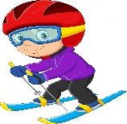  1 | 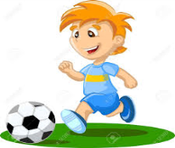  2 | 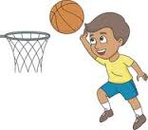  3 | 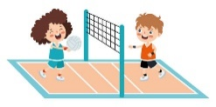  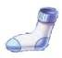  4 | 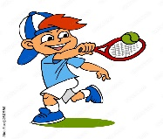  5 | 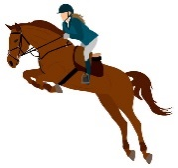  6
a. skiing | a. volleyball | a. swimming | a. volleyball | a. basketball | a. race
b. swimming | b. tennis | b. football | b. swimming | b. jogging | b. horse riding
c. tennis | c. football | c. basketball | c. running | c. tennis | c. football
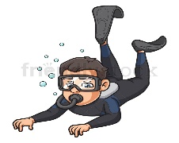  7 | 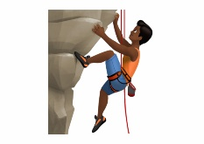  8 | 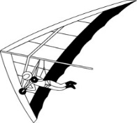  9 | 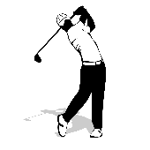  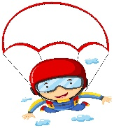  10 | 11 | 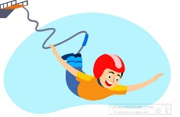  12
a. scuba diving | a. hiking | a. hang gliding | a. flying | a. tennis | a. bungee jumping
b. flying | b. tennis | b. jumping | b. sky diving | b. pottery | b. football
c. tennis | c. rock climbing | c. karate | c. cycling | c. golf | c. swimming
2) Choose the right answer:
1- I ( play - do - does ) tennis.
2- They (does – plays – do ) pottery.
3- Horse riding is (exciting -more exciting -most exciting ) than cycling.
4- Hang gliding is the ( dangerous – more dangerous - most dangerous).
5- He ( like - likes - do ) snowboarding.
6- What sport ( do - does – doing ) Omar like ?
3) Answer the questions
1- Does your brother play word games ?
a-No, he do b-No, he doesn't c- No, do.
2- What sport do you like?
a-I like golf. b- He has a car. c- Nice to meet you.
4) Fill in the missing letter :
ai
oy
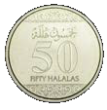  oi | 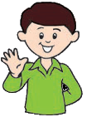 | 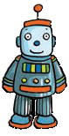 | 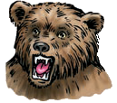 | 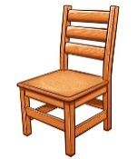
C _ _ n | B _ _  oy | T _ _ | B _ _ r  ea | Ch _ _ r
5) Unscramble the following to make meaningful paragraph:
1. like / I / tennis.
2. is / exciting/ I / tennis/ think
3. I / sky diving / try / want to
4. Sky diving / is / dangerous / more / tennis/ than

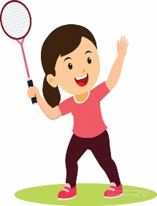
I like tennis.
I think tennis is exciting.
I want to try sky diving.
Sky diving is more dangerous than tennis.

