

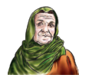
My family
The objective:
Unit : 3 Lesson : 4 page:26




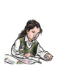

I can recognize and use the articles
(A & An).

Choose
A | An

 |  | 
 |  | 
 |  | 
 |  | 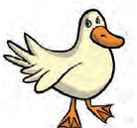
 |  | 


Teacher \ Zuhra Hattan
Teacher \ Haleema Al-Mahmoudi

