S.G.5 Unit 3 [ When Are You Leaving ]
1. Vocabulary
A) Match the word and picture correctly:
1. Ticket 2. suitcase 3. vaccination 4. Passport 5- ID card 6- air plane
5
3
2
1
4
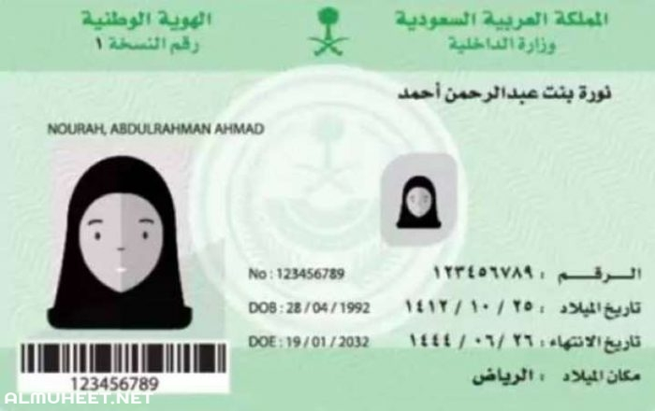

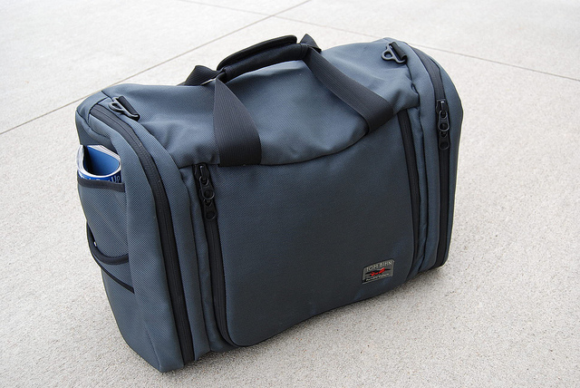
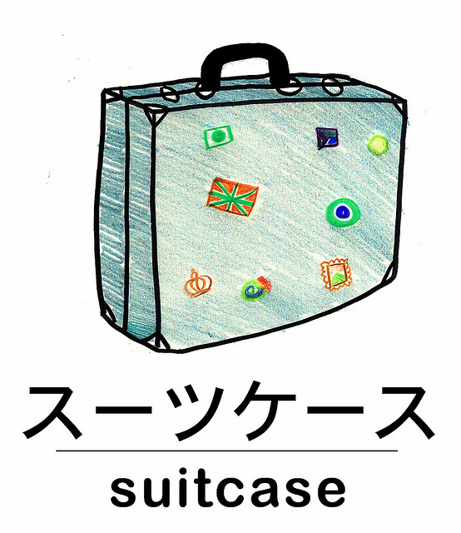
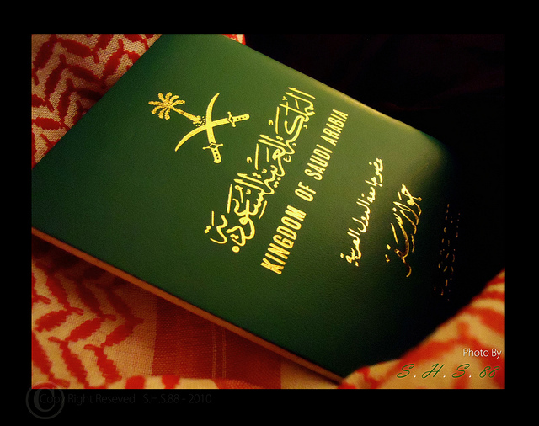

B) match each word to its meaning:
( A ) ( B )
- Pretty ( 4 ) weather
- pick up ( 2 ) learn easily
- delayed ( 1 ) very / quiet
- climate ( 3 ) be late

C) Choose the correct word to complete each sentence:
[ visa - boarding pass- tag - baggage ]
- You need a ……………boarding pass……. to get on a plane.
- You must have a ………………visa…………………… to enter European countries.
- Put a name ………tag……… on your suitcase .
2- Grammar

D ) Choose the correct word:
1- They [ am leaving – is leaving – are leaving ] now.
2 –I am [ study – studies - studying] at the moment.
3- What are you doing [ yesterday – now – often ] ?
- Samara will [ travel - travels - traveling ] to Abha next week.
- Maybe the girls will [ cook –cooking – cooked ] dinner tonight.
- They won't [ buy – bought – buys ] a new car next year .
- Ali is going to [ play - plays - playing ] basketball tomorrow.
- He went [ across – towards – out of ] the room to smoke.

E )Do as shown between brackets:
- Amal is ( read ) a book now. [ Correct the verb ]
………………reading ………
- I will travel to London next month . [ Change into negative ]
…I …wont travel ……………………..
They are waiting at the airport. [ Form a Wh- question ]
…where are they waiting ?…………………
- 4- I will go to the mall to buys a dress . [ Correct the verb ]
………………… buy ………………………………
F) Match the phrase with the correct time clause :
1-Take your ticket and passport with you ……3… while you are in college
2- They will probably visit musueum ……2… when they are in London
3- We are going to miss you …1…. before you leave for the airport .

Best wishes
T. Mayadh Fayhan

