20

English Language
Midterm Exam
\3\1444
King of Saudi Arabia
Ministry of Education
3rd Intermediate Grade

Class\ |  | Student's name

Section A: Read and answer the following questions:_
4
This is Salwa. She lives in a house. It is a big house. There are 4 bedrooms upstairs. There is a living room downstairs. They have a garage, they keep the car inside it. They have a beautiful garden. The garden has flowers and trees. Her family is nice. She has 2 sisters and I brother. His name is Ali. Her mother works in the kitchen and her father works in the garden.
A) Choose the right answer
1-The living room is [ downstairs - behind – upstairs ]
2-The garden has [ beds - cars – flowers ]
B) Put ( √ ) or ( x )
1-Salwa's father works in the garden. [ ]
[ ] 2-They keep the car in the garage.
5
------------------------------------------------------------------------------------------
Section B: _ "Grammar"

1) Nora always…………………. in the morning.
a) drink b) is drinking c) drinks d) are drink

2) …………… of them are teachers.
a) Both b) Neither c) not d) no

3) A: …………..time do you spend in the shower? B: I spend about 5 mints.
a) What B) How much c) When d) Where

4) She teaches English language . ( make yes- no question )
………………………………………………………………………………………..

5) He was play football . ( correct the verb )
8
………………………………………………………………………..
-------------------------------------------------------------------------------------
Section C: Vocabulary" Write the correct word under each picture:
1-cellphone 2- Olympics 3- donated 4- newborn
5-disabled 6-space shuttle 7-gym 8-hearbal tea 9- Webcam
 | 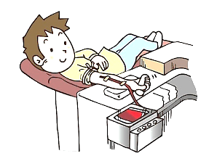 |  | 
 |  |  | 

3
-------------------------------------------------------------------------------------------------
Section D: Match each wor with meaning.
1. metropolis |  | a. a person who helps others
2. humanitarian |  | b. in other countries .
3. abroad |  | c. a big city.

Good luck T.Safa

