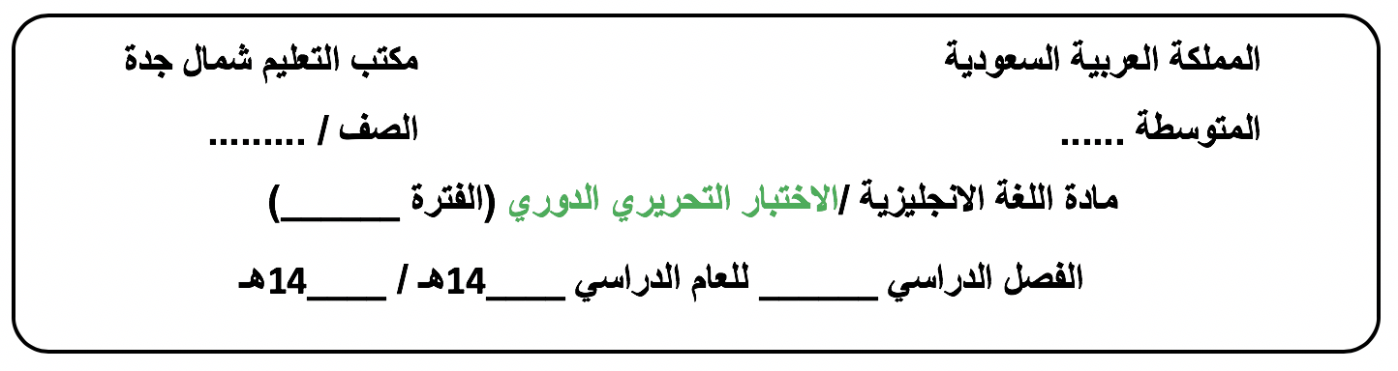

الثالث متوسط
A
الأولى الوحدة 1
44
43
الأول

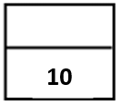
Day/ ………………………. Date/ …… / ….. / 1444H

Name /…………………………………………………………………..…………….Class/ 3 - …….
-------------------------------------------------------------------------------------------------------------------------------------------------------------------------------------------
Vocabulary: ½ for each
A. Choose the correct answer:
1.They’re doing exercises to improve their……………………………
a-herbal b- addict c-thumb d-fitness
2. Work hard but don't…………………..it
a-overdo b-solve c- help d-grow up
3.I'm trying to…………..this problem.
a- enjoy b- work out c-solve d-play
4.Khaled never eats meats.He’s …………………………………..
a-popular b-vegetarian c-proud d-different
5.Saeed always works on the weekend.He’s …………………..employee.
a-lazy b-kind c- devoted d-unfaithful
6.Hadi works very hard .He …….takes work home from the office.
a-often b-never c-always d-sometimes

B. Match the word with its meaning (synonym), antonym( opposite ) or definition:
7.Andy is a health food fanatic.. |  | a.The meaning is the way in which a person lives.
8.He works out at the gym regularly. |  | b.The meaning is to find answer.
9.Omar is a bit of an exercise freak. |  | c.It means someone who exercises a lot.
10.You must check your lifestyle. |  | d.The antonym is addict negatively.
 |  | e.It means to exercise.

Grammar + Orthography ½ for each
Choose the correct answer:
11. I’m downloa__ing the pictures now.
a- ( m ) b- ( d ) c- ( k ) d- ( s)
- Does he usu__lly play football on Sunday ?
a- ( o ) b- ( e ) c- ( i ) d- ( a )
13.Do you always sleep late ? (Grammar )
a-No, you do. b-No, I doesn’t. c-Yes,I don’t. d-No, I don’t.
14.They don’t ……….the dishes.It’s not their job .
a-did b-do c-does d-doing
15.Khaled and Ali speak English. of them speaks Chinese.
a-All b-Neither c-None d-Both
16.My grandpa …………. watching documentaries.
a-loving b-is loving c-loves d-loved
17……………you fight with your sister every day ?
a- Do b- Does c- Did d-Are
18.All of ………are teachers.
a- they b- their c- theirs d- them
19. Wasan talks to ……..every day.
a-me b- I c- my d-mine
20……………..of them are mothers.
a- None b-Neither c-Both d- All

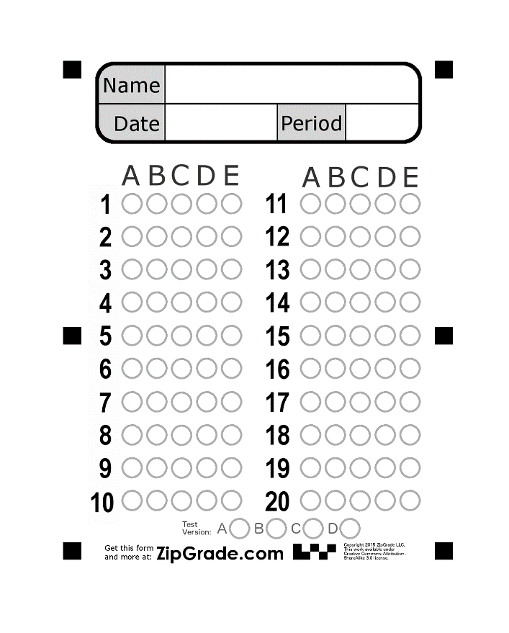


Good luck.

