Name / ………………………………………………………….. Midterm 3rd grade
Q1 - Read the following paragraph then answer the questions below:
Let me tell you about my best friend, Ali. Ali and I went to the same elementary school. He was born in Jeddah. He was grew up in Abha. He was educated in a privet school. He has three brothers. He used to play with football. We started going to the intermediate school in 1991. He likes reading so, He usually spends most of his free time reading short stories.
A-Choose the correct answer :
Where was Ali born ? a Jeddah - Makkah - Riyadh
-He was educated in : Dammam - privet school – Hail
b-( ) or ( )
-Ali likes swimming ( )
-He spent his free time in reading ( )
_______________________________________________________________________________________________
Q2 -Grammar – Choose the correct answer
?a- Does ............... usually drink coffee
She - you - they
b-The students ...................... study hard , can easily pass the exams
Which - who – where
of the 3 books are not mine.........................c-
Both - Neither - none
.d-I ................play video games
used to - use to
_____________________________________________________________________________________
Q3-a-Vocabulary - choose the correct answer
exercise freak ) = a big city - exercise a lot - gave to charity )
b- write the correct word under the picture :
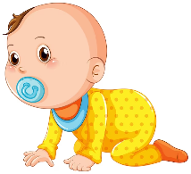
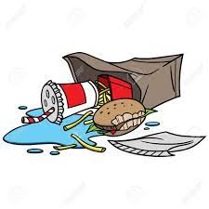
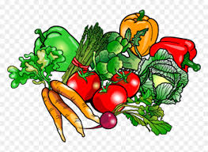
Litter - infant - vegetarian - puzzle

---------------------------------- ---------- ------------------------- ----------------------------- -
Q4- choose the correct spelling ;
a-Rahaf is a health food fan...tic ( a - t - m ) b-He dona...ed blood ( a - t - n )

