Unit 2 [ Life Stories ]
I. Vocabulary
A) Match the word and picture correctly:
1. infant 2. donate 3. gather
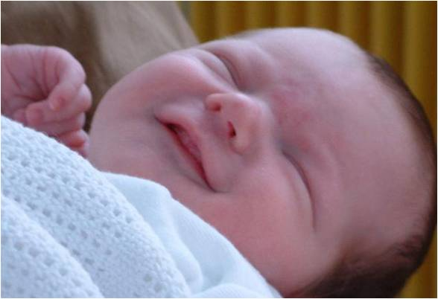

B) match each word to its meaning:
( A ) ( B )
- infant ( ) support someone to succeed
- donate ( ) take away stress and pain
- outstanding ( ) throwing waste material around
- twin ( ) give to charity
- encourage ( ) important opportunity
- effort ( ) get together / meet
- big break ( ) newborn / baby
- litter ( ) two persons who looks exactly alike
- gather ( ) excellent
- relief

C) Choose the correct word to complete each sentence:
[ used to - operation - not into - big break - donations - employee - a cripple ]
What about – turn up - principal - abroad – twins – into]
- I didn't see the match. I'm ……………………………… football.
- When I was a kid I ……………………………………………… play with dolls.
- Our ………………………… is very strict about students' attendance.
- It is wrong to make fun of ………………….. .
- That's Mr. Adnan today is his first day with us. He is a new ……………………………………… .
- Our religion encourages us to give ……………………………………… to others.
- After high school Nada plans to travel to study .............................. .
- Adnan and his brother look exactly alike. They are ………………………… .
- They could ………………………………any time, they love surprises.
- Har ……………………………… came when she won the coding competition.
- Nada is really …………………………… make up.
- I know you plann to take a course but ……………………………… travelling to France instead.

- Past Simple
They
We
You
I
He
She
It

+ V+ ed +
Did?

Fatima cooked dinner. They ate fish.
Fatima didn't cook dinner. They didn't eat fish.

Did Fatima cook dinner? Did they eat fish?

What Did Fatima cook? What Did they eat?

- Choose the correct word:
- Nada [ visit – visits – visited ] her aunt last week.
- They played football 2 days [ everyday – next - ago].
- I [ sleep – sleeps – slept ] early yesterday.
- We [ meet – meets – met ] Amal 5 years ago.
- Ali [ watch – watches – watched ] a movie last night?
- I didn't [ drink – drinks –drinking ] milk yesterday.

- Do as shown between brackets:
- Amal ( buy ) a book yesterday. [ Correct the verb ]
…………………………………………………………………………………………………………………………………………………………
- Ali ( drive ) to Riyadh last month. [ Correct the verb ]
………………………………………………………………………………………………………………………………………………………………
- I [ have ] lunch with my friends last week. [ Correct the verb ]
…………………………………………………………………………………………………………………………………………………………
- They visited their grandmother last week. [ Form a Wh- question ]
……………………………………………………………………………………………………..…………………………………………………
- Sami went to Rome two years ago. [ Form a Yes/ No question ]
………………………………………………………………………………………………………………………………………………………
- Noura attended a lecture 2 days ago. [ Form a Yes/ No question ]
………………………………………………………………………………………………………………………………………………………
- I went to the mall yesterday. [ Form a Wh- question ]
……………………………………………………………………………………………………………………………………………………

- Used to
He
She
It
I
We
You
They

S + used to + V …………

I used to play with dolls.

I didn't use to play with dolls.

Did you use to play with dolls?

- Choose the correct word:
- They [ use to –used to – used ] use cell phones.
- Ahmad didn’t use to [ help – helps – helped ] poor people.
- The boys used to [ buy – bought - buys] ice cream after school.
- I used to [ sleep – sleeps – slept ] late.
- I didn't [ use to –used to – used ] play football when I was 6 years old.

- Do as shown between brackets:
- They used to play tennis on Tuesday. [ Form a question ]
…………………………………………………………………………………………………………………………………………
- Ali used to go to the beach every week. [ Change into negative ]
…………………………………………………………………………………………………………………………………………
- Mona used to chat on line. [ Form a Yes / No question]
…………………………………………………………………………………………………………………………………………
- Amani used to like pasta. [ Form a Wh- question ]
…………………………………………………………………………………………………………………………………………
- We didn't use to go school on Thursday. [ Form a Wh- question ]
…………………………………………………………………………………………………………………………………………

- Be + Born

Was Were
We
You
They

He
She
It
I

I was born in Jeddah. They were born in Abha.
I wasn't born in Jeddah. They weren't born in Abha.
Were you born in Jeddah? Were they born in Abha?
- Choose the correct word:
- We [ are – was – were ] born in Saudi Arabia.
- Nick [ is – was – were ] born in New York.
- Those students [ are – was – were ] born in Tokyo.

- Do as shown between brackets:
- They were born in Madrid. [ Form a Yes / No question ]
…………………………………………………………………………………………………………………………………………
- Ali was born in Cairo. [ Change into negative ]
…………………………………………………………………………………………………………………………………………
- She was born in Riyadh. [ Form a Wh question ]
…………………………………………………………………………………………………………………………………………
- We [ be ] born in Jeddah. [ Correct the verb ]
…………………………………………………………………………………………………………………………………………

- Preposition of time
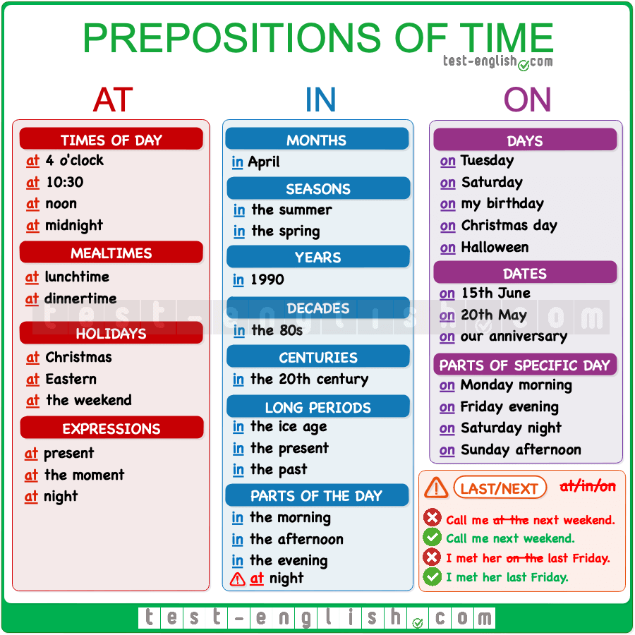

- Choose the correct word:
- I saw Amal [ in – on – at ] the morning.
- The twins were born [ in – on – at ] Tuesday.
- The internet was invented [ in – on – at ] 20th century.
- The arrived home [ in – on – at ] midnight.
- My sister got married [ in – on – at ] 1442 H.
- They are going to leave [ in – on – at ] Monday.

- Dictation

- relief 2. abroad 3. cripple 4. twins

