
English Language
elementary Grade …..
1st period Exam
…………….\20
Kingdom of Saudi Arabia
Ministry of Education
………………… School
Student's Name : class:

5

A-Choose the correct answer.

her | my | his | This is our little brother. ……..name is Ahmad. | 1
she | I | mine | Whose shoes are these? - They're ………….. | 2
has | are | have | He …………. a new bag. | 3
cutest | cuter | cute | A dolphin is ………………………... | 4
slowest | slower | slow | A snail is the …………………… | 5

2

B- reorder.

1- cook \ you \ Can \ ?
………………………………………………………………………………………….………
2- have \ Thay \ a car.
……………………………………………….………………………………………………….

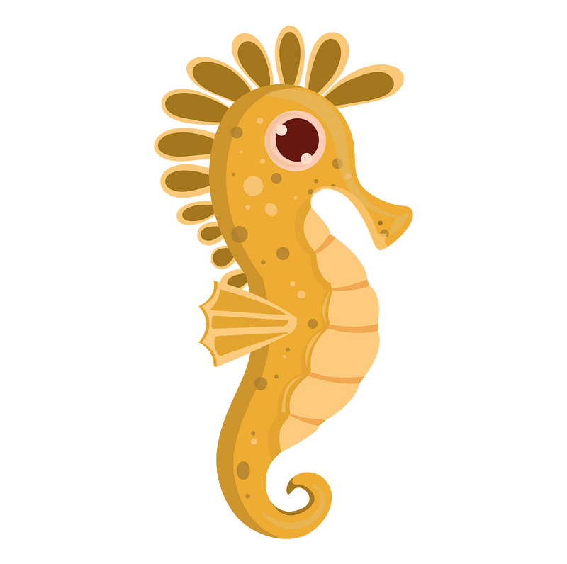
C-Answer the question.
1-what's that ?
3
It's a ( seahorse - fish - sharks ).


2-What are those?
Those are ( crocodile – seagull - baby seals).


3-What‘s that?
it's a ( squid – crab – squid ).
3

D.Match
Nice to meet you, too . |  | What's your name? | 1
I live in Jeddah. |  | Nice to meet you . | 2
My name is Ali. |  | Where do you live? | 3

4

E. Write the correct words under each picture
Sleep goat rice turtle

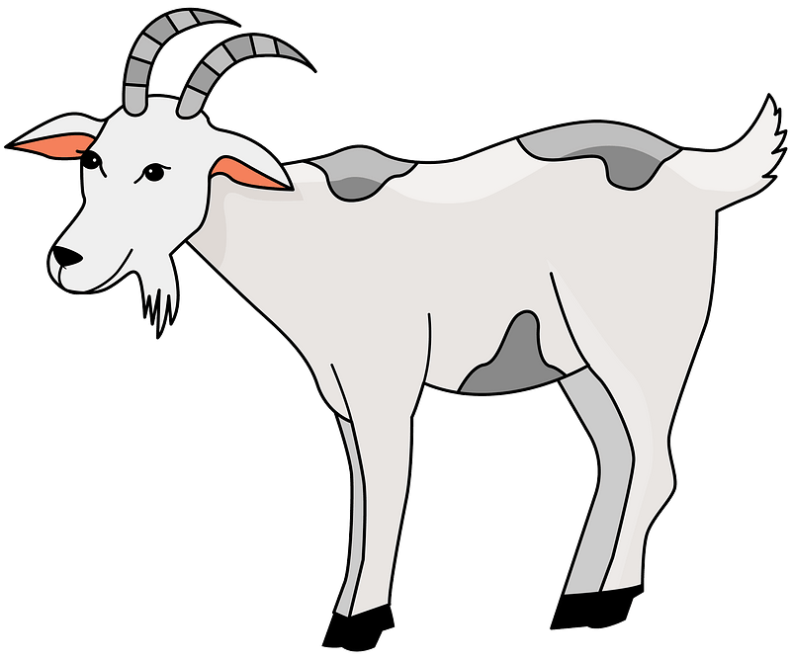
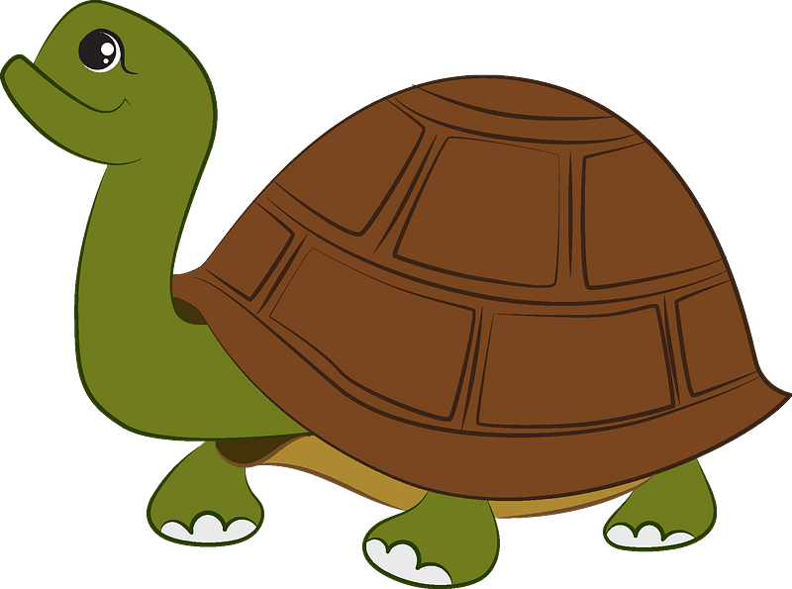


……………………….ر
……………………….ر
……………………….ر
……………………….ر

F.Complete the missing letters.
ee ay ou oa
4



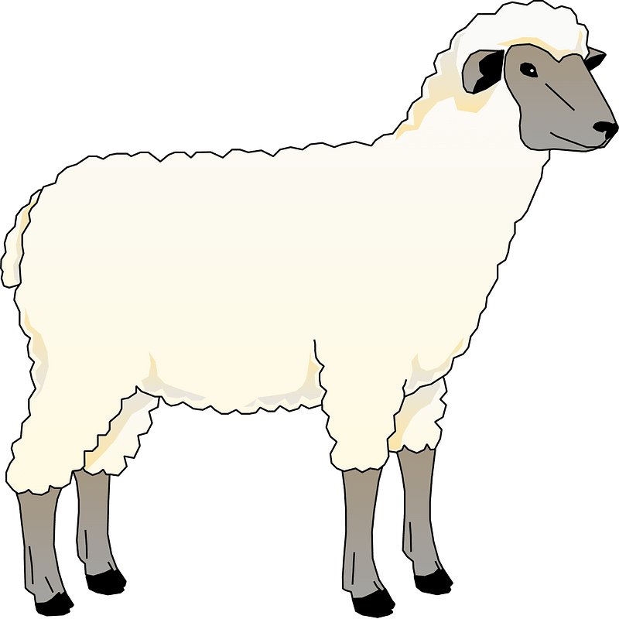


H…….se
Pl………
Sh……..p
C…….t

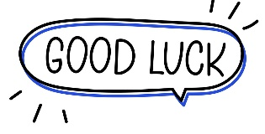
Your teacher:

