Unit 3 WHEN ARE YOU TRAVELLING?
Name _______________________________________ class _____
- List items that you need for a trip to Spain
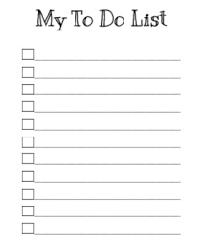
To take list

- What are going to need?

Ex. I am going to need a passport.

__________________________________________________
__________________________________________________
__________________________________________________

