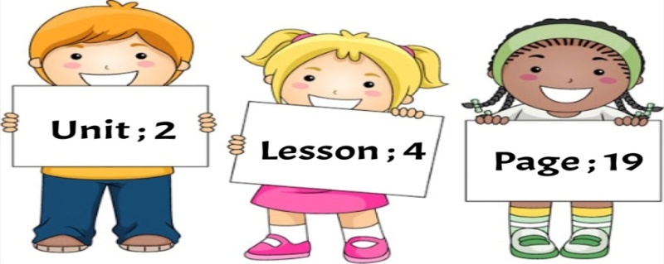
Objective: I can determine if the small letter is tall, short or tail.
Drag each letter to its column :

n
x
c
z
v
b
m

h
k
g
l
j
f

q
w
e
r
t
y
u
o
i
d
s
a
p

Tail Letters | Short Letters |  | Tall Letters
Teacher / Reefa Alotaibi

